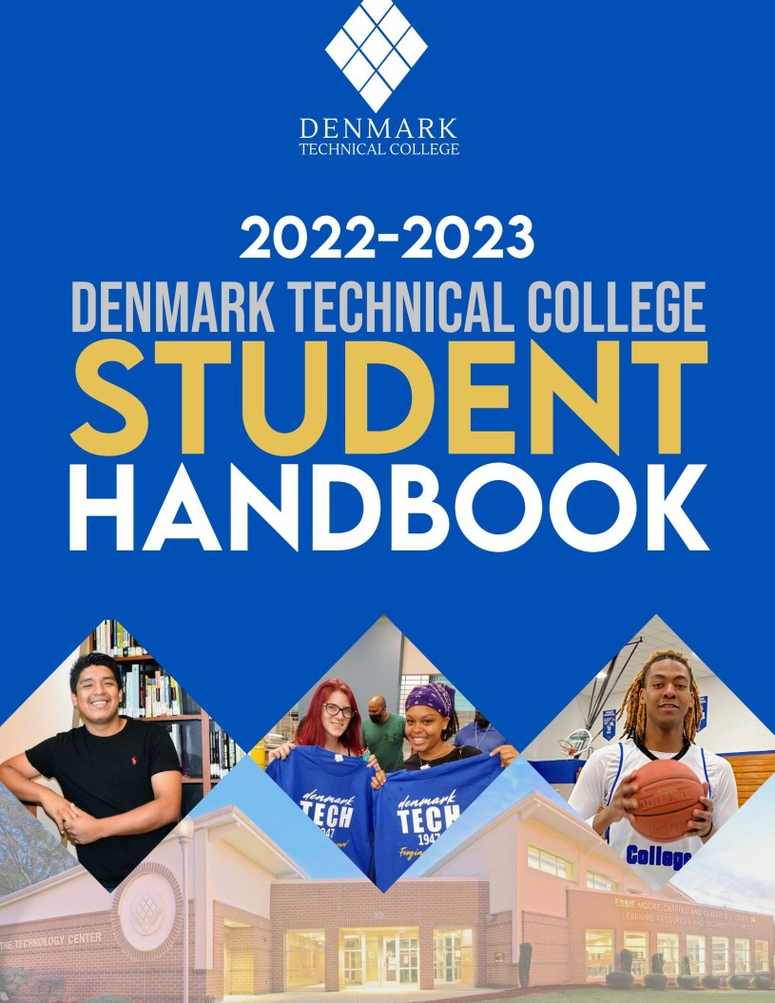

1

CONTENTS

PRESIDENT’S MESSAGE 1
- GENERAL INFORMATION 7
  - History 7
  - Mission 7
  - Campus Buildings 10
  - Office of Admission and Recruitment 13
  - Admission Requirements 13
  - Admission Process 13
  - Admission to a Specific Academic Program 13
  - Residency Requirements 13
- Policy 13
- Factors in Making a Determination of Residency 14
- Changes in Residency 14
- Penalties for Willful Misrepresentation 14
- Proof of Eligibility for In-State Tuition 14
  - Enrollment of Senior Citizens 15
  - International Students 15
  - Transfer Students 15
  - Advanced Standing Transfer Credit 17
  - Transfer Procedures 17
  - Applying for Re-Admission 17
  - Transient Students 17
  - Dual Enrollment Students 17
  - Student Orientation 18

DIVISION OF STUDENT AFFAIRS 19
  - Applying for On-Campus Housing: 19
  - Student Health Services 20
  - Mental Health Policy 20
  - Psychiatric and Psychological Services 21
  - Counseling and Mentoring 21
  - Student Leadership & Engagement 21
  - Student Government Association 22
  - Student Social Functions 22
  - Intercollegiate Athletics 22
  - Intramural Sports 23
  - Clubs and Organizations 23
  - Student Clubs & Organizations Requirements 25
  - Advisors to Organizations 25
  - Cultural Enrichment Program 25
  - Transportation 25
  - Policies, Rules and Regulations 26

PUBLIC SAFETY REGULATIONS 26
  - Weapons On Campus 27
  - Parking And Traffic Regulations 28
  - General 28
  - Vehicle Registration/Liability Insurance 28
  - Traffic Controls 29
  - Towing and Impoundment 29
  - Parking Decals 29
  - Campus Parking Fines 29

REGULATIONS 29
  - Animal Regulations 29
  - Cafeteria Regulations 30
  - Student Center Regulations 30
  - Gym Regulations 30
  - Regulations for Outdoor Sports Facilities 30

CAMPUS SEXUAL ASSAULT PROCEDURE 31
- RESIDENTIAL LIFE 33
  - Breakage Fee 33
  - Procedures 33
  - Rules for Campus Living 34
  - Alcohol/Drugs Policy 36
  - Curfew Policy 37
  - Campus Leave Policy 37
  - Noise Code Policy 37
  - Vandalism Policy 37
  - Drug Testing Policy 38

OFFICE OF STUDENT CONDUCT 40
  - Purpose 80
  - Definitions 80
  - Handler’s Responsibilities 80
  - Student Rights 81
  - Removal of Service Animals 82
  - Emotional Support Animals 82
  - Grievance Procedures 82

OFFICE OF FINANCIAL AID 84
  - Expenses 84
  - Fees and Student Aid… 85-86
  - Activity Fee 87
  - Senior Citizen Exemption… 87
  - Graduation Regalia 87
  - EBooks and Supplies 87
  - Continuing Education Fees 87
  - Payment of Fees 87
  - Debts owed to College 87
  - Vehicle Registration… 87
  - ID Cards 87
  - Student Insurance 87
  - Late registration… 88
  - Refund Policy… 88
  - Refunds to Veterans, Non-Degree 88
  - Requesting a refund after Overpayment 88

FINANCIAL AID 88
  - Types of Aid… 89-90
  - Satisfactory Academic Progress Policy… 90
  - Frequency of Monitoring and Evaluation… 90
  - Financial Aid Warning… 91
  - Financial Aid Suspension… 91
  - Pace of Progression… 91
  - Maximum Time Frame 91
  - Appeal Procedures 92
  - Academic Plan… 92
  - Reinstatement of Financial Aid… 93
  - Reinstatement of Financial Aid without a Successful Appeal 93
  - Return of Title IV Financial Aid… 93

TRANSFER: STATE POLICIES AND PROCEDURES 94
  - Placement Testing and Entrance Requirements 94

ACADEMIC REGULATION AND ACADEMIC SUPPORT 95-116
  - Academic Advising… 95
  - Pre-Registration 95
  - Registration… 95
  - Schedule 95
  - Schedule Changes, Dropping, Withdrawing from Classes 95
  - Career Planning and Placement 96
  - Academic Forgiveness 96
  - Academic Support Center… 97
  - Students with Disabilities 98-101
  - Service Animals 98-101
  - Classification of Student 101
  - Definition of Student Status 101
  - Course Load… 101
  - Changes in Program of Study… 101
  - Independent Study… 101
  - Attendance Policy… 101
  - Excused and Unexcused Absences 102
  - Tardiness 102
  - Veterans Affairs Attendance 102
  - Student Reinstatement 103

GRADE REPORTING 103
  - Grading System 103
  - Grade Point Average 104

STANDARD OF ACADEMIC PROGRESS 104-106
  - Other Academic Regulations 106-107
  - Academic Records 107
  - Official Student Records 107
  - Change of Name and Address 108
  - Privacy of Student Records 108
  - Transcript Fees 108
  - Honors and Presentations 108
  - Academic Awards 108
  - Graduation Requirements 109
  - Transfer and Articulation… 109-114
  - Related Reports and Statewide Documents 114-116
  - General Information Continuing Education Admission… 116-118
  - Admission Procedure for PN Program 119-122
  - Transitional Studies 122
  - Alma Mater… 124
  - Campus Map… 125
ACCREDITATIONS AND POLICIES

PRESIDENT’S MESSAGE

WELCOME TO DENMARK TECHNICAL COLLEGE
“Denmark Technical College has a commitment to an ‘enduring spirit’ that promotes the fostering of an innovative learning-arena for all and the creation of a stronger co-curricular experience for students and staff. We continue to possess the grit needed when times get hard, and to have the strength to push forward for a better Denmark Technical College. These, and many other factors are assurance to me that Denmark Tech is an amazing place. I am honored to continue my journey at this historic institution. I look forward to working collaboratively with all stakeholders to transform the lives.” My vision is simple and shared by many at the College: “To make Denmark Technical College a recognized, high- performing Technical College with graduates that are not only capable and competitive but also creative and inventive.” - Willie L. Todd, Jr. Ph.D.

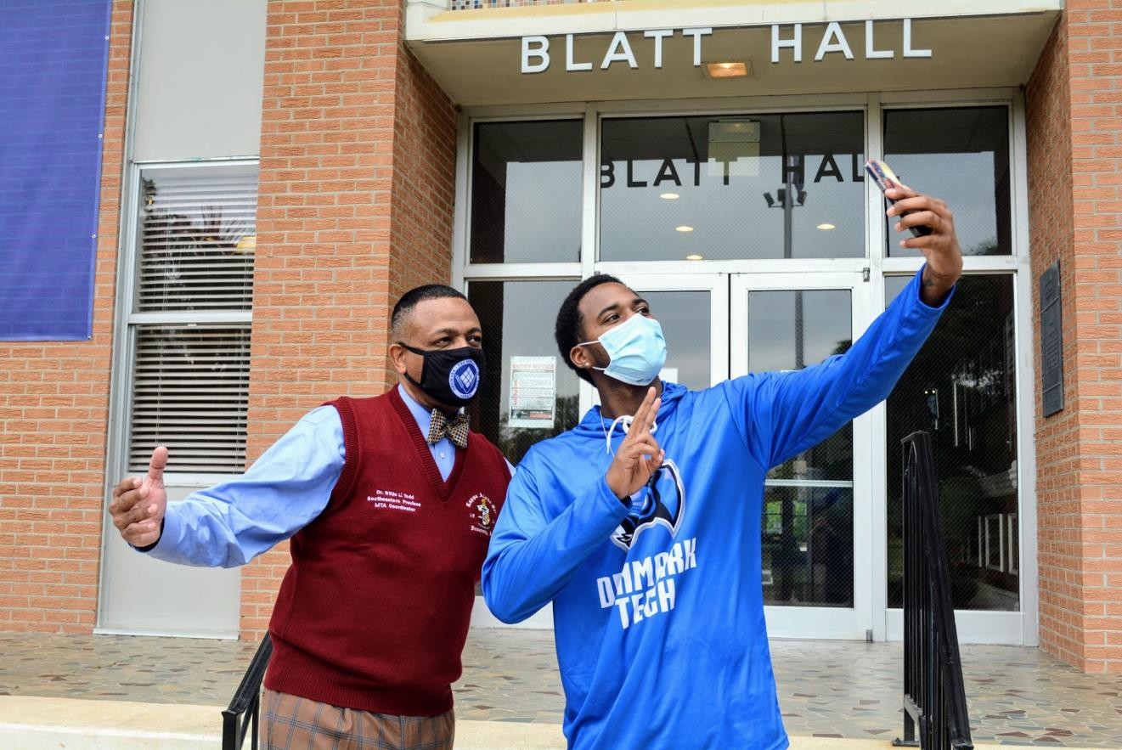

1


2021-2022 STUDENT HANDBOOK DENMARK TECHNICAL COLLEGE

Established in 1947, Denmark Technical College is accredited by the Southern Association of Colleges and Schools Commission on Colleges to award Associate Degrees, Diplomas, and Certificates.
Contact the Commission on Colleges at Southern Association of Colleges and Schools Commission on Colleges, 1866 Southern Lane, Decatur, Georgia 30033-4097, by telephone at 404-679-4500 or at http://www.sacscoc.org, for questions about the accreditation of Denmark Technical College.
Normal inquiries about the institution, such as admission requirements, financial aid, educational programs, etc., should be addressed directly to Denmark Technical College and not to the Commission's office. The Commission on Colleges should be contacted only if there is evidence that appears to support the college's significant non-compliance with a requirement or standard.

Denmark Technical College 1126 Solomon Blatt Boulevard Post Office Box 327
Denmark, South Carolina 29042-0327 (803) 793-5176

PROGRAM ACCREDITATION

Denmark Technical College’s Early Care and Education Associate Degree Program is fully accredited by the National Association for the Education of Young Children, 1313 L St., N.W., Suite 500, Washington, DC 20005. The telephone number is (202) 232-8777.

Denmark Technical College’s Electromechanical Engineering Technology Associate Degree Program is accredited by the Engineering Technology Accreditation Commission of ABET, http://www.abet.org.

Denmark Technical College’s Business Administration Associate Degree Program is fully accredited by the Accreditation Council for Business Schools and Programs, 11520 West 119th Street Overland Park, Kansas, 66213. The telephone number is (913) 339-9356.

Denmark Technical College’s Practical Nursing Diploma Program is approved by the South Carolina Board of Nursing, 110 Centerview Drive, Suite 202, Columbia, SC 29210. The telephone number is (803) 896-4550.

2
NON-DISCRIMINATION

Denmark Technical College is committed to a policy of non-discrimination in the provision
of equal opportunity and equal access in student services, programs and student employment, and in faculty and staff employment and advancement without regard to race, color, religion, sex, age, ethnic origin, political affiliation, disability, veteran status or marital status.

TITLE IX STATEMENT

The Title IX Coordinator for students is Dr. Samuel L. Hinton, Dean of Students and Title IX Coordinator, Bldg. 027, Enrollment Building. The telephone number is (803) 793-5154.

The Title IX Coordinator for faculty and staff is Dr. Sasha Johnson-Coleman, Vice President of Institutional Advancement and Effectiveness, Main Campus, Bldg. 024. The telephone number is (803) 793-5197.

The Office of Assistant Secretary for Civil Rights, (202) 453-5955). Updated August 2020

STATE BOARD FOR TECHNICAL COMPREHENSIVE EDUCATION
Dr. Tim Hardee President
Mr. Gregory B. Askins (Chair) Sixth Congressional District
Mr. Warren L. Helm, (Vice-Chair) First Congressional District
Mr. Robert E. Barnett Second Congressional District
Mr. Anthony G. Barker Third Congressional District
Mr. E. Grantland Burns Fourth Congressional District
Mr. Ralph A. Odom, Jr. Fifth Congressional District
Mr. Philip G. Homan Seventh Congressional District

AT-LARGE
Mrs. Gwendolyn A. Bright Mr. Montez C. Martin, Jr. Mr. Roger P. Schrum Mr. Orville S. Smith, III

EX-OFFICIO
Mr. Robert M. Hitt, III, Secretary of Commerce Ms. Molly M. Spearman, Superintendent of Education

DENMARK TECHNICAL COLLEGE AREA COMMISSION
Mr. Kevin Whitt, Chair Mr. Jim Kearse, Vice Chair Reverend Dr. Herman Wallace, Secretary Mr. Al Matheny
Mr. Phil Homan, Ex-Officio Mr. James Pinkney Mr. W. James Bowden

3

DENMARK TECHNICAL COLLEGE CHIEF EXECUTIVE OFFICERS

Dr. Willie L. Todd, Jr. | 2020-Present
Dr. Christopher J. Hall, Interim President | 2017-2020
Dr. Leonard A. McIntyre, President | 2014-2017
Dr. Joann R. G. Boyd-Scotland, President | 1993-2007; 2011-2014
Dr. Michael M. Townsend, Sr., President | 2010-2011
Dr. Walt Tobin, Interim President | 2009-2010
Dr. John K. Waddell, President | 2007-2009
Dr. Douglas W. Brister, Interim President | 1992-1993
Dr. Curtis Eugene Bryan, President | 1986-1992
Dr. Marianna W. Davis, Acting President | 1985-1986
Mr. John W. Henry, Jr., President | 1977-1985
Mr. William L. McDuffie, Director | 1969-1977
Mr. Roland B. Grant, Acting Principal | 1967-1969
Mr. L. H. Dawkins, Principal | 1948-1968

4
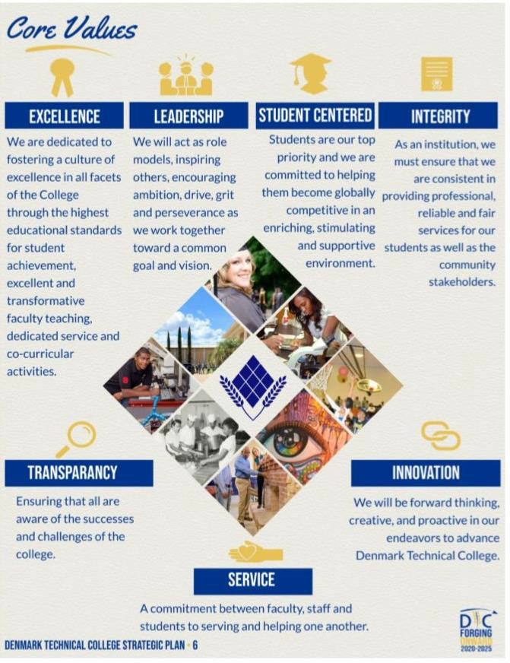

5
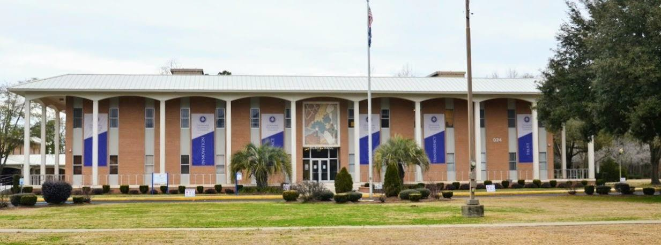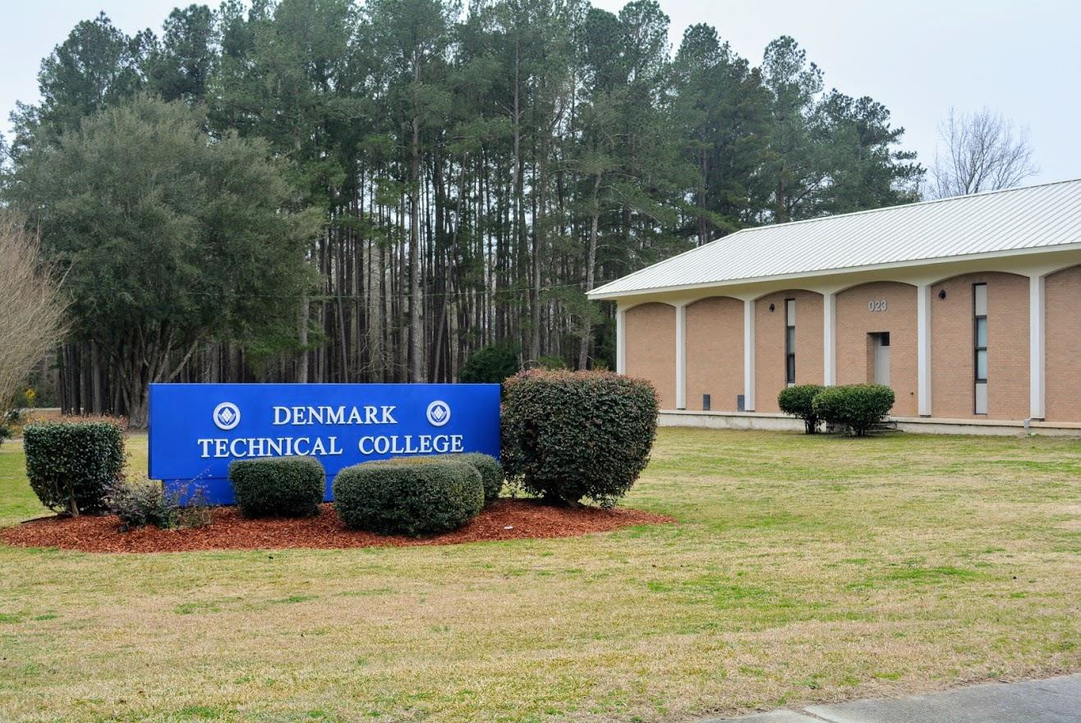

GENERAL INFORMATION

History
The General Assembly of the State of South Carolina authorized the establishment of Denmark Technical College in 1947, and the College began operation on March 1, 1948, as the Denmark Branch of the South Carolina Trade School System. At its inception, the institution functioned under the authority of the South Carolina Department of Education and was mandated to educate black citizens in various trades.

In 1969, the control of Denmark Area Trade School (Denmark Technical College) was transferred to the South Carolina Advisory Committee for Technical Training which acted under the supervision of the State Board for Technical and Comprehensive Education. During the same year, the name of the College was changed to Denmark Technical Education Center. In 1979, the institution was accredited by the Southern Association of Colleges and Schools and assumed its present designation as Denmark Technical College.

Since 1948, the College has experienced significant growth and now takes pride in the fact that it has become a comprehensive two-year college which offers a broad range of programs and services. The College is located in Denmark, South Carolina, a small city of approximately 5,000 citizens. The campus stands on 53 beautifully landscaped acres of land conveniently located about 50 miles south of Columbia, 85 miles northeast of Charleston, and 50 miles east of Augusta, Georgia.

Mission
Denmark Technical College is a public, comprehensive, Historically Black, two-year technical college located in rural Bamberg County in South Carolina. The college annually serves approximately 2,000 credit and continuing education students, a mix of traditional, nontraditional, full-time and part-time. Denmark Technical College is the only technical college in the State of South Carolina with on-campus housing.

As a member of the South Carolina Technical College System, Denmark Technical College’s mission is related to the educational mission of the State of South Carolina and the Technical College System. The College's primary service area is comprised of Bamberg, Barnwell, and Allendale counties with a legislated mandate to serve students throughout the state. As an open-door institution, the College provides affordable, post-secondary education culminating in associate degrees, diplomas, and certificates, to citizens from diverse educational and socioeconomic backgrounds and reaches out to its service area high schools with opportunities for the students. The college provides training needed by business and industry through collaborative partnerships and resource allocation.

Denmark Technical College: 1) Provides Student Learning Outcome based educational opportunities for its students with embedded continuous improvement plan that will afford the necessary skills and knowledge for the emerging job market.
2) Develops and implement processes for seamless transition of students from high school through Denmark Technical College to four-year institutions. 3) Provides the graduates with the intellectual and practical skills including but not limited to inquiry and analysis, critical and creative thinking, written and oral communications, quantitative literacy, information literacy, teamwork and problem-solving. 4) Provides the graduates with the personal and social responsibility skills including but not limited to civic knowledge and engagement—local and global, intercultural knowledge and competence, ethical reasoning and action, foundations and skills for lifelong learning. 5) Engages in efforts to form extensive partnerships/consortia leading to branding the college as a leader in training for the business and industry that will enhance the economic development and growth of the service area and the state. 6) Provides a competency-based program for the students to attain and maintain certifications for the job market.
Denmark Technical College pursues its mission within a student-centered environment based on the
fundamental values of a commitment to excellence;
fostering a positive learning process, well balanced social and cultural experiences; in an atmosphere of mutual respect, an understanding of and the ability to function in a technologically advance world; and with a realization of the need for a strong work ethic. The College seeks to fulfill its mission by offering programs in engineering technology, welding, building construction, transfer programs, allied health, early care and education, human services, criminal justice, general business, computer and related technologies. The instructional methods include traditional lectures and lab and distance education for both on-campus and off-campus instruction. The College strives to achieve its mission with a set of clearly defined academic programs, partnership initiatives, and sustainability endeavors such as:

Senior College/University Transfer Program Courses directly equivalent to the first two years of traditional college study as offered at senior colleges and major universities which may be transferred to senior colleges.

Technical Education
Curriculums designed to provide the knowledge and skills needed for employment in industry, business, and government.

General Education
Courses to provide the common knowledge, skills, and attitudes needed by each individual to be effective as a worker, a consumer, and a participant in a democratic society.

Continuing Education: Credit and noncredit classes offered with flexibility in time, place, and modality to assist the adults in the region to continue their learning experiences.

Transitional Studies
Denmark Technical College wants all students to achieve the goals they have set for themselves.
Enrolling in developmental studies courses is the first step toward a successful college experience for many students. The Transitional Studies department offers academic and support services as part of the college’s comprehensive program to
help students succeed in their chosen programs of study. Courses in the department meet a variety of student needs. New or readmitted students whose test scores on the college’s placement tests identify academic needs will enroll in developmental courses in math, reading and/or English before entering core courses that are required for their degrees. Students who are attending college for the first time should enroll in COL 103 or IDS 102 to help them succeed in college and improve personal study habits and skills.

Specialized Training Programs: Training coordinated with South Carolina industries through the Ready SC program and provided where specific job opportunities are available for new or expanding industries.

Region and Community Services
Specialized services to help meet the cultural and educational needs of the region including cultural events, workshops, meetings, lectures, conferences, seminars, and other special community projects.

Student Development Programs and Services Programs and services to enrolled and prospective students and alumni to increase their success and enhance their potential for personal, educational and professional growth. The college increases student access to higher education through recruitment, developmental education, financial services, counseling and career services, and evaluation and support services.

Sustainability Services
A Continuous Improvement Plan to include technology integration, internal control measures for financial health and green technology measures for conservation.

Region and Community Services
Specialized services to help meet the cultural and educational needs of the region including cultural events, workshops, meetings, lectures, conferences, seminars, and other special community projects.
Institutional Goals Marketable Graduates Prepare graduates with the skills and competencies to meet the demands of a technologically dynamic, competitive workplace and academically challenging senior college environments.

Academic Programs
Provide comprehensive instructional programs using flexible access to education, training, and retraining using distance learning, evening and weekend scheduling, and variable length courses in addition to traditional instruction and implement Student Learning Outcome based teaching and learning processes across all academic programs as well as developing and implementing processes for a seamless transition of students from high school through Denmark Technical College to a four year institution.

Resources
Expand and upgrade the financial and infrastructure resources necessary to achieve the College’s Mission by implementing sustainable practices to increase effectiveness, efficiency, and productivity.

Institutional Effectiveness
Ensure accountability and the effective and efficient performance of all aspects of the College through assessment and the continual professional development of the faculty, staff and administrators.

Economic Development: Contribute to the economic and community development of the service area and the state financial need as
determined through cooperative and collaborative programs with business and industry, community agencies and organizations, local schools and other colleges and universities by developing partnerships with the stakeholders to promote economic development and enhance quality of life and by implementing training programs based on the needs of businesses and industries for workforce development.

Student Development
Provide students with instructional support and cultural, recreational, and social experiences in a student-centered environment with respect for diversity and implement technologies to enhance student learning and support programs.

Marketing and Image
Provide quality customer service and develop a marketing strategy to enhance perception, through branding and continuously promoting culturally diverse experience, and globally competitive educational opportunities and promote the image of the College to facilitate the recruitment of students.

Campus Facilities
The College is situated on 53 landscaped acres with a baseball field, tennis courts, and basketball courts for recreational use. The cafeteria is open to students for breakfast, lunch, and evening meals. A canteen, with a lounge area for residential and commuting students, is housed in the William L. McDuffie Student Services Center and provides an alternate meal - snack area.

Campus Buildings
022 | Physical Plant Building | Physical Plant and Motor Vehicles, Public Safety
023 | Thomas N. Rhoad Dining Hall | Cafeteria and the Culinary Arts (Food Service) Programs
024 | Blatt Hall | President’s Office, Information Office, Academic Affairs Office, Student Affairs, Conference Room, Fiscal Affairs, Personnel, Business Office, Institutional Research & Planning, Title III and Grants, Division of Business, Computer & Related Technologies, Administrative Office Technology, Computer Technology
025 | Smith Hall | Marketing & Media Relations, Cosmetology, Barbering, QEP and Career Planning, Placement, Student Success, Open Lab, Information Technology Center, Academic  Support Center
026 | Samuel L. Faust Multicultural Center | Multipurpose room
027 | Enrollment Management | Admissions and Recruitment, Financial Aid, Registrar
028 | Science & Engineering Building | Criminal Justice, Early Childhood, Public Services, Chemistry, Biology Lab, Early Childhood Lab, Faculty Offices and Nursing
029 | Academic Center | Dual Enrollment, Continuing Education, and Dean of Students and Title IX
030 | Academic Support Center | Auditorium, Health Center and Division of Arts & Sciences
100 | William L. McDuffie Student Services | Game Room, Canteen, TV Lounge, Gymnasium, Basketball Coaches’ Offices, and Locker Rooms
113 | Essie Moore Carroll & Clarence V. Lebby, Sr.  Learning Resources and Technology Center | Learning Resources and Technology Center
200& 300 | Continuing Education  Building Technology Classroom, and South Bld. | Continuing Education, Work Keys, Masonry, ET  Classroom, Prime Ed Lab, Carpentry, Plumbing, Electricity, and Welding Programs
400 | Engineering Technology Center | Classrooms and a Laboratory for Electromechanical Engineering Technology, Electronics Technology & Robotics, Physics Lab
500 | Dawkins Hall | Residence Hall for approximately 87 female students, Director of Housing
600 | Martin Luther King, Jr. Hall | Residence Hall for approximately 96 male students

700 | Edisto Hall | Residence Hall for approximately 65 students
900 | Records Storage | Records Management Center, Archives

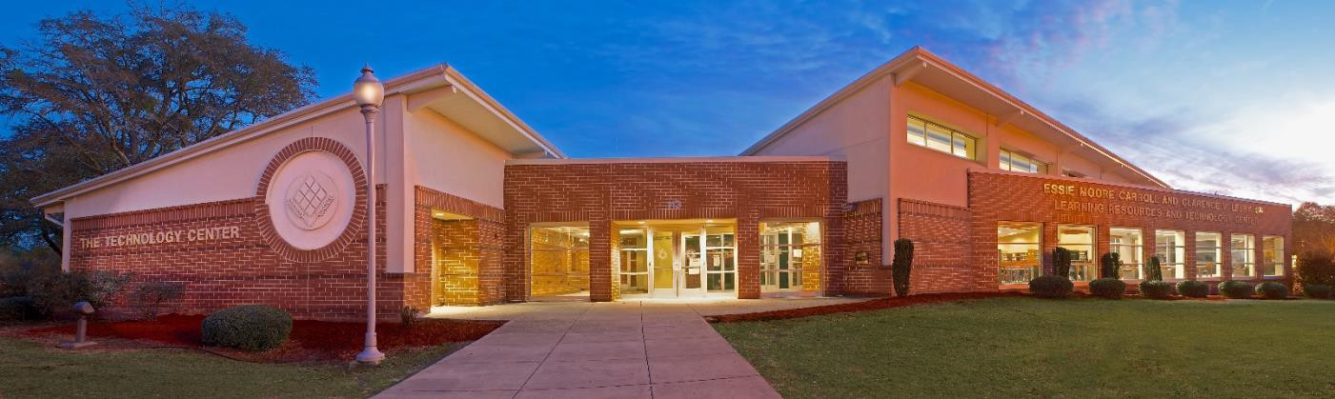

Learning Resources
The Essie Moore Carroll and Clarence V. Lebby, Sr. Learning Resources and Technology Center. The mission of the Learning Resources Center is to support the intellectual and cultural environment of the College by providing information and services to meet the needs of the students, faculty, staff and community users.

Constructed in 2004, the Learning Resources Center (LRC) is a modern one level facility, consisting of 11,945 square feet, with a seating capacity of 224. Centrally located on campus, the facility is conducive for study and is well equipped with technology to maximize access to world-wide information by students, faculty, staff and the community.

The adjoining Technology Center is a multi-purpose facility with teleconferencing capabilities. The Center also features a wireless computer network with two-way interactive video to allow remote access for professional development such as webinars and streaming video on social media, meetings, as well as any form of classroom instruction.

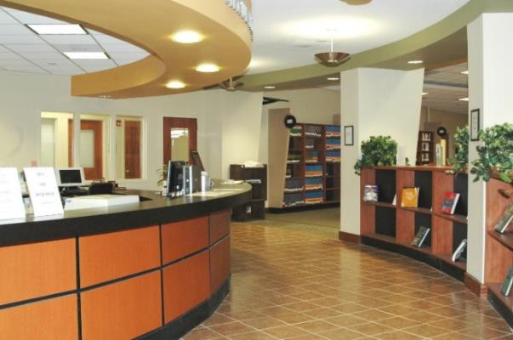

All users have access to 25 computer workstations for accessing the Internet and word processing using the Microsoft Suite. Students also have access to D2L, an online portal available to students, faculty, and staff. This portal gives users’ access to Web Advisor, email, personal storage space, online tutoring, and emergency alerts.

Additional services include use of a color copier with scanning capabilities, borrowing privileges, access to two (2) study rooms, interlibrary loan, internet access, and a technology/computer lab.
The Learning Resources Center’s webpage serves as a starting place for students and faculty to begin research and provides a wealth of information for on- campus as well as off-campus users. The webpage also provides an extension of access to library

services and resources--beyond the library building-
-via the Internet using electronic devices such as smartphones and tablets. The online library catalog houses the library’s complete book collection and is accessible from the library’s webpage.

From the library’s webpage, users can also access DISCUS – South Carolina’s Virtual Library. DISCUS is the “information place” for all South Carolinians. DISCUS provides free access to an electronic Library that is available 24/7.

PASCAL is another valuable resource that provides shared licensing of electronic resources and universal borrowing (PASCAL Delivers). As a member of PASCAL, the library has access to core electronic resources that includes Academic Search Premier (EBSCO) and an e-library collection of over 100,000 e-books that is unlimited and provides multi-user access.

PASCAL Delivers is another service allowing current students and DTC faculty/staff to search for and request books owned by college and university libraries across South Carolina. Owning libraries will send the requested books directly to the DTC Library for students and faculty/staff to check out.

Other Interlibrary Loan options include Voorhees College. Denmark Technical College’s library has a reciprocal borrowing agreement with the Voorhees College library. If you would like to check out materials from the Voorhees College library, please inform the library staff at Voorhees that you are a DTC student, faculty, or staff member. A comprehensive Information Literacy program is provided to all classes as a part of library instruction.

Technology Center is a multi-purpose facility with teleconferencing capabilities

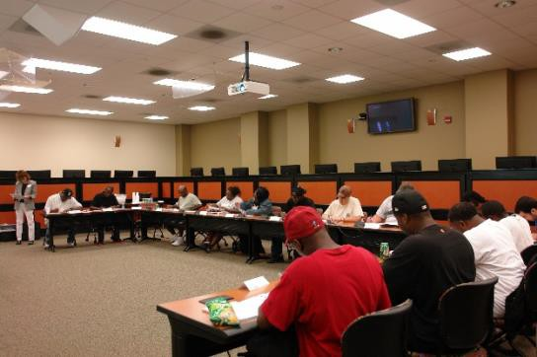

12

Office of Admission and Recruitment Office Phone: (803)793-5175
Email: admissions@denmarktech.edu

Denmark Technical College follows an “open door” policy and imposes reasonable standards for admission to the institution. However, the criteria for entry into individual programs vary. All new students, both freshmen and transfer students, must apply to be admitted to a program of study by the Admissions Office.

Admission to a specific program requires that the applicant has appropriate educational preparation, satisfactory placement test scores, and all admission requirements completed. Students having academic deficiencies will be required to enroll in the Transitional Studies Program. This is determined by the College Board’s Accuplacer, which is administered to all students. Educational programs have minimum test score requirements. These requirements, and any others necessary for entrance to a specific program of study, are stated in each program of study.

Admission Requirements
Applicants for admission to the College must be 18 years of age or older. A high school diploma or GED certificate, though desired, is not a prerequisite for college admission but may be required for specific program admission Under certain circumstances, an applicant under the age of 18 who has not graduated from high school may be considered for enrollment through special arrangements between the College and the principal of the school where the applicant has been or is enrolled. In order for a student who does not have a high school diploma to receive Title IV funds, they must meet the College’s policy and procedures for equivalency of a high school diploma.

Admission Process
Step 1: Complete and submit an application form online at www.denmarktech.edu or mail the completed form and application fee of $10.00 (payable by cashier’s check or money order) to: The Admission Office, Denmark Technical College, 1126 Solomon Blatt Blvd. P.O. Box 327, Denmark,
SC 29042. The application must be filled out carefully and completely.

Step 2: Before you can register for courses at Denmark Technical College, you must take the Placement Test. If you have already taken the Placement Test, through your high school, request a copy to be sent to the Admissions Office. Please be advised that scores three years or older will not be accepted. SAT or ACT scores may be presented in lieu of the college Placement Test. Students who do not have high school credentials must take a Department of Education approved entrance exam to be considered for Title IV funding through Ability to Benefit.

Step 3: The applicant for a specific program may be required to request an official copy of his or her high school transcript be sent to the Admissions Office. Applicants who possess a GED should submit official GED scores. As of July 1, 2012, an applicant may self-certify on the FAFSA that he has received a high school diploma or GED or another equivalency. If you have attended other colleges, please request that an official transcript from each college be sent to the Admissions Office.

Step 4: Students will receive notification of acceptance by the Admissions Office.

Admission to a Specific Academic Program Students must meet the Denmark Technical College admission requirements in order to gain program admission. See curriculum display sheets in the Academic Program section for specific Information.

Residency Requirements

Policy
In compliance with the laws of South Carolina, out-of-state fees must be paid by any student who has not been domiciled for a period of twelve months prior to enrolling at Denmark Technical College with an intention of making a permanent home here.
The word "domicile" means a "person's true, fixed, principal residence and place of habitation; it indicates the place where such a person intends to remain, and where such a person expects to return upon leaving without establishing a new
13
domicile in another state." A person may have only one legal domicile and is presumed to abandon automatically an old domicile upon establishing a new one. Housing at State Institutions shall be presumed not to be a place of principal residence, as residency in such housing is, by nature, temporary.

An "independent person" for residency purposes, shall mean a person who is at least 18 years of age, whose predominant source of income is his or her own earnings of from employment, investments, or payments from trusts, grants, scholarships, loans, or payments of alimony or separate maintenance made pursuant to court order.

A "dependent person" for residency purposes, shall mean one whose financial support is provided not through his own earnings or entitlements, but whose pre-dominant source of income or support is payments from a parent, spouse, or guardian and who qualifies as a dependent on the federal tax return of the parent, spouse or guardian. A "minor" shall mean a person who has not attained the age of 18 years.

Factors in Making a Determination of Residency
  - Persons domiciled in South Carolina for a period of at least 12 months for reasons of permanent employment with an intention of making a permanent home therein, and their dependents, may be considered eligible for in-state rates.
  - Independent persons who reside in and have been domiciled in South Carolina for fewer than twelve months but who have full-time employment in the state, and their dependents, may be considered eligible for in-state rates.
  - The residence and domicile of a dependent minor shall be presumed to be that of the parent of such dependent minor.

Changes in Residency
  - A student shall not become eligible for in-state rates until the beginning of the next academic session after expiration of
12 months from date of domicile in this state.
  - Loss of eligibility for in-state rates shall end on the last day of the academic session in which the loss occurs.
  - Marriage to a South Carolina resident does not automatically make a student eligible for in-state rates. If at least 18 years of age, a married person may establish residency exclusive of the spouse's status.
  - Becoming a full-time employee of a company or Industry based in the state may make a student eligible for in-state rates even though the residency requirement of 12 months has not been met.
  - Military personnel and their dependents may be considered eligible for in-state rates during the period of their assignment to duty in South Carolina.
  - Full-time faculty and administrative employees of South Carolina state college and their dependents are always eligible for in-state rates regardless of their place of residence.
  - Foreign students are presumed not to be in-state residents. They may qualify for in-state rates depending on the types of visas they possess or if they are the dependents of persons who have previously established residency.

- Penalties for Willful Misrepresentation Persons who gain domiciliary status improperly by making or presenting willful misrepresentations of facts shall be charged fees past due and unpaid at the out-of-state rate, plus interest at a rate of eight percent per annum, plus a penalty amounting to twenty-five percent of the out-of-state rate for one semester. Until these charges have been paid, no such student shall be allowed to receive transcripts or graduate from any state institution.

- Proof of Eligibility for In-State Tuition Positive steps which reflect an intent to make South Carolina a permanent residence are vital in determining eligibility. All documentation requested by the Dean of Student Services must
be furnished prior to making a determination for in-state rates or the student will automatically be required to pay out-of-state rates. Acceptable legal documents include the following:
- A driver's license
- A vehicle registration certificate
- A voter registration certificate
- Copies of recent state income tax returns
- Letters from employers indicating full-time status as an employee, date of employment, employment status as of present date, and home address on company rolls
- Receipts for housing

Enrollment of Senior Citizens
Persons 60 years old or over who are legal residents of South Carolina may enroll in courses free of charge on a space- available basis provided that neither they nor their spouse receive compensation from any type of employment. Such persons must follow standard admissions procedures, meet all course prerequisites as stated in the catalog, and complete a Senior Citizen Exemption Waiver Verification Form.
Registration will take place during regular registration periods but will not be finalized until the last day of late registration to assure available space. In the event space is limited, senior citizens may pay the full tuition to reserve a place in the class.

International Students
All international students who desire a student visa or who are transferring from another college on a student visa must complete the following requirements in addition to the admissions procedures for new students.
- Complete an Application for Admission Form at least three months prior to admission. Submit the $10 non-refundable application fee.
- Furnish official English translations of secondary and post-secondary records and transcripts showing passing scores on native secondary school exams and completion of secondary school education.
- Submit TOEFL (Test of English as a Foreign Language) scores. An acceptable total score on the TOEFL is 500 or more. An official report from an English language institute or program with the United States will be accepted in lieu of test scores
- Meet individual college program requirements on the College Placement Test.
- Persons transferring from another college in the United States must initiate Form I-538 to be completed by the last college attended and must submit an official transcript and a letter of recommendation from the foreign student’s advisor at that college.
- Submit a certified financial statement from a recognized financial institution (i.e., governmental agency or bank), indicating the applicant will have sufficient funds to meet academic and living expenses and funds to return home.
- Provide proof of health insurance coverage for one year from the date he/she will commence enrollment.
- Pay an advance deposit of tuition for one academic year.
When all requirements are met, the College will provide a completed Immigration Form I-20 and an acceptance letter.

Transfer Students
Denmark Technical College will accept and give credit for work completed at other accredited colleges and universities. Applicants seeking such credits should complete the regular application form and request an official transcript of work from all colleges previously attended. If fewer than 15 hours have been earned on the collegiate level, a completed high school transcript may be requested for specific programs.
The rules regulating the transfer of credit will be at the discretion of the Vice President of Academic Affairs and the appropriate Divisional Dean using the following guidelines:
  - Courses being transferred must closely parallel courses being offered by Denmark Technical College.
  - In order to transfer credit, a grade of “C” or better must have been made in the course.
  - Transfer credit will not be included in the computation of the student’s grade-point ratio.
  - Courses taken more than 6 years at DTC will be validated for transferring by the
discretion of the Division Dean, Registrar Services, and the Vice President for Academic Affairs.

Advanced Standing Transfer Credit
Applicant may apply for advanced standing by being awarded transfer credit when they have earned academic credit from another accredited post- secondary educational institution.

PLEASE NOTE: The submission of fraudulent records or information constitutes grounds for denial of admission or dismissal from the College.

Transfer Procedures
New students applying to the College in a transfer status must provide official transcripts for each accredited post-secondary institution from which they are seeking transfer credit.
- Only course work in which a minimum grade of “C” or its equivalent has been earned will be considered for credit.
- Course work earned must be college level to be creditable.
- Course work is evaluated individually on the basis of its course content and credit hours received for the course.
- For transfer credit to be awarded, a comparable Denmark Technical College course must exist within the student’s curriculum with the course content and credit hours being equivalent as described in the Catalog of Approved Courses.
- Transfer credit will be awarded to degree, diploma, and technical certificate seeking students.
- When advanced standing has been awarded for transfer credit, a grade of “TR” will be posted on the student’s approved curriculum profile and recorded on the student’s academic transcript.
- A copy of the curriculum profile with transfer credit noted will be provided to the student and the student’s academic advisor.

Applying for Re-Admission
Former Denmark Technical College students who were not enrolled for the preceding academic term (excluding summer term) and who wish to re-enroll, must first complete a readmission application. Forms are available in the Admissions Office. Students who have attended another college during the interim should request the college to send an official transcript of all academic work. Applicants for re-
admission are subject to established assessment and placement guidelines to ensure appropriate course placement and to promote student success. A student completing one program may apply for admission to another program by following the general admission procedures. Credits for parallel courses will be granted accordingly.
The College reserves the right to refuse admission to any student who has an unacceptable academic, conduct, or health record. Persons who have any financial obligation to the College must resolve these obligations before they will be allowed to register for classes.

Transient Students
Students enrolled at other colleges who wish to take courses at Denmark Technical College, may do so by following the admissions procedures. Written documentation of course approval from the primary college should be on file to assure transfer of the course work. It is the student’s responsibility to determine the applicability of the transfer of courses through contact with the primary college.

Dual Enrollment Students
Upon the written approval of their principal, qualified high school juniors and seniors may be granted early admission to the College on a space available basis.
Requirements for dual enrollment admission are the same as for the admission of new students. Upon graduation, the student may apply for admission as a regular student in a degree, diploma or certificate- granting curriculum.
In order for a high school student to be granted dual enrollment admission, he or she must:
- Be a high school junior or senior.
- Submit written permission from the high school principal. This permission must indicate that the student is in good standing with the high school.
- Have demonstrated sufficient academic preparation for college work.

If upon graduation from high school, if the student enrolls at Denmark Technical College, all credits earned will be applicable toward the appropriate degree, diploma or certificate. If enrolling at another post-secondary institution, students may have their
credits transferred, pending acceptance by the other institution.

DIVISION OF STUDENT AFFAIRS
Office of Vice President of Student Affairs Office Phone: (803) 793-5242
Email: whitel@denmarktech.edu

Applying for On-Campus Housing:
- Student must be fully accepted to Denmark Technical College
*The Admissions Office will send a full acceptance letter once all admission required documents and placement testing information have been received. You may contact the Enrollment Management Office at 803.793.5294 or email admissions@denmarktech.edu to check your admission status.

Complete a Housing Application
*All sections of the Housing Application must be completed and returned to the Office of Residential Life. You may contact the Office of Residential Life at 803.793.5134.

Complete and submit the Housing Agreement Form and mandatory deposit
*A $75.00 housing deposit and $50.00 breakage fee is required to reserve a room on campus. The housing fee is a non- refundable fee, and the breakage fee is refundable if the room is in satisfactory condition at the end of the term. Please be advised that the housing deposit simply reserves a space, however, all required documents must be completed and submitted before a room assignment will be issued.

Complete a Health & Physical Form (with proof of required immunizations)
*All students residing in on-campus housing must complete a Health and Physical Form with updated required immunization records. This form must be signed by a physician.

Required Immunizations:
  - Proof of Measles, Mumps, & Rubella (MMR)
Administration
All students born after 1957 must provide a statement of immunization against Measles, Mumps and Rubella (MMR), giving the month and year of immunization. A statement of an up to date is not sufficient. If a student is unable to provide dates of immunization to Measles, Mumps and Rubella, he or she may document immunity by blood test at the student’s expense. If this testing shows no immunity to Measles, Mumps, or Rubella, the student may register following documentation of the first dose of MMR, with the second to follow in 30 days, if required.
  - Proof of Tuberculin Skin Test (PPD)
Administration
Tuberculosis screening (within the past year, 12 months) is required of all new students. Students at risk for TB will be required to have a PPD skin test (Mantoux). Any student with a positive skin test will be required to provide a report of a normal (negative) chest x- ray (done after the positive PPD). The negative report must be documented within six (6) months prior to residing on campus. A physician should evaluate individuals with a positive tuberculosis skin test.
  - Proof of Tetanus Toxoid Booster Administration within the last ten (10) years.

Strongly Recommended Immunizations:
- Meningitis, Hepatitis B, and Varicella (Chicken Pox) Immunization College students may be at increased risk for meningitis, hepatitis B, and varicella. Students residing on campus are encouraged to provide proof of the immunization.

Exemptions from compliance with the immunization policy include:

19


  - Religious exemption, written on letterhead stationery, signed by a religious official and notarized.
  - Medical exemption, written on office stationery, and signed by a health care provider. The letter should state the reason for the exemption, and whether the exemption is permanent or temporary.
Do not assume that childhood immunizations are adequate; requirements have changed during the past several years. Medical facilities in the U.S. and in other countries are required to keep records of vaccinations. Additional sources of immunization information include doctors’ offices, health departments, and schools. Students should make copies of the completed health form for their own files, and then mail the original forms. Do not rely on health care providers, family members, or other colleges to mail the forms.
Some academic programs have additional immunization requirements. Students are advised to check with their desired program of study for any additional requirements.
Contact the Office of Health Services at 803.793.5224 for questions or concerns.

Payment of Room and Board Fees
*All room and board fees must be paid prior to a room assignment being issued. If you are applying for financial aid that will cover the cost of your room and board fees, you must have received an award letter with enough financial aid to cover all required fees. To check your Financial Aid status, call 803.793.5161 or email finaid@denmarktech.edu.

Re-Admitted Students
*All re-admitted students who have not been in attendance within three (3) years immediately prior to the date of application are required to complete and submit a new Health & Physical Form.

Student Health Services
The Health Services Center provides first-aid treatments for injuries, accidents, and illness and makes referrals to local medical resources as deemed necessary. Family Planning Services are made available through Health Services. Routine orders for the treatment of minor illnesses and injuries are made available by the College’s doctor. Students are to report all illnesses and/or accidents as soon as they occur.

A medical record is kept on all residential students; therefore, all residential students are asked to obtain a medical examination before a housing assignment is given. Students are asked to report any chronic illnesses to Health Services upon arrival to campus and to report all prescription medication. Students are asked to provide additional medical insurance information during the registration process.

Mental Health Policy
Anyone who is troubled emotionally may seek services through the Area Mental Health Center. Consultation, education and prevention are the primary focus of community services available. Denmark Technical College’s Health Services and
/or Counseling Service Department will contact the mental health center, arrange for an interview appointment for the student, and provide transportation if needed. Arrangements can be made for the student to seek services at home if he or she so desires. Emergency services are available on a
24-hour basis. Personal contact to assess a crisis situation is provided during regular working hours (8:30 a.m. - 5:30 p.m.). After 5:30 p.m. on weekdays, weekends, and holidays, crisis intervention will occur in the following manner:

- A telephone call to 803-536-0390 will give a response from the physicians’ answering service requesting name and telephone number. The contact will be informed that a mental health professional will return your call within 15 minutes.
- The on-call mental health professional will respond and help you with your problem.
- If the College is seeking services for someone with violent behavior patterns, the College will contact the Sheriff’s Office and the local probate court office and have the individual detained by “An Order of Detention” which mandates that the student be examined by a physician and a mental- health professional. IMPORTANT NOTE: Psychiatric and Psychological Services

Psychiatric and Psychological Services
Any student who has suicidal tendencies will be referred immediately to his or her family physical for psychiatric evaluation and will be medically withdrawn from college. If the student is a residential student, he or she must vacate the residential premises immediately. Only upon proof that the student has participated in and completed professional counseling and treatment will the student be readmitted to residential living. Any other expenses incurred will be the responsibility of the student and/or/guardian.

Counseling and Mentoring
Denmark Technical College offers counseling options with experienced professional counselors providing personal, academic and group counseling along with an organized tutorial program. Denmark Technical College provides the following services:

Individual Counseling—Counseling on a one-to- one basis is the most important service offered to students. The staff provides services in an atmosphere in which students may discuss problems with the assurance that all counseling information is confidential.
Group Counseling—The Counseling Center provides a variety of growth experiences through counseling, ranging from personal growth to decision-making skills.

Academic Counseling—Academic counseling is available to all students to assist them in developing strategies to improve academic performance.
Academic counseling is also available for students experiencing difficulty in achieving satisfactory progress in an academic area.

Peer Counselors—The Peer Counselor Program is a student peer helper program which utilizes talented students as peer advisors or counselors to other students.

Testing—The Counseling Center administers the placement tests for all new students for admission requirements.

Student Leadership & Engagement
Office of Student Leadership & Engagement Phone: 803.793.5112
Email:

Student Leadership & Engagement are considered a vital part of a student’s educational process.
Students are encouraged to participate in programs which emphasize leadership and training, service to the college and community, and the opportunity to interact with those from different cultural backgrounds. Inter-collegiate sports include Men and Women’s basketball. The College sponsors other co-curricular activities during the year and encourages students to participate.

Students who maintain a “C” average or above shall be excused with the instructor’s permission to attend approved student activities in which they participate.

The student is responsible for all work missed during the absence. In order to participate in student activities, the student must be accepted by the institution as a full-time student. A full-time student is enrolled in at least 12 credit hours. If at any time during the semester, the student carries less than 12 semester credit hours, he or she will immediately be ineligible for participation. A student must maintain
at least a 2.0 GPA after the first semester of entrance in order to participate in activities. After the first semester, the chart will be used to determine eligibility:

Minimum Grade Requirements
TOTAL SEMESTER

Hours Carried | Minimum GPA
0-35 | 1.50
36-50 | 1.80
51-above | 2.00

Probationary status will be determined by the cumulative semester GPA. The cumulative semester GPA must be equal to or exceed the levels indicated in the table above. A student placed on academic probation will be ineligible to participate in the activity. A student placed on non-academic probation will also be ineligible to participate.

Student Government Association
The Student Government Association (SGA) is one of the principal organizations through which students share in the administration of the College. The SGA assists college personnel in coordination of student organizations and activities, and helps plan and direct recreational and cultural activities, and supports the observance of college policies and regulations.

The sponsored activities of the Student Government Association are those described below.
- All suggestions for student activities shall be forwarded to the SGA.
- A Student activities committee composed of SGA members shall be appointed, and these committee members should become thoroughly familiar with the matters involving student activities.
- After the committee has analyzed a request for a new activity and found the request to be favorable, it shall be brought to the full SGA membership for a vote.
- If the SGA approves the recommendation, it is then forwarded to the Executive Dean of Student Services for administrative approval.
- The Dean of Student Affairs will present the request to the President.
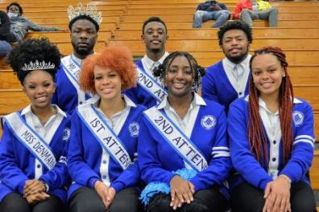

Student Social Functions
Social functions for students are the responsibility of the SGA. As the SGA develops a budget for the following year, social functions requested by the majority of the students are placed in the budget.
At the present time, student social functions consist of the following, which are all planned and administered by the SGA:

- Athletic Events
- Awards Night
- Homecoming
- Miss DTC Coronation
- Spring Ball

Clubs and Organizations
Many clubs and organizations are active on the campus. Through participation in the program of particular interest, students may explore and extend interest and develop skills and abilities in working with fellow students. Membership is open to all students who meet the qualifications of respective clubs. Those desiring information may contact the club advisor or the Student Activities Office. Clubs and organizations include the following:

Administrative Office Club - for all Administrative Office Technology and Administrative Support students. This club helps students to understand their roles in a modern business environment.

Barbering Club - for all barbering students. Promotes service to the community through various experiences (projects) and helps students to understand their roles as future entrepreneurs.

Building Construction Fundamentals Club – for all building construction students. Provides an important network for students looking for career- path jobs in the building industry.

Cheerleaders Club - is a voluntary club consisting
of those students desiring to enhance school spirit. The club members attend games and other functions to provide school spirit. A faculty or staff member acts as advisor and monitors the club’s operation.
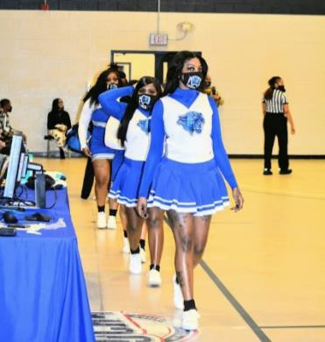

Computer Technology Club - for all computer technology students. Promotes academic excellence and provides a student support network.

Cosmetology Club - for all cosmetology students. Promotes service to the community through various projects/experiences and helps the students to understand their roles as competitive cosmetologists.

Criminal Justice Club – for all criminal justice students. Promotes service to the community through numerous projects which give students experience in working with the public.

Culinary Arts Club - for all food services students. This club provides an important network for students looking for career-path jobs in hotel and restaurant tourism.

Dawkins Hall Club – this organization provides female students with an opportunity to share in promoting a harmonious and wholesome environment in the residence halls and in developing good citizenship.

Early Childhood/ECE Club - the purpose of the ECD club is to promote early literacy in the community; to promote academic excellence in early childhood education for all young children; to develop network in the community through various projects, events and activities; to promote diversity, equity and inclusion.

Freshman Class - for all entering freshmen. This club provides opportunity for members to promote freshman concerns and activities.

General Business Club – for all general business students. This club helps students to understand entrepreneurial decision- making through various student events/activities.

Human Services Club – for all human services students. Promotes service to the community through numerous projects which give students experience in working with the public.

M.I.R.R.O.R. – designed to help male students matriculate through college and develop skills to be change agents in our community and the world.

Off-Campus Club - for all commuting students. Promotes opportunities for students to develop teamwork through numerous projects on-campus and in the community.

Phi Theta Kappa Honor Society – Phi Theta Kappa, over 500 chapters strong, was founded in 1918 for recognizing and encouraging scholarship in accredited community and junior colleges. This scholastic fraternity provides service and opportunities for the development of leadership for its members, while stimulating interest in continuing academic excellence. To qualify for membership, a student must be enrolled in a two-year college degree program and have a grade point average of 3.5 or better in at least 12 credit hours.
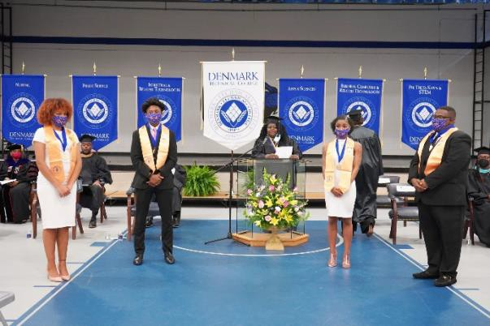

Student Christian Association – open to all interested students, faculty, and staff. Provides a ministry to individuals in the campus community and encourages Christian growth and outreach.

Welding Club – for all welding students. Provides an important network for students looking for career-path jobs in the welding field.

Student Clubs & Organizations Requirements
- Each group, in order to be recognized, must make application through the Office of Student Activities and have the approval of the Dean of Student Services and Academic Support and officers of the SGA.
- Each organization must have a constitution which states its purpose, rules for operation, and a slate of officers. A copy of the constitution must be on file in the Office of Student Activities.
- Each organization must have a faculty or staff advisor.
- Each organization must adhere to all institutional policies and standards.
- A roster of the officers, members, and advisor of each organization must be on file with the Dean of Students and Academic Support and the Office of Student Activities.
- Each organization must submit a schedule of activities it expects to sponsor during a school year to the Office of Student Activities.
- Classrooms may be secured for approved organizations. Requests for reservations are made in writing by the president and advisor and submitted to the Office of Student Activities.
- It is expected that rooms used for meetings are to be left clean and orderly.
- All social activities must be approved by the Dean of Student Services and Academic Support and cleared at least one week in advance of the event. Forms for filing are available in the Office of Student Activities.
- Social events held preceding a school day must end, at 12:00 midnight, except on Friday and Saturday at which time they end

at 1:00 a.m. Advisors are to be present during all organizational activities.
- Advisors are to be present during all organizational activities.

Advisors to Organizations
Only Denmark Technical College faculty and staff members, or someone approved by the administration, may serve as advisor to student
groups. Advisors to student organizations have the following responsibilities:
- To attend all meetings of the organization.
- To give counsel and advice pertaining to programs and projects.
- To review the group’s operations for consistency with the college’s regulations and policies.
- To assist with the proper management of group funds. All funds must be necessary for withdrawal. The advisor must sign all checks and requests for withdrawals of funds.

Cultural Enrichment Program
The College plans for and offers experiences that are designed to produce a socialized and well- rounded individual and ensure that campus-living has achieved its optimum purpose.
The following cultural activities are sponsored through this program:

Cultural trips to: Museums
Seminars Concerts Conferences Plays Lyceums Historic tours
Special community interest events

Transportation
Denmark Technical College provides bus transportation to and from the campus for students in Allendale, Bamberg, and Barnwell Counties. The Student Services Division at Denmark Technical College can furnish information about schedules and cost for transportation. Bus Transportation is also available for resident students to attend area churches and for off-campus shopping trips and activities.

Policies, Rules and Regulations

Conduct
The responsibility for maintaining discipline at the College is vested in the Office of Student Services, which investigates any instances of misconduct.
They may refer cases to either of the judicial boards for the appropriate disciplinary action. Dorm Supervisor has the authority to ensure that the rules and regulations of the College are adhered to by all of the College’s students in the residential centers and on the campus. Registration at the College involves the student’s acceptance of all rules not only those that are published.

Smoke-Free Campus

For Denmark Technical College to fulfill its role and responsibility to provide a safe and healthy environment for faculty, staff, and students, it is essential to eliminate exposure to the toxic substances produced by tobacco smoke. Smoking is prohibited at the College. Please see additional information in Public Safety.

Dormitory Loitering Policy
No females should be loitering at the side entrances of the male residence hall, nor should males be loitering at the windows, back, and/or side entrances of female dormitories; and no females or males should use or be loitering in the path behind King Hall.

Visitors of the opposite sex are only allowed to visit in the lobby areas of the resident halls. Front entrances of residence halls for visitation should be always used. Females may page young men; however, DUE TO LIMITED SPACE IN THE MALE RESIDENCE HALL, IT IS RECOMMENDED THAT MALE/FEMALE VISITATION TAKE PLACE IN THE CANTEEN AREA AND NOT IN THE MALE DORMITORY LOBBY.
Disciplinary action will be taken against students who violate the dormitory loitering policy.
For Denmark Technical College to fulfill its role and responsibility to provide a safe and healthy environment for faculty, staff, and students, it is essential to eliminate exposure to the toxic substances produced by tobacco smoke. Smoking is prohibited at the College. Please see additional information in Public Safety.
Public Safety Regulations OFFICE OF PUBLIC SAFETY
Chief Rodney Bond, Chief of Public Safety
Phone: 803.793.5114 / 803.928.7301
Email: bondr@denmarktech.edu

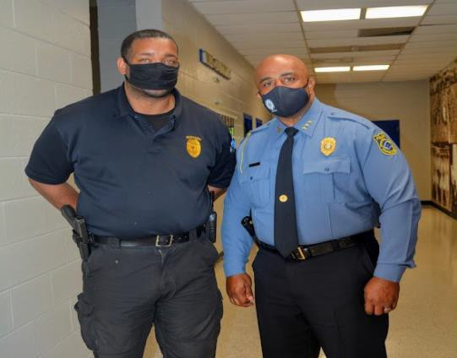

Department of Public Safety (located in Building 022) enforces federal, state, county, and municipal laws, rules and regulations to ensure the protection and security of persons and property in the Denmark Technical College (DTC) campus.

The College’s Public Safety Officers are Certified Class I Law Enforcement officers; and commissioned by the Governor as state constables with full police powers and state-wide jurisdiction. All South Carolina State Statutes are enforced in accordance with the law on the campus of Denmark Technical College. Students are requested to adhere to the laws, rules, and regulations provided to promote public safety and security in the Denmark Tech Community.

S. C. Code of Law (16-11-510), Malicious Injury to Property makes it a misdemeanor for anyone to willfully damage, destroy, or change
in any manner the property of another, in this case, your fellow students, faculty/staff or property of Denmark Technical College. (Malicious injury to real property – damage less than $2,000 (misdemeanor), more than $2,000 (Felony).

S.C Code of Law (16-11-770) Illegal Graffiti Vandalism
Any inscription, writing, drawing, marking or design that is painted, sprayed, etched, scratched, or otherwise placed on structures, buildings, dwellings, statues, monuments, fences, vehicles or other similar materials that are on public or private property and that are publicly viewable without the consent of the owner, manager, or agent in charge of the property.

Misdemeanor -
1st offense - fined not less than $1,000.00 or imprisoned not less than 30 days nor more than 90 days.
2nd offense - within 10 years, fined not more $2500.00 than 1 year.
3rd offense - within 10 years if 1st offense, fined not more than $3,000.00 or imprisoned not more than 3 years in addition to removal of the illegal graffiti, pay the cost of the removal, or make further restitution in the discretion of the court.
Law Enforcement Officers will conduct periodic surveillance. Violators will be prosecuted in accordance with the law.

Speeding or Failing to Stop for Stop Sign
The speed limit on campus is 15 mph. Violators will be issued a uniform traffic ticket and a summons to magistrate court. Violators will be fined not less than $155 or 30 days in jail and/or two or more points will be assessed on their driver’s license.
S.C. Code of Law (16-17-53) Public Disorderly Conduct - A person who is: (1) found on any highway or at any public place or public gathering in a grossly intoxicated condition or otherwise conducts himself in a disorderly or boisterous manner; (2) uses obscene or profane language on any highway or at any public place or gathering or in hearing distance of any schoolhouse or church; or (3) while under the influence or feigning to be under the influence of intoxicating liquor, without just cause or excuse, discharges any gun, pistol, or other firearm while upon or within fifty yards of any public road or highway, except upon his own premises, is guilty of a misdemeanor and, upon conviction, must be fined not more than one hundred dollars or be imprisoned for not more than thirty days. Disorderly conduct laws apply on the campus of Denmark Technical College.

Alcohol and Drug Use on Campus
It is against DTC’s Policy to have in your possession or use any alcoholic beverages or illicit drugs. Student found in violation of this policy are subject to DTC sanctions and/or criminal prosecution.

Loitering on Campus
Loitering on campus at night after visiting hours is strictly prohibited. Students are requested to either be in dormitories or leave the campus. Students may be stopped DTC Public Safety personnel and asked to present a student ID card to determine status.

Students are required to produce identification upon request by any law enforcement officer or security officer on the campus of Denmark Technical College.
Students are requested to adhere to the laws, rules, and regulations provided to promote safety and security at the college.

Weapons on Campus
S.C. Code of Law (16-23-420). Possession of firearm on school property.

- It is unlawful for a person to possess a firearm

of any kind on any premises or property owned, operated, or controlled by a private or public school, college, university, technical college, other post- secondary institution, or in any publicly owned building, without the express permission of the authorities in charge of the premises or property.
The provisions of this subsection related to any premises or property owned, operated, or controlled by a private or public school, college, university, technical college, or other post-secondary institution, do not apply to a person who is authorized to carry a concealed weapon pursuant to Article 4, Chapter 31, Title 23 when the weapon remains inside an attended or locked motor vehicle and is secured in a closed glove compartment, closed console, closed trunk, or in a closed container secured by an integral fastener and transported in the luggage compartment of the vehicle.

- It is unlawful for a person to enter the premises or property described in subsection (A) and to display, brandish, or threaten others with a firearm.

- A person who violates the provisions of this section is guilty of a felony and, upon conviction, must be fined not more than five thousand dollars or imprisoned not more than five years, or both. Possession of any kind of weapon, i.e., handguns, fireworks or explosives is prohibited on any property owned or operated by Denmark Technical College.

NOTE: Penalty for possession of firearms or other dangerous weapons on or off Denmark Technical College Property: ANY STUDENT WHO IS FOUND TO BE IN THE POSSESSION OF A FIREARM OR OTHER DANGEROUS WEAPONS WHILE ON OR OFF DENMARK TECHNICAL COLLEGE PROPERTY WILL BE EXPELLED FROM THE COLLEGE AND REMOVED FROM THE CAMPUS IMMEDIATELY.

PLEASE NOTE: Denmark Technical College expressly prohibits the possession of alcohol and drugs; firearms or other dangerous weapons; and fighting (on campus and/or off campus). The
penalty for violation of this regulation is suspension and/or expulsion from the college.

Parking and Traffic Regulations General
  - All South Carolina State laws, and Bamberg
County laws apply on the Denmark Technical College campus unless specifically superseded by Denmark Technical College’s regulations.
  - The Bamberg County Court has jurisdiction over all traffic and parking offenses.
  - Drivers must obey the instructions of designated traffic controllers.
  - All posted traffic signs and signals must be obeyed.
  - Uniform state and Denmark Technical College citations will be issued to violators.
  - Traffic, parking and registration violation fines must be paid to the Business Office. Failure to pay at the Business Office will result in a summons to magistrate’s court and additional fines imposed.
  - Denmark Technical College assumes no responsibility for any vehicle or its contents.
  - Vehicle traffic on campus between the hours of 1:00 a.m. and 7:00 a.m. is restricted.
  - Vehicle accidents on campus must be reported to the Office of Public Safety immediately.
  - Pedestrians always have the right of way.

Vehicle Registration/Liability Insurance
  - Temporary parking permits are issued for any reasonable need by the Denmark Technical College Department of Public Safety.
  - All vehicles of faculty/staff and students regularly or occasionally driven on campus must be registered with the Denmark Technical College Department of Public Safety.
  - Identification decals or visitor’s passes must be displayed as directed on all vehicles while on the campus of Denmark Technical College.
  - Vehicle registrants are responsible for all non-moving and parking violations.

  - Proof of liability insurance and driver’s license must be shown to any Public Safety or Security Officer upon request.
  - All vehicles must stop at the security booth before entering the campus.

Traffic Controls
  - Parking, standing, loading and unloading are prohibited on yellow curbs and where posted.
  - Parking on grass in front of shop buildings or doorways is prohibited at any time.
  - Fast take-offs, loud mufflers, or loud radios are not allowed on campus.
  - Vehicles are not allowed to park or be parked or sitting in a lane of traffic except to avoid an accident.

Towing and Impoundment
  - Vehicles may be towed and impounded at owner’s risk and expense if:
  - The vehicle is blocking a fire lane.
  - The vehicle is blocking another vehicle’s traffic lane, driveway, or service entrance.
  - The vehicle is parked in a restricted area. (This includes Faculty and Staff parking areas).
  - Three or more outstanding traffic and/or parking citations have been issued against the vehicle.
  - The vehicle is creating a safety hazard as determined by a DTC Public Safety Officer.
  - Vehicles are repaired in parking lots or traffic lanes at any time for any reason.
  - Vehicle(s) left on campus during college breaks.

Parking Decals
  - Parking decals can be obtained from The Office of Public Safety located in building 022.
  - All decals must be displayed on the bottom left side of the front windshield.
  - Vehicle decals should be removed upon expiration or when a student’s or employee’s status changes.

Fees for Decals
Faculty/Staff Reserve
-$160.00
Faculty/Staff Non-Reserve
-$80.00
Student
-$25.00 per semester

Campus Parking Fines
Handicapped Parking
- $150.00
Not Registered or Failure to Display Sticker
- $30.00
Faculty/Staff/Visitor Parking Space
- $30.00
No Parking Zone/Loading Zone/Grassy Area
- $30.00
Blocking Vehicles/Roadway/Walkway
- $30.00
Parking in Fire Lane
- $30.00
Occupying Two Spaces
- $30.00
Other - Noise Violation, Curfew Violation, etc.
-$50.00-$25.00
-Fines double if not paid or appealed within 10 days.
-Written appeals must be filed within 5 days from date listed on the ticket.
- Payment may be made in person at the Cashiers Office and no personal checks are accepted.
*All students must have a decal sticker to park on campus. All handicap parking sticker holders must have a decal to park on campus.

Regulations

Animal Regulations
No animals are allowed on the campus of Denmark Technical College.
All animals will be brought to the attention of Animal Control and subsequently picked up

for loitering on the campus of Denmark Technical College.

Cafeteria Regulations
The Thomas N. Rhoad Hall is the main cafeteria on campus. All student, faculty and staff meals are prepared and served in this building during academic sessions. Students are required to adhere to the following policies while using the cafeteria:
- Male students are required to remove hats, caps or any head wear.
- Large containers, jars, jugs, etc. are not allowed in the cafeteria.
- Boom boxes (large stereos) are not allowed in the cafeteria.
- It is unlawful to remove dishes, glasses, and silverware from the cafeteria.
- Loud noise and the use of profanity is prohibited in the cafeteria.
- Cutting the serving line is prohibited. Those persons found in violation of cutting the line will not be served.
- Students must present a valid student
I.D. card with the proper sticker affixed in order to be served during all meals.
- Students are not allowed behind the serving line or in the kitchen.
- Students are required to remove trays from the table after each meal.
- Smoking and vaping is prohibited.

Student Center Regulations
The Student Center is provided for the use of current students enrolled at Denmark Technical College, faculty, staff, and their guests. A valid Denmark Technical College I.D. card should always be kept in your possession to verify your status.
Please adhere to the following rules while visiting the Student Center:

- Shirts and shoes are always required.
- Profanity is not allowed.
- No alcoholic beverages, weapons, or drugs are allowed.
- Sitting on pool tables or any other tables is prohibited.
- Chairs are not to be moved from their position or from one room to another.
- Keep the center clean by throwing trash and other garbage in the trash containers provided, especially after eating and drinking in the canteen food area.
- Please do not beat on the pool tables or video games.
- Radios may be played on low volume in the game area only.
- Failure to comply with these rules will result in the suspension of your privilege to use of this facility.

Gym Regulations
Please adhere to the following rules and regulations while visiting the gym:
- Proper gym attire must always be worn (tennis shoes, warm-ups, or shorts, shirt, etc.).
- Good conduct must be maintained. (No Profanity Allowed).
- You must have approval to be in the gym (persons turning on the lights and playing without approval will be charged with trespassing).
- Lights are to be turned on by a Denmark Technical College staff member.
- No alcoholic beverages, weapons, or drugs are allowed.
- Keep gym floor and bleacher area clean. Always throw trash in the proper container.
- This facility is for the use of current Denmark Technical College’s students, faculty, staff, and/or authorized guests of the College.

Regulations for Outdoor Sports Facilities
Please adhere to the following regulations while using the outdoor courts:
- Proper tennis attire must be worn while playing on tennis courts (shorts, tops, and tennis shoes).
- Tennis shoes must be worn on basketball courts.

- No skates, hover boards, skateboards, bicycles, or toys are allowed on the courts.
- Good conduct and courtesy is expected.
- No profanity is allowed on or near the courts.
- Persons involved in vandalism will be prosecuted.
- No alcoholic beverages, weapons, or drugs are allowed.
- No food or drink is allowed inside the fence.
- No loitering.
- Keep courts and area clean and orderly.
- Turn lights off when not in use.

Campus Sexual Assault Procedure
Sexual assault is a violent act of aggression. Studies show that between 19- 27 percent of female college students are victims of rape or attempted rape and between 85-90 percent know their attacker. Victims of sexual assault are urged to report the crime. Persons who commit this crime are known to repeat the act and cannot be caught or stopped without the victim’s assistance. The following applies to all members of the Denmark Technical College community: students, faculty, administrators, staff, contract employees and visitors.

Denmark Technical College (DTC) is committed to providing an institutional environment where all persons may pursue their studies, careers, duties and activities in an atmosphere free of all threat of unwelcome and unwanted sexual actions. DTC strongly condemns sexual offenses and will not tolerate sexual offenders and supports those who have been victimized.

Denmark Technical College urges all students and personnel to exercise sound judgment when moving about the campus. Dormitory students are always informed during student orientation to lock their doors and windows. They should let someone know where they are going and should not walk alone, particularly at night.
If a sexual assault occurs on campus, The Department of Public Safety should be notified immediately. If the responding officer is not a female, a female officer or female authority figure may be requested. The main objectives are to get medical assistance for the victim and preserve the crime scene. The College Nurse, the President, the Chief Student Services Officer and Academic Support and the Chief of Public Safety should be notified immediately. Every effort will be made by college personnel to handle sexual assault with the utmost discretion.

Sexual assault is committed against a person’s will, as well as evidenced by refusal of consent or the use of force, threat or intimidation, or against a person who by virtue of mental incapacity or physical helplessness, is unable to give or withhold consent. This includes, but is not limited to, incapacity or helplessness caused by alcohol or other drugs.
Intoxication of the assailant shall not diminish the assailant’s responsibility for sexual assault.

If sexual assault occurs off-campus, the police officers from the proper jurisdiction should be notified immediately. Emergency Medical Services should be notified. In order to preserve the evidence needed for the investigation, the victim should avoid douching, showering, changing clothes, brushing teeth, drinking or disturbing the crime scene in any way.

Denmark Technical College personnel will respond promptly, fairly and decisively to all reports of sexual assault. Members of the college community accused of these actions will be subject to college disciplinary procedures when the alleged incident has occurred on campus or when the action has occurred off-campus and materially affects the learning environment or operations of DTC.

Sexual assaults are serious violations of DTC’s student code, (DTC’s) faculty standards and employee policies. They are crimes under state law and are punishable by fines and/or imprisonment.
In addition, these actions are subject to civil suit for damages.

Any student or employee who experiences sexual harassment (including sexual misconduct, sexual assault or sexual violence), harassment or discrimination based on sex is encouraged to contact the DTC Title IX Coordinator. The office is located on the Main Campus in Bldg. 029, (Academic Support Center) and she may be reached at (803) 793-5241. Students and employees are also encouraged to contact the DTC Campus Police at (803) 793-5173 or email bondr@denmarktech.edu to report alleged sexual harassment, sexual misconduct, sexual violence, or sexual assault or any other criminal behavior based upon their sex.

The Jeanne Clery Disclosure of Campus Security Policy and Crime Statistics Act (Clery Act)

This Act is a federal law that requires colleges to report crimes that occur “on campus” and school safety policies. This information is available each year in an Annual Security Report (ASR), which can be found on your school’s website. The Clery Act also requires schools to send timely warnings to the school community when there are known risks to public safety on campus.

A Campus Security Authority (CSA) is an individual, who by virtue of their college/university responsibilities and under the Clery Act, is designated to receive and report criminal incidents to the Department of Public Safety so that they may be included and published in the college/university's Annual Security Report.

Clery Act regulations define "campus security authorities" as:

- An institution’s campus safety or security department
- Other individuals with security responsibilities, such as those monitoring access to campus property (e.g., parking lots, residence halls, and athletic venues
- Individuals or organizations designated in the institution’s security policy as those to whom students and employees should report crimes
- Officials with significant responsibility for student and campus activities, such as student housing, student discipline, and campus judicial proceedings

**For more information about The Jeanne Clery Act please visit The Department of Education: https://www2.ed.gov/admins/lead/safety/cam pus.html

Title IX Reporting

Any administrator or supervisor, including a department chair, or other administrator, or person in a position with power over a student or employee who receives notice of a student’s or employee’s complaint of alleged prohibited harassment, including sexual misconduct, sexual violence, sexual assault or any other criminal behavior based upon sex or discrimination, must immediately contact the DTC Title IX Coordinator. Failure to immediately report any Title IX matter may result in disciplinary action against any person, (administrators, and faculty or staff member) in a position of power over a student or employee. The Title IX Coordinator will work in coordination with Student Development Services administrators in cases involving students and with the Office of Human Resources in cases involving DTC employees. *The U.S. Department of Education's Office for Civil Rights on Wednesday, June 16, 2021, issued a Notice of Interpretation explaining that it will enforce Title IX's prohibition on discrimination on the basis of sex to include: (1) discrimination based on sexual orientation; and (2) discrimination based on gender identity. Title IX of the Education Amendments of 1972 prohibits discrimination on the basis of sex in any education program or activity offered by a recipient of federal financial assistance.

For more information about Title IX please visit The Department of Education: https://www2.ed.gov/about/offices/list/ocr/docs/tix_ dis.html

RESIDENCE LIFE


Office of the Director of Residence Life Dawkins Hall 803.780.7094
Edisto Hall 803.780.7095
King Hall 803.793.5282
Email: hintons@denmarktech.edu

Denmark Technical College is the only technical college in the state system that maintains college operated residential facilities for full-time students. Students must be actively enrolled for at least 12 credit hours (9 hours in the summer) in order to reside in the dorm. If at any point during the semester the student’s course load drops below the 15 credit hours (9 hours in the summer) he or she must move out of the residence hall.

An application is necessary to ensure a room in a residential center. The initial application for housing is made when the student is accepted to the College.

The room reservation fee is $75 nonrefundable. The arrangements for housing are made by the Office of Residence Life. The Residence Agreement contract must be signed by the student (or parent if the student is under 18 years of age) and a Residential Life official to ensure a room in the residence hall.

Breakage Fee
Purpose: To establish procedures whereby students at Denmark Technical College may receive timely adjustments to their accounts and to promote operational effectiveness, the guidelines listed below have been developed.

General Guidelines
A breakage fee will be assessed to the account of each student who resides on campus at the beginning of each academic term during the registration process. The breakage account will be reconciled by the Office of Fiscal Affairs at the close of each academic term based on “Fee Assessment Forms for Residence Damages” received from the office of Dean of Students and Director of Residence Life. Students who do

not have breakage damages in excess of the breakage deposit, will receive a full refund. Students who have breakage damages less than the breakage deposit will receive appropriate refund equaling the deposit. And, if students have breakage damages in excess of the breakage deposit, the account will be charged for said amount due.

Procedures
  - The student must be accepted to the college, have submitted a housing application with a (nonrefundable) housing deposit of $75.00, and have received a financial aid award, if applicable.

  - Once the $75.00 housing deposit has been received, the “Student Housing Contract Agreement” Office of Residence Life with a
$50.00 deposit for breakage.

  - The housing assignment is emailed.

  - During the residence hall check-in process, a “Residence Hall Agreement” form is completed by the student indicating the condition of the room upon entrance. This form is signed by the student and desk monitor.

33

  - The $50.00 breakage fee is credited to the account of each student that resides on campus at the beginning of each academic term during the registration process.

  - At the close of each term during the residence check-out process, the Director of Residence Life along with the student re- evaluates the condition of the room. If there are breakage damages in excess of the breakage deposit, the student is to complete the “Fee Assessment Form for Residence Damages” for submittal to the Dean of Students and Director of Residence Life.

  - The Dean of Students and Director of Residence Life verifies the charges and submits forms to the Office of Fiscal Affairs.

  - The Office of Fiscal Affairs reconciles each student’s breakage account at the close of each academic term and students are notified of breakage charges assessed. Refund checks are distributed by the Business Office, when applicable.

Rules for Campus Living
Each student will be responsible for obtaining housing contract. You may receive a contract from the Office of Housing and Residential Life.
CONTRACT VIOLATIONS: Any student who violates the rules and regulations will be referred to the Dean of Students and Director of Residence Life. Penalties for housing contract violations include:
- Written warning.
- Transfer to a different room.
- Removal from campus housing.
- Referral to the Dean of Students for disciplinary action, including probation and suspension.
- Fines and/or work projects.

REGISTERING FOR A ROOM: All
resident students must register with the Office of Residence Life before occupying a room. Anyone occupying a room without registering will be fined $10 and asked to leave.

USE OF DORM LOUNGE
FURNITURE: Lounge furniture is not allowed to be moved to residence rooms. Residents with furniture in their rooms taken from lounges or other rooms will be fined
$10.

DAMAGE OF PERSONAL PROPERTY:
Residents must not deliberately damage personal and/or real property. This includes throwing liquids or objects from doors, windows, and roofs. Violators will face actual damage charges and actions through the Dean of Students and Academic Support office.

FIRE ALARMS AND EQUIPMENT:
Residents who deliberately damage property or set false fire alarms will be evicted from the dormitory. It is also a violation of state laws to tamper with fire-fighting equipment. Convictions of this offense can bring a $100 fine and/up to 30 days in prison.

HEALTH AND SAFETY CHECKS:
Room checks are made weekly by the Office of Residence Life. Notices are posted well in advance of these checks; however, follow- up checks can be made without notice.
Violations of any dorm regulations will result in disciplinary action.

- OVERNIGHT GUESTS: No overnight guest is permitted.

PERSONAL PROPERTY and
INJURIES: Denmark Technical College assumes no liability for any personal property that is lost or damaged or any personal injuries that residents and their guests sustain.

- QUIET HOURS: Quiet hours will be observed between Sunday-Thursday 11pm- 7am and Friday-Saturday 1am-9am. These hours will be posted in each residence hall. Loud noises and music are prohibited during quiet hours.

- MUSIC: Consideration of others is requested when playing stereos. Pointing speakers out of the window or door is prohibited. Violators will be disciplined.

- VACATING A ROOM: Residents must check with the residence supervisor before moving out of a room during the semester or at the end of a semester. The Residence Supervisor will inspect the room with the resident to assess its condition. The room key must be returned at this time. A $50 fine will be charged for each key that is not returned.

- ELECTRICAL APPLIANCES: Because
the residence halls have electrical circuit limitations, multiple plugs and extension cords are not allowed. Radios, stereo equipment, and televisions can be used if they do not require outside antennas. All appliances must be registered with the dormitory supervisor. Residents with unregistered appliances will be disciplined.

COOKING EQUIPMENT AND
REFRIGERATORS: Cooking equipment, such as, microwave ovens, coffee pots and burners are not allowed in the dorm rooms. Small refrigerators are allowed.

FLAMMABLE MATERIALS AND
FIREWORKS: The ignition or detonation of anything which could cause damage by fire, explosion or similar means to persons or property, and possession of any kind of weapon, i.e., handguns, fireworks or explosives is prohibited on any property owned or operated by Denmark Technical College.
NOTE: Penalty for Possession of Firearms or other Dangerous Weapons on or off Denmark Technical College Property: ANY STUDENT WHO IS FOUND TO BE IN THE POSSESSION OF A FIREARM OR OTHER DANGEROUS WEAPON WHILE ON OR OFF DENMARK TECHNICAL COLLEGE PROPERTY WILL BE EXPELLED FROM THE COLLEGE AND REMOVED FROM THE CAMPUS IMMEDIATELY.

- ALCOHOL AND DRUGS: Possession of any alcohol or non-prescription drugs is prohibited. The sale, barter, exchange or gift of such drugs or alcohol from anyone without legal authority to possess them is prohibited. Violators will face disciplinary actions which could result in suspension from school or prosecution by law. NOTE: Penalty for possessing, using, or distributing narcotics or unlawful drugs on or off Denmark Technical College Property: ANY STUDENT WHO IS FOUND TO BE IN THE POSSESSION OF, USING, OR DISTRIBUTING ANY NARCOTICS OR UNLAWFUL DRUGS, OR DRUG PARAPHENEIA ON OR OFF DENMARK TECHNICAL COLLEGE PROPERTY WILL BE EXPELLED FROM THE COLLEGE AND REMOVED FROM THE CAMPUS IMMEDIATELY.

- ROOM VISITATIONS: The residence hall rooms are to be occupied by members of the same sex. Males or females who live on campus are allowed to have visitors of the opposite sex in their living space outside of quiet hours. Visitation is only allowed between students who reside on campus. Every visitor will have to be checked in and checked out at the front desk. Failure to adhere in this process will lead to suspension of visitor privileges or even loss of visitation privileges altogether.
*Denmark Technical College expressly prohibits the presence of infants, or any other persons who are not officially registered as student residents in the dormitories for any extended period of time. While visitors are permitted, their visitation may not exceed a period of 48 hours. The violation of these provisions may result in an immediate termination of the student resident contract.

- CLEANLINESS – Occupants of residence halls are required to keep their rooms clean and tidy. Dirty and untidy rooms create a health and safety hazard. Failure to adhere to this rule will result in cancellation of the housing contract and fines.

SMOKE-FREE ENVIRONMENT -
Smoking is prohibited in the residence halls in compliance with South Carolina guidelines for state buildings. Students who do not have a breakage fee will receive a full refund. Students who have breakage damages less than the breakage deposit, will receive an appropriate refund equaling the deposit. If students have breakage damages in excess of the breakage deposit, their account will be charged for the amount due.

Alcohol/Drugs Policy
It is the policy of the South Carolina Technical College System to provide a drug-free, healthful, safe, and secure work and educational environment.
Employees and students are required and expected to report to their work, class, or student activities in appropriate mental and physical condition to meet the requirements and expectations of their respective roles.

The South Carolina Technical College System prohibits the unlawful manufacture, distribution, dispensation, possession or use of narcotics, drugs, other controlled substances, or alcohol at the workplace and in the educational setting. Unlawful for these purposes means in violation of federal/state/local regulations, policy, procedures, rules and legal statutes.

Workplace means either on agency premises or while conducting agency business away from the agency premises. Educational setting includes both institutional premises or approved educational sites off campus.

In order to prevent the consequences of alcohol and/or drug abuse at the workplace and in the educational setting, the South Carolina Technical College System has implemented this policy to ensure a drug-free work and educational environment.

The South Carolina Technical College System recognizes that chemical dependency through the use of controlled or uncontrolled substances, including alcohol, is a treatable illness. The agency supports and recommends employee and student rehabilitation, and assistance programs and encourages employees and students to use such programs.

All locations will also implement drug-free awareness programs for employees and students. Such programs will annually ensure employees and students are aware that:
- Alcohol and other drugs at the workplace and in the educational setting are dangerous because they lead to physical impairment, loss of judgment, safety violations and the risk of injury, poor health or even death. Information concerning health risks and
effects of controlled substances and alcohol will be provided to students and employees.
- Alcohol and other drug abuse can also significantly lower performance on the job and in the classroom, thus impacting on the agency and the College Mission, as well as seriously affecting the student’s educational and career goals.
- Employees must report any personal conviction under a criminal drug statute for conduct at the workplace to their personnel officer within five days.
- It is a condition of employment and admission that all employees and students must abide by the policy on alcohol and other drug use and related procedures/statements/laws/ guidelines. Violation of any provisions may result in disciplinary action up to and including termination or expulsion respectively and may have further legal consequences consistent with federal and state laws and regulations. Additionally, management may require an employee or student to enter an employee/student assistance or drug rehabilitation program as a condition of employment or enrollment.
- Use of employee assistance programs (EAP), student assistance programs, (SAP), or drug/alcohol rehabilitation services is encouraged.

PLEASE NOTE
Denmark Technical College expressly prohibits the possession of alcohol and drugs; firearms or other dangerous weapons; and fighting (on campus and/or off campus). The penalty for violation of this regulation is suspension and/or expulsion from the College.

Curfew Policy
The back gate to the College will close at 9:00 p.m. and the doors to Residence Halls will close at 12:00 a.m., Sunday through Thursday, and 1:00 a.m.
Fridays and Saturdays. Lobbies will close to visitors at 11:00 p.m. daily.
Students who violate curfew will be given a letter of warning. A second letter of warning will require a
conference with the Executive Dean of Student Services and/or a Counseling Services designee. A third violation will result in the student having to move off campus.
When the Residence Halls are closed, students are required to be in the building. There should be no loitering on “the yard” after curfew. Provisions for the students who work beyond curfew hours can always be made with the Residence Hall Directors and Public Safety. Failure to make such arrangements will result in the denial of any consideration beyond what is stated. *Currently there is no curfew, however students are required to adhere to all residence and college policies and procedures.

Campus Leave Policy
Students who leave campus at any time (including overnight) are required to sign out. This is for the mutual protection of the student and the institution.

Noise Code Policy
No radio, stereos, or tape decks should be placed in windows or played openly on campus. Radios should be played at a level maintained in the room. Radios, stereos, or tape decks played loudly and heard outside rooms and windows will be confiscated and held until the end of the semester in a secured room in the Student Services area.
Consideration of others is requested when playing stereos, radios, and/or tape decks.
It is a violation of the institution’s noise code to point speakers out of the window or door. Violators will be disciplined, and musical equipment confiscated.

Vandalism Policy
Anyone who willfully damages, destroys, or changes in any manner the property of another, in this a fellow student, faculty, staff, property of Denmark Technical College and/or company vendors (i.e., Coke machine) is in violation of state law. State, county, and municipal laws, rules, and regulations for the protection and security of persons and/or property at Denmark Technical College will be strictly enforced.
Students who violate S.C. Code of Law 16-11-520 (a misdemeanor) will be prosecuted according to
law. (Malicious injury to real property) damage not less than $200 (Magistrate Court Bond $237), more than $200 (General Sessions Court) and immediate suspension from the college.

Drug Testing Policy
It is the policy of Denmark Technical College to provide a drug free, healthful, safe and secure education and work environment for its students. Students are required and expected to report to class in an appropriate mental and physical condition to meet the requirements and expectations of their classes.

Anyone who displays physical impairment and/or behavior abnormalities of such an aggressive nature that College Administrators feel there is “probable or reasonable cause” that the individual may disturb the educational environment and/or cause bodily harm to the welfare of others will be subject to a drug test.

Violation of any provisions found in the testing may result in disciplinary action up to and including expulsion and may have further legal consequences consistent with federal and state laws and regulations.

HEALTH AND WELLNESS
The recommendation has been made to no longer require COVID-19 testing due to the public health emergency ending on May 11, 2023. Procedures to testing positive will remain in place as far as stating home per CDC guidelines.

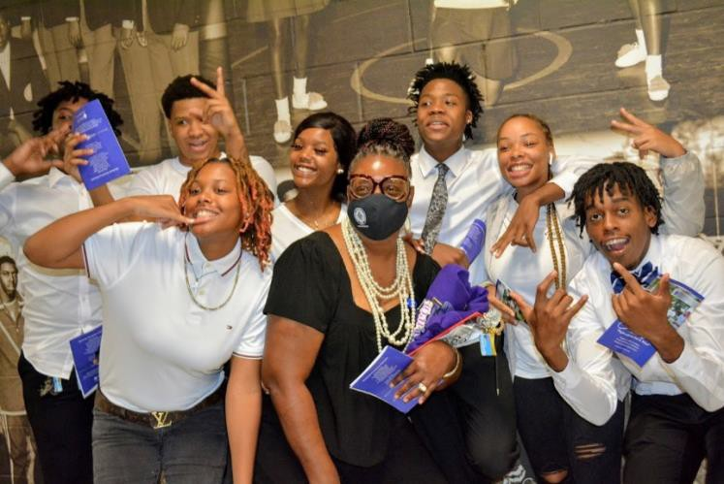

OFFICE OF STUDENT CONDUCT
Office of the Dean of Students Office Phone: (803) 793-5154 Email: hintons@denmarktech.edu

GENERAL PROVISIONS

Purpose
The purpose of the student grievance procedure is to provide a system to channel and resolve student complaints against a college employee concerning decisions made or actions taken. A decision or action can be grieved only if it involves a misapplication of a college’s policies, procedures, or regulations, or a state or federal law. This procedure may not be used in the following instances: (1) to grieve a claim against a college employee for any matter unrelated to the employee’s role or position at the college; (2) for complaints or appeals of grades awarded in a class or for an assignment, unless the complaint is based upon alleged discrimination on the basis of race, color, religion, sex, sexual orientation, national origin, age, disability, genetic information, gender, veteran status, pregnancy, childbirth, other categories protected by applicable law or on the basis of alleged sexual harassment/violence; or (3) to grieve a decision for which other grievance or appeal procedures exist (e.g., appeal of a disciplinary case, a residency appeal, a financial aid appeal, FERPA grievances, transfer credit evaluations).

The student filing the grievance must meet the definition of a “student” at the time of the decision or action being grieved and must be the victim of the alleged mistreatment. A grievance cannot be filed on behalf of another person.

Principles
Technical/community college students are members of both the community and the academic community. As members of the academic community, students are subject to the obligations that accrue to them by virtue of this membership.

As members of a larger community, students are entitled to all rights and protections accorded them by the laws of that community, the enforcement of which is the responsibility of duly constituted authorities. If a student's alleged behavior simultaneously violates college regulations and the law, the college may take disciplinary action independent of that taken by legal authorities.

When it has been determined that a student violated a federal, state, or local law, college disciplinary action may be initiated only when the presence of the student on campus will disrupt the educational process of the college.

When a student's alleged violation of the law, whether occurring on campus or off campus, may adversely affect the college's pursuit of its educational objectives or activities, the college may enforce its own regulations through this Student Code.

Solutions of Problems
The college will first seek to solve problems through internal review procedures. When necessary, off-campus law enforcement and judicial authorities may be involved.

In situations where South Carolina Technical/Community Colleges have shared programs, the Chief Student Services Officer where the alleged violation of the Student Code for the South Carolina Technical College System occurred will handle the charges. A change of venue to the other college may be granted, based on the nature of the offense, provided it is agreed to by the Chief Student Services Officers of both colleges. Any sanctions imposed will apply across both colleges.
In situations where a student is dually enrolled in two or more South Carolina Technical/Community Colleges and is charged with a violation of the Student Code for the South Carolina Technical College System, the Chief Student Services Officer of the college where the alleged infraction occurred will handle the charges and the sanctions may apply at each college in which the student is enrolled

Definitions
When used in this document, unless the content requires other meaning,
- "College" means any college in the South Carolina Technical College System.
- "President" means the chief executive officer of the college.
- "Administrative Officer" means anyone designated at the college as being on the administrative staff such as President, Vice President, Dean of Students or Student Services, Chief Academic Officer, Dean of Instruction, or Business Manager.
- "Chief Student Services Officer” means the Administrative Officer at the College who has overall management responsibility for student services, or his/her designee.
- "Chief Academic Officer" means the Administrative Officer at the College who has overall management responsibility for academic programs and services, or his/her designee.
- “Student” means an individual currently enrolled in a program and/or registered for the current or upcoming academic term.
- “Instructor" means any person employed by the college to conduct classes.
- “Staff” means any person employed by the college for reasons other than conducting classes
  - "SGA'' means the Student Government Association of the college or other group of students convened for the purpose of representing student interests to the college's administration or in the college's governance system.
  - "Campus" means any place where the college conducts or sponsors educational, public service, or research activities.
  - "Violation of Law" means a violation of a law of the United States or any law or ordinance of a state or political subdivision which has jurisdiction over the place in which the violation occurs.
  - “Instructional Days” means any weekday (M-F) in which classes are in session.
  - “Close of Business” means the time that the administrative offices of the college close on that specific workday.
  - “Approved Method of Notification” means any communication from college personnel through a communication channel to which the student has consented or which confirms receipt of the communication by the student, such as a hand-delivered letter, restricted mail delivery services, or e-mail. A student who communicates with the college via e-mail or otherwise provides an e-mail address in connection with communications relating to a grievance thereby consents to the service of documents and all other correspondence associated with the grievance by e-mail, and the date and time of such e-mail(s) shall be deemed the date and time of service.

STUDENT AFFAIRS

STUDENT CODE

Student Rights

    - Freedom from Discrimination--There shall be no discrimination in any respect by the college against a student or applicant for admission as a student on the basis of race, color, religion, sex, sexual orientation, national origin, age, disability, genetic information, gender, veteran status, pregnancy, childbirth or other categories protected by applicable law.

    - Freedom of Speech and Assembly--Students shall have the right to freedom of speech and assembly without prior restraints or censorship subject to clearly stated, reasonable, and nondiscriminatory rules and regulations regarding time, place, and manner developed and approved by the college. In the classroom and in other instructional settings, discussion and expression of all views relevant to the subject matter -are recognized as necessary to the educational process, but students have no right to interfere with the freedom of instructors to teach or the rights of other students to learn.

    - Freedom of the Press--In official student publications, students are entitled to the constitutional right of freedom of the press, including constitutional limitations on prior restraint and censorship. To ensure this protection, the college shall have an editorial board with membership representing SGA, faculty, and administration. Each college has the responsibility of defining the selection process for its editorial board. The primary responsibility of defining the selection process for its editorial board. The primary responsibility of the board shall be to establish and safeguard editorial policies

    - Freedom from Unreasonable Searches and Seizures--Students are entitled to the constitutional right to be secure in their persons, dwellings, papers, and effects against unreasonable searches and seizures. College security officers or administrative officers may conduct searches and seizures only as authorized by law.

    - Right to Participate in College Governance--Students should have the opportunity to participate on college committees that formulate policies directly affecting students, such as in the areas of student activities and student conduct. This participation may be coordinated through a Student Government Association whose constitution or bylaws have been approved by the college’s area commission.

    - Right to Know Academic and Grading Standards--Instructors will develop, distribute, explain, and follow the standards that will be used in evaluating student assignments and determining student grades. Grades are awarded for student academic performance. No grade will be reduced as a disciplinary action for student action or behavior unrelated to academic conduct.

    - Right to Privacy--Information about individual student views, beliefs, and political associations acquired by instructors, counselors, or administrators in the course of their work is confidential. It can be disclosed to others only with prior written consent of the student involved or under legal compulsion.

    - Right to Confidentiality of Student Records--All official student records are private and confidential and shall be preserved by the college. Separate record files may be maintained for the following categories: (I) academic, (2) medical, psychiatric, and counseling, (3) placement, (4) financial aid, (5) disciplinary, (6) financial, and (7) veteran’s affairs. In addition, disciplinary records are maintained by the Chief Student Services Officer. Student education records will be maintained and administered in accordance with the Family Educational Rights and Privacy Act of 1974, the guidelines for the implementation of this act, and other applicable federal and state statutes and regulations.

    - Right to Due Process--At a minimum, any student charged with misconduct under this code is guaranteed the following: 1) the right to receive adequate notice of the charge(s); 2) the right to see and/or hear information and evidence relating to the charge(s), and 3) the right to present information and evidence relating to the charge(s). Additional due process requirements will be identified in other sections of this Code.

Student Responsibilities
    - Students are expected to conduct themselves in a manner that is civil, that is respectful of the rights of others, and that is compatible with the college's educational mission.
    - Students are expected to comply with all of the college's duly established rules and regulations regarding student behavior while on campus, while participating in off-campus college sponsored activities, and while participating in off-campus clinical, field, internship, or in-service experiences.
    - Students are expected to comply with all course requirements as specified by instructors in course syllabi and to meet the standards of acceptable classroom behavior set by instructors. Instructors will announce these standards during the first week of classes. Ordinarily, if a student’s behavior disrupts class, the instructor will provide a warning about said behavior. However, if the unacceptable conduct/disruption jeopardizes the health, safety, or well-being of the student or others, or is otherwise severe or pervasive, the instructor may immediately dismiss the student for the remainder of the class. Any disruption may result in a written referral to the Chief Student Services Officer. This written referral may result in the initiation of disciplinary action against the student. The college reserves the right to review syllabi in connection with this provision.

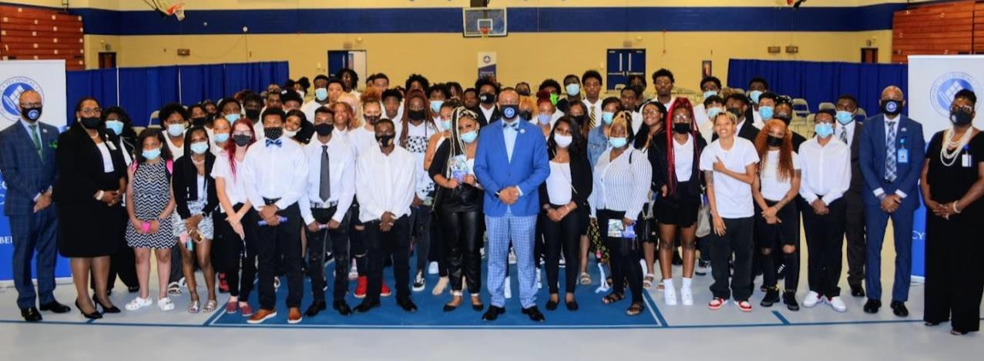

Student Conduct Regulations
The following list identifies violations for which students may be subject to disciplinary action. The list is not all inclusive, but it reflects the categories of inappropriate behavior and provides examples of prohibited behaviors.

    - Academic Misconduct
All forms of academic misconduct including, but not limited to, cheating on tests, plagiarism, collusion, and falsification of information may call for disciplinary action.
      - Cheating on tests is defined to include the following:
        - Copying from another student's test or answer sheet.
        - Using materials or equipment during a test not authorized by the person giving the test.
        - Collaborating with any other person during a test without permission.
        - Knowingly obtaining) using, buying, selling, transporting, or soliciting in whole or in part the contents of a test prior to its administration.
        - Bribing or coercing any other person to obtain tests or information about tests.
        - Substituting for another student or permitting any other person to substitute for oneself.
        - Cooperating or aiding in any of the above.

      - "Plagiarism" is defined as the appropriation of any other person's work and the unacknowledged incorporation of that work in one's own work.

      - "Collusion" is defined as knowingly assisting another person in an act of academic dishonesty.

      - "Fabrication" is defined as falsifying or inventing information in such academic exercises as reports, laboratory results, and citations to the sources of information.

    - Abuse of Privilege of Freedom of Speech or Assembly
No student acting alone or with others, shall obstruct or disrupt any teaching, administrative, disciplinary, public service, research, or other activity authorized or conducted on the campus of the college or any other location where such activity is conducted or sponsored by the college. This disruption does not necessarily have to involve violence or force for the student to face disciplinary actions. In addition to administrative action, any person in violation of any federal, state, or local law will be turned over to the appropriate authorities.

    - Falsification of Information and other Acts Intended to Deceive
Falsification of information and other acts intended to deceive include, but are not limited to the following:
- Forging, altering, or misusing college documents, records, or identification cards.

- Falsifying information on college records.

- Providing false information for the purpose of obtaining a service.

    - Actions which Endanger Students and the College Community
Actions which endanger students and the college community include, but are not limited to the following:
- Possessing or using on campus a firearm or other dangerous or potentially dangerous weapon unless such possession or use has been authorized by the college.
- Possessing, using, or threatening to use any incendiary device or explosive unless such possession or use has been authorized by the college.
- Setting fires or misusing or damaging fire safety equipment.
- Using, or threatening to use, physical force to restrict the freedom of action or movement of others or to harm others.
- Endangering the health, safety, or wellbeing of others through the use of physical, written, or verbal abuse, threats, intimidation, harassment, and coercion.
- Sexual violence, which refers to physical sexual acts perpetuated against a person’s will or when a person is incapable of giving consent. Cases of alleged acts of sexual violence will be adjudicated through SBTCE procedure 3-2- 106.2.
- Retaliating, or threatening to retaliate, against any person for filing a complaint, providing information relating to a complaint, or participating as a witness in any hearing or administrative process.
    - Infringement of Rights of Others
Infringement of rights of others is defined to include, but is not limited to the following:
    - Stealing, destroying, damaging, or misusing college property or the property of others on campus or off campus during any college activity.
- Sexually harassing another person. In addition to sexual violence, sexual harassment can include unwelcome sexual advances, requests for sexual favors, and other verbal, nonverbal , or physical conduct of a sexual nature, when submission to such conduct is made a term or condition of a student's education, a basis for academic conditions affecting the student, or the conduct is sufficiently serious to interfere with the student's academic performance or otherwise deny or limit the student's ability to participate in any aspect of the college's program, thereby creating an intimidating or hostile learning environment. Cases of alleged
acts of sexual harassment will be adjudicated through SBTCE procedure 3-2-
106.2 or SBTCE procedure 8- 5-101.1.
- Stalking, which is defined as engaging in a course of conduct, through physical, electronic, or other means, that would place a reasonable person in fear for his/her safety, or that has, in fact, placed an individual in such fear. Where the stalking is based on sex, race, national origin, color, age, religion or disability, it may constitute harassment under other provisions of this Code.
- Bullying or harassing conduct, including verbal acts and name calling; graphic and written statements, which may include the use of cell phones, the internet, or other electronic devices; and other conduct that may be physically harmful, threatening, or humiliating. Bullying or harassment based on race, color, religion, sex, sexual orientation, national origin, age, disability, genetic information, gender, veteran status, pregnancy, childbirth or other categories protected by applicable law, will be a violation of the Code when it is a basis for academic decisions affecting the student or the conduct is sufficiently serious to interfere with the student's academic performance or otherwise deny or limit the student's ability to participate in any aspect of the college's program, thereby creating an intimidating or hostile learning environment.
- Engaging in any activity that disrupts the educational process of the college, interferes with the rights of others, or adversely interferes with other normal functions and services.

    - Other Acts which Call for Discipline
Other acts which call for discipline include, but are not limited to the following:
- Possessing, using, or distributing any narcotics or other unlawful drugs as defined by the laws of the United States or the State of South Carolina.

- Possessing, using, or distributing on campus any beverage containing alcohol.

- Violating institutional policies while on campus or off campus when participating in a college sponsored activity or event.

- Violating any South Carolina and/or federal laws while on campus or off campus.

Student Disciplinary Procedures
The procedures and sanctions that follow are designed to channel faculty, staff or student complaints against students, except for those complaints alleging acts of sexual violence or sexual harassment which are processed under SBTCE procedure 3-2-106.2 or SBTCE procedure 8-5-101.1. Because due process is essential in dealing with infractions of college regulations, any disciplinary actions taken, and sanctions imposed on a student or student organization will follow the provisions of this code.

- Interim Suspension
In certain situations, the President, or President's designee, may temporarily suspend a student before the initiation of disciplinary procedures. Interim suspension may only be imposed when there is reason to believe that the continued presence of the accused student at the college poses a substantial and immediate threat to the student or to others or poses a serious threat of disruption of, or interference with, the normal operations of the college.

The interim suspension process is as follows:
  - When the Chief Student Services Officer, or designee, becomes aware of a situation which may warrant interim suspension, the Chief Student Services Officer, or designee, will consult with the President, or President’s designee, to confirm the imposition of interim suspension. This consultation includes providing the President, or President’s designee, with the nature of the alleged infraction, a brief description of the incident(s) and the student’s name. The decision to impose interim suspension should occur by the close of business within two instructional days.

  - The Chief Student Services Officer, or designee, will inform the student through an approved
method of notification about the decision to impose an interim suspension. This notification must be sent within two (2) instructional days of receiving the information from the President, or designee.
The notification must include the following information:
    - the reason(s) for the interim suspension.
    - notice that the interim suspension does not replace the regular hearing process.
    - information about requesting a hearing before the Hearing Committee; and
    - notice that the student is denied access to the campus during the period of suspension without prior approval of the Chief Student Services Officer.
B. Academic Misconduct
- An instructor who has reason to believe that a student enrolled in his/her class has committed an act of academic misconduct must discuss the matter with the student. The instructor must advise the student of the alleged act of academic misconduct and the information upon which it is based. The student must be given an opportunity to refute the allegation. If the student chooses not to participate in the discussion, the instructor will make a decision based upon the available information.
- If the instructor, after meeting with the student, determines that the student has engaged in academic misconduct as alleged, the instructor will inform the student about the decision and the academic sanction that will be imposed. The instructor may impose one of the following academic sanctions:
  - Completion of an educational activity relating to the nature of the offense.
  - Assign a lower grade or score to the paper, project, assignment or examination involved in the act of misconduct.
  - Require the student to repeat or resubmit the paper, project, assignment, or examination involved in the act of misconduct.
  - Assign a failing grade for the course.
  - Require the student to withdraw from the course.
  - Egregious or repeat offenders may be referred to the College’s conduct officer for a review of the matter. Such referrals will follow the Student Misconduct procedures and the sanctions that accompany it.

- If the student is found responsible for the academic misconduct, within five (5) instructional days of the meeting with the student, the instructor, or designee, will submit a written report about the incident and the sanction imposed to the Chief Academic Officer.

- The Chief Academic Officer, or designee, will send a notification to the student summarizing the incident, the finding, the terms of the imposed sanction, and informing the student that he/she may appeal the decision and/or the sanction by submitting a written request to the Chief Academic Officer within seven (7) instructional days of the date of the Chief Academic Officer's notification.

- If the student requests an appeal, the Chief Academic Officer, or designee, will sedan approve method of notification to the student’s address of record. The notification must contain the following information:
- a restatement of the charge(s).
- the time, place, and location of the appeal.
- a list of witnesses that may be called; and
- a list of the student's basic procedural rights. These rights follow:
  - The right to consult with counsel. The role of the person acting as counsel is solely to advise the student. Counsel may not participate in any of the questioning or make any statements on behalf of the student. The student will be responsible for paying any fees charged by his/her counsel.
  - The right to present witnesses on one's behalf.
  - The right to present evidence and notice that the Chief Academic Officer, or designee, may determine what evidence is admissible.
  - The right to know the identity of the person(s) bringing the charge(s).
  - The right to hear witnesses on behalf of the person bringing the charges.
  - The right to testify or to refuse to testify without such refusal being detrimental to the student.
  - The right to appeal the decision of the Chief Academic Officer to the President.
  - A statement informing the student that the sanction imposed by the instructor will be held in abeyance pending the outcome of the appeal.

- Based on the information presented at the appeal, the Chief Academic Officer, or designee, will render one of the following decisions:
- Accept the decision and the sanction imposed by the instructor.
- Accept the instructor's decision but impose a less severe sanction.
- Overturn the instructor’s decision.

Within two (2) instructional days of the meeting with the student, the Chief Academic Officer, or designee, will notify the student of the decision through an approved method of notification. The notification must also inform the student that the decision may be appealed to the College's President and that any appeal request must be written and must detail the reason(s) for the appeal. The student seeking the appeal must provide reasons for the appeal which sets forth a statement that specifies the issues that further review is sought and any evidence which supports the issue(s) on appeal. The written appeal must be sent to the President within five
(5) instructional days of the receipt of the Chief Academic Officer's decision.

After receiving the student's request, the President will review all written materials, non-written materials, and evidence relating to this incident and render one of the following decisions:
- Accept the decision and the sanction imposed
- Accept the decision, but impose a less severe sanction
- Overturn the decision
- Remand the case to the Student Hearing Committee to be re-heard. The decision of the hearing committee is final.

The President's decision is final and cannot be appealed further.

C. STUDENT MISCONDUCT
Any member of the college community may file charges alleging a violation of the Code. A charge, that includes a description of the alleged violation, must be submitted in writing to the Chief Student Services Officer as soon as possible after the incident occurs, but no later than ten (10) instructional days after the incident, unless the person filing the charge demonstrates that exceptional circumstances prevented filing the charge within this time period. The Chief Student Services Officer, or designee, will determine whether the circumstances merit an extension of the deadline.

- Preliminary Investigation
Within seven (7) instructional days after the charge has been filed, the Chief Student Services Officer, or designee, shall complete a preliminary investigation of the charge and schedule a meeting with the student. After discussing the alleged infraction with the student and reviewing available information, the Chief Student Services Officer, or designee will decide whether the information presented during the meeting indicates that the violation occurred as alleged. When the student cannot be reached to schedule an appointment, or when the student fails to attend the meeting, the Chief Student Services Officer, or designee, will base the decision upon the available information.

If the available information indicates that the violation occurred as alleged, then one of the following sanctions will be imposed:
- Reprimand--A written warning documenting that the student violated a student conduct regulation and indicating that subsequent violations could result in more serious disciplinary sanctions.
- Restitution--Compensation for loss or damage to college property or the property of others while on the campus or at a college event or activity including but not limited to field trips, internships, and clinicals.
- Special Conditions-Completion of a variety of educational activities, relating to the nature of the offense may be imposed. Examples include, but are not limited to, the following: a formal apology, an essay or paper on a designated topic, or participation in a special project or activity.
- Disciplinary Probation-- A written reprimand documenting that the student violated a student conduct regulation. Probation is for a specified period of time and it serves as a warning that subsequent violations could most likely result in more serious disciplinary sanctions.
- Loss of Privileges-- Suspension or termination of particular student privileges.
- Suspension from the College--Separation from the college for a specified period of time. Suspended students will not receive academic credit for the semester in which the suspension was imposed. During the suspension period, the student may not return to the campus unless prior permission by the Chief Student Services Officer, or designee, has been granted.
- Expulsion from the college--Permanent separation from the college. An expelled student may not return to the campus unless prior permission by the Chief Student Services Officer, or designee, has been granted. An expelled student will not receive academic credit for the semester in which the expulsion was imposed.

- Any combination of the above.
Within five (5) instructional days of the preliminary investigation, the Chief Student Services Officer, or designee, will send an approved method of notification to the student. This notification will confirm the date of the investigation, identify the specific regulation(s) that the student allegedly violated, identify the decision, summarize the rationale, and, if the student violated the regulation(s), state the sanction that was imposed. This notification must also state that if the student disagrees with the decision or the sanction, the student may request a hearing before the Hearing Committee, that the student must submit this request no later than five
(5) instructional days after receiving the decision unless a request is made and approved by the Chief Student Services Officer, or designee, for an extension, and that any decision made and sanction imposed after the preliminary investigation may be held in abeyance should the student decide to go before the Hearing Committee.

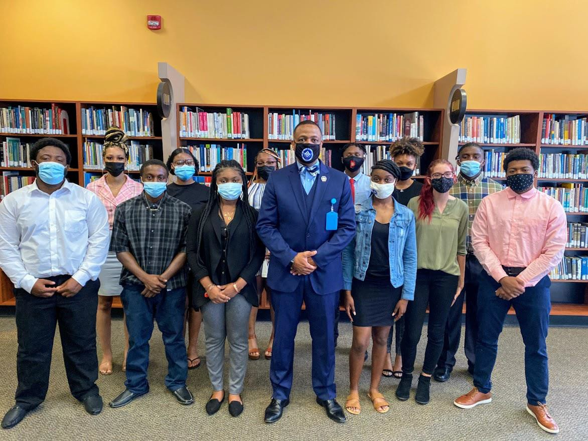

- Hearing Committee
- The Hearing Committee shall be composed of the following:
  - Two faculty members are appointed by the Chief Academic Officer and approved by the President.
  - Two student members are appointed by the appropriate student governing body and approved by the President.
  - One member of the Student Affairs staff appointed by the Chief Student Services Officer and approved by the President.
  - The Chief Student Services Officer, or designee, serves as an ex officio non- voting member of the Committee and who presents the case.

- The Hearing Committee shall perform the following functions:
  - Hear cases of alleged violations of the Code of Student Conduct. Insure that the student's procedural rights are met.
  - Make decisions based only on evidence and information presented at the hearing.
  - Provide the student with a statement of the committee's decision including findings of fact and, if applicable, impose one or more of the following sanctions:
    - Academic Misconduct Sanctions
      - Refer to Student Code; IV. Disciplinary Procedures; B. Academic Misconduct; Section 2
    - Student Misconduct Sanctions
      - Refer to Student Code; IV. Disciplinary Procedures; C. Student Misconduct; Section 1

- Hearing Committee Procedures
  - The Chief Student Services Officer, or designee, shall refer the matter to the Hearing Committee together with a report of the nature of the alleged misconduct, the name of the person(s) filing the complaint(s), the name of the student against whom the charge(s) has (have) been filed, and a summary of the findings from the preliminary investigation.
  - At least seven (7) instructional days before the date set for the Hearing

meeting, the Chief Student Services Officer, or designee, shall send an approved method of notification to the student’s address of record. The notification must contain the following information:
    - A statement of the charge(s).
    - A brief description of the incident that led to the charge (s).
    - The name of the person(s) submitting the incident report.
    - The date, time, and place of the scheduled hearing.
    - A list of all witnesses who might be called to testify.
    - A statement of the student's procedural rights. These rights follow:
      - The right to consult counsel. This role of the person acting as counsel is solely to advise the student. Counsel may not address the Hearing Committee or participate in any of the questionings. The student has the responsibility for paying any of the counsel's fees and any other of the counsel's charges.
      - The right to present witnesses on one's behalf.
      - The right to know the names of any witnesses who may be called to testify at the hearing.
      - The right to review all available evidence, documents, exhibits, etc., that may be presented at the hearing.
      - The right to present evidence; however, the Hearing Committee will determine what evidence is admissible.
      - The right to know the identity of the person(s) bringing the charge(s).
      - The right to hear witnesses on behalf of the person bringing the charges.
      - The right to testify or to refuse to testify without such refusal is detrimental to the student.
      - The right to a fair and impartial decision.
      - The right to appeal the Hearing Committee's decision.
  - On written request of the student, the hearing may be held prior to the expiration of the seven (7) day advance notification period if the Chief Student Affairs Officer, or designee, concurs with this change.
  - The Chief Student Affairs Officer, or designee, may postpone the hearing due to circumstances beyond the control of the parties.

- Hearing Committee Meetings
  - The Chair shall be appointed by the College's President from among the membership of the Committee. Ex officio members of the Committee may not serve as its Chair.
  - Committee hearings shall be closed to all persons except the student ("Student") accused of the violation(s), the person(s) initiating the charge(s), respective counsel for the Student and the College, witnesses authorized by the Committee
to participate in the hearing, and one or more persons designated by the Committee to be responsible for making an official written record or audio recording of the hearing.
The Committee will arrange for an official audio recording or written record of the hearing (not including deliberations) to be made, and only the person(s) designated by the Committee may make any kind of record of the proceedings. No record of the Committee's deliberations shall be permitted to be made by any means. The official audio recording or written record of the hearing is the property of the College and will be maintained in the office of the Chief Student Affairs Officer. The student may review the official audio recording or written record of the hearing (as applicable) under the supervision of the Chief Student Affairs Officer or designee, but the student is not entitled to a copy of the audio recording or written record. Notes made by Committee members for use as a personal memory aid shall not be made a part of the written record and are not subject to review by the student.
- Witnesses shall be called in one at a time to make a statement and to respond to questions, as permitted by the Chair.
- After the portion of the hearing concludes in which all pertinent information has been received, everyone other than the Committee will be excused, and its deliberations will begin. The "preponderance of the evidence" standard shall apply to the deliberations, which means that the Committee members must determine if the information presented at the hearing leads them to conclude that it is more likely than not that the violation(s) occurred as alleged. The Committee members will determine by majority vote whether the violation(s) occurred and, if so, the Committee members will decide upon the appropriate sanction(s) by majority vote.
- The hearing board’s sanction recommendation is forwarded to the Chief Student Affairs Officer/Vice President of Student Affairs or designee for approval.
- The Chief Student Affairs Officer/Vice President of Student Affairs or designee will review the hearing process, all evidence, and sanction (s); to ensure the sanction is aligned with case precedence at the college. If the sanction is not aligned, it is the responsibility of the Chief Student Affairs Officer/Vice President of Student Affairs or designee to upgrade or downgrade the sanction.
- Chief Student Affairs Officer/Vice President of Student Affairs or designee will inform the Chair of the Committee of the approved sanction.
- The Chair of the Committee will send an approved method of notification to the student’s address of record within two (2) instructional weekdays of the Committee's decision. The letter shall inform the Student of the Committee's decision, the date of the decision, any sanction(s) imposed, and the appeal process.

- Appeal
If the student disagrees with either the decision or the sanction, the student may submit a written appeal to the College’s President. This letter must be submitted within seven (7) instructional days of the date on which the Hearing Committee made its decision. The written appeal must include a statement indicating why the student disagrees with the Hearing Committee's findings.

The President, or designee, shall review the Hearing Committee's findings, conduct whatever additional inquires as deemed necessary, and render a decision within ten (10) instructional days of receiving the appeal. The President, whose decision is final, shall have the authority to approve, modify, or overturn the Hearing Committee's decisions and, if needed, void the process, and reconvene another Hearing Committee. The President’s decision regarding disciplinary actions under the Student Code 3-2-106.1 is non-grievable.
The President, or designee, will inform the student about the outcome of the appeal in a certified letter sent to the student's address on record.

Grievance Policy and Procedures
STATE BOARD FOR TECHNICAL AND COMPREHENSIVE EDUCATION PROCEDURE
PROCEDURE NUMBER: 3-2-106.3
TITLE: THE STUDENT GRIEVANCE PROCEDURE FOR THE SOUTH CAROLINA TECHNICAL COLLEGE SYSTEM POLICY REFERENCE NUMBER: 3-2-106
DIVISION OF RESPONSIBILITY: ACADEMICS, STUDENT AFFAIRS & RESEARCH
DATE OF LAST REVISION: April 29, 2020, DATE APPROVED: May 14, 2020

PURPOSE
The purpose of the student grievance procedure is to provide a system to channel and resolve student complaints against a college employee concerning decisions made or actions taken. A decision or action can be grieved only if it involves a misapplication of a college’s policies, procedures, or regulations, or a state or federal law. This procedure may not be used in the following instances: (1) to grieve a claim against a college employee for any matter unrelated to the employee’s role or position at the college; (2) for complaints or appeals of grades awarded in a class or for an assignment, unless the complaint is based upon alleged discrimination on the basis of race, color, religion, sex, sexual orientation, national origin, age, disability, genetic information, gender, veteran status, pregnancy, childbirth, other categories protected by applicable law or on the basis of alleged sexual harassment/violence; or (3) to grieve a decision for which other grievance or appeal procedures exist (e.g., appeal of a disciplinary case, a residency appeal, a financial aid appeal, FERPA grievances, transfer credit evaluations). The student filing the grievance must meet the definition of a “student” at the time of the decision or action being grieved and must be the victim of the alleged mistreatment. A grievance cannot be filed on behalf of another person.

DEFINITIONS
When used in this document, unless the content requires other meaning,
  - “College” means any college in the South Carolina Technical College System.
  - “President” means the chief executive officer of the college.
  - Administrative Officer" means anyone designated at the college as being on the administrative staff, such as the President, Chief Academic Officer, Chief Student Services Officer, etc.
  - "Chief Student Services Officer" means the Administrative Officer at the College who has overall management responsibility for student services or his/her designee.
  - "Chief Academic Officer" means the Administrative Officer at the College who has overall management responsibility for academic programs and services or his/her designee.
  - “Grievable Act or Decision” means a misapplication of a college’s policies, procedures, or regulations, or a violation of a state or federal law.
  - “Instructional Days” means any weekday (M-F) in which classes are in session.
  - “Student” means an individual currently enrolled in a program and/or registered for the current or upcoming academic term.
  - "Instructor" means any person employed by the college to conduct classes.
  - “Staff" means any person employed by the college for reasons other than conducting classes.
  - "Campus" means any place where the college conducts or sponsors educational, public service, or research activities.
  - “Approved Method of Notification” means any communication from college personnel through a communication channel to which the student has consented, or which confirms receipt of the communication by the student, such as a hand-delivered letter, restricted mail delivery services, or e-mail. A student who communicates with the college via e-mail or otherwise provides an e-mail address in connection with communications relating to a grievance thereby consents to the service of documents and all other correspondence associated with the grievance by e-mail, and the date and time of such e-mail(s) shall be deemed the date and time of service.
  - “Close of Business” means the time that the administrative offices of the college close on that specific workday.

GRIEVANCE PROCESS
  - Filing a Complaint
This procedure must be initiated by the student within fifteen (15) instructional days of becoming aware of the decision, action, or event giving rise to the grievance. This time limit may be extended by the President or his/her designee, if the student requests an extension within the fifteen (15) instructional day period.
Before initiating the Student Grievance process, a student may go to the college employee who originated the alleged problem and attempt to resolve the matter informally. In instances alleging discrimination or harassment, including sexual harassment and violence, the student is not required to initially try to resolve the matter with the person alleged to have committed the violation under this policy. Where applicable, if the student is not satisfied with the outcome of this meeting or if the student prefers to ignore this step, then the student may file a written complaint and initiate the grievance process. This written complaint should describe the decision or action that is being grieved, the date of the decision or action, and the college employee(s) involved in the decision or action.
    - Written complaints about alleged discrimination or harassment on the basis of race, color, religion, sex, sexual orientation, national origin, age, disability, genetic
information, gender, veteran status, pregnancy, childbirth, other categories protected by applicable law and written complaints about alleged sexual harassment or violence shall be submitted to the employee(s) designated in the college’s Statement of Nondiscrimination to coordinate Section 504, Title II, and Title IX compliance.
    - Written complaints about decisions and actions not related to discrimination based on race, color, religion, sex, sexual orientation, national origin, age, disability, genetic information, gender, veteran status, pregnancy, childbirth, other categories protected by applicable law or sexual harassment shall be submitted to the college’s Chief Student Services Officer.
    - Any written complaint naming the College’s President as the person whose alleged action or decision originated the problem shall be submitted to the President of the South Carolina Technical College System.

Preliminary Investigation and Findings
The person receiving the student’s written complaint will send a written acknowledgement to the student no later than two (2) instructional days after receiving the written complaint.
    - When the complaint is against anyone other than the President of a College:
The person receiving the complaint will forward the complaint to the immediate supervisor of the employee named in the complaint no later than two (2) instructional days after it has been received.
As a part of the effort to resolve the matter, the supervisor, or designee, will consult, as needed, with the employee named in the complaint, the student filing the complaint, the Chief Administrative Officer of the division or component concerned, and any other parties relevant to the resolution of the complaint.
The supervisor, or designee, shall respond in writing to the student within ten (10) instructional days of receipt of the complaint. The response, sent through an approved method of notification, shall include a summary of the findings and, as needed, propose the steps that shall be taken to resolve the complaint. If the student does not agree with the proposed resolution, the student may request to have the complaint heard by the Student Grievance Committee (see Section III.c.2.a).
    - When the complaint is against the President of a College:
The South Carolina Technical College System’s Vice President for Academics, Student Affairs, and Research (Vice President) or designee, will be responsible for the preliminary investigation and findings.
As a part of the effort to resolve the matter, the South Carolina Technical College System’s Vice President, or designee, will consult, as needed, with the College President named in the complaint, the student filing the complaint, the Chief Administrative Officer of the division or component concerned, and any other parties relevant to the resolution of the complaint.
The South Carolina Technical College System’s Executive Vice President, or designee, shall respond in writing to the student within ten (10) instructional days of receipt of the complaint. The response, sent through the approved method of notification, shall include a summary of the findings and, as needed propose the steps that shall be taken to resolve the complaint. If the student does not agree with the proposed resolution, the student may request to have the complaint heard by an ad hoc committee.
The President of the South Carolina Technical College System will convene a three-person ad hoc committee consisting of System Presidents or a three-person ad hoc committee from within the System to hear the student’s complaint.

Grievance Committee
      - When the complaint is against anyone other than the President of a College:
        - The student must submit a written request for a Grievance Hearing to the Chief Student Services Officer within seven (7) instructional days after receiving the supervisor's written response. The request must be related to the original complaint and include a statement describing why the supervisor's response was unsatisfactory.
        - If the student does not submit the written request for a hearing within seven (7) instructional days after receiving the supervisor's written response, and the student can demonstrate that extenuating circumstances resulted in the failure to meet this deadline, the Chief Student Services Officer may allow the hearing to take place.
        - Within two (2) instructional days of receiving the request for a hearing, the Chief Student Services Officer shall notify the College President about the need to convene a Student Grievance Committee. These committees shall be formed to hear specific complaints and a new committee may be formed each time a grievance covered by this procedure is filed.
      - When the complaint is against the President of a College:
        - The student must submit a written request for a Grievance Hearing to South Carolina Technical College System’s Vice President, or designee, within seven (7) instructional days after receiving the Vice President’s written response. The request must be related to the original complaint and include a statement describing why the Vice President's response was unsatisfactory.
        - If the student does not submit the written request for a hearing within seven (7) instructional days after receiving the Vice President’s written response, and the student can demonstrate that extenuating circumstances resulted in the failure to meet this deadline, the Vice President may allow the hearing to take place.
        - Within two (2) instructional days of receiving the hearing request, the Vice President shall notify the South Carolina Technical College System President about the need to convene an ad hoc committee of System Presidents or a three-person ad hoc committee from within the System to hear the student’s complaint. These committees shall be formed to hear specific complaints and a new committee may be formed each time a grievance covered by this procedure is filed.
    - Grievance Committees
      - When the complaint is against anyone other than the President of a College:
        - Student Grievance Committee- The College President must approve all recommended members. The committee shall be composed of the following:
          - Two students recommended by the governing body of the student body.
          - One faculty member recommended by the Chief Academic Officer;
          - One Student Services staff member recommended by the Chief Student Services Officer.
          - One administrator, other than the Chief Student Services Officer, to serve as the Committee's chairperson.
          - The Chief Student Services Officer, or designee, who serves as ex-officio, nonvoting member of the committee.
        - The Chief Student Services Officer, or designee, will send copies of the student’s request for a hearing to the committee members, the employee, and the employee's supervisor. The employee against whom the grievance was filed has an opportunity to submit his/her response to the request for a hearing to the Committee prior to the hearing.
        - The Student Grievance Committee’s hearing shall be conducted within twenty-one (21) instructional days following the date of the request. The chairperson may grant a postponement if either party submits a written request no later than five (5) instructional days prior to the scheduled hearing. The chairperson of the Student Grievance Committee, in his/her discretion, may postpone the hearing due to circumstances beyond the control of the parties. The rescheduled hearing must take place within ten (10) instructional days of the date of the previously scheduled hearing.
      - When the complaint is against the President of a College:
        - Ad hoc committee- The President of the South Carolina Technical College System will select three College Presidents from the System to serve on this committee and identify one of the three College Presidents to serve as the chairperson for the hearing. The President of the South Carolina Technical College System may also choose to select a three-person ad hoc committee from within the System to hear the student’s complaint.
        - The President of the South Carolina Technical College System, or designee, will send copies of the student’s request for a hearing to the committee members, and the President at that college. The President against whom the grievance was filed has an opportunity to submit his/her response to the request for a hearing to the Committee prior to the hearing.
        - The ad hoc committee hearing shall be conducted within twenty-one (21) instructional days following the date of the request. The chairperson may grant a postponement if either party submits a written request no later than five (5) instructional days prior to the scheduled hearing. The chairperson of the ad hoc committee, in his/her discretion, may postpone the hearing due to circumstances beyond the control of the parties. The re-scheduled hearing must take place within fifteen (15) instructional days of the date of the previously scheduled hearing.
    - Hearing Procedures
      - When the complaint is against anyone other than the President of a College:
        - The South Carolina Technical College System, or designee, shall send notice through an approved method of notification to the student filing the complaint and to the College President named in the complaint at least fifteen (15) instructional days before the scheduled hearing. This notification shall include:
          - a brief description of the complaint, including the name of the person filing the complaint.
          - the date, time, and location of the hearing.
          - a list of the student’s procedural rights. These rights follow:
            - The right to review all available evidence, documents or exhibits that each party may present at the hearing. This review must take place under the supervision of the South Carolina Technical College, or designee.
            - The right to appear before the Hearing Committee and to present information and additional evidence, subject to the Committee’s judgment that the evidence is relevant to the hearing.
            - The right to consult with counsel. This person serving as counsel may not address the committee, question the College President named in the complaint, or any witnesses. The student will be responsible for paying any fees charged by the counsel.
            - The right to present witnesses who have information relating to the complaint. Witnesses will be dismissed after presenting the information and responding to questions posed by the Committee, the student filing the complaint, and the College President named in the complaint.
        - At least ten (10) instructional days before the scheduled hearing the parties must submit the names of persons that the parties anticipate calling as witnesses as well as any evidence that the parties intend to introduce at the hearing.
        - At least five (5) days prior to the hearing, the Chief Student Services Officer shall provide the list of witnesses and evidence to the Parties involved in the hearing and shall send hearing information to the witnesses to include, at minimum, the date, time, and location of the hearing.
        - Committee hearings shall be closed to all persons except the student filing the complaint, the College President named in the complaint, respective counsel for the student and the employee (s), witnesses authorized by the Committee to participate in the hearing, committee members, and one or more persons designated by the Committee to be responsible for making an official written record or audio recording of the hearing.
        - The Committee will arrange for an official audio recording or written record of the hearing (not including deliberations) to be made, and only the person(s) designated by the Committee may make any kind of record of the proceedings. No record of the Committee's deliberations shall be permitted to be made by any means. The official audio recording or written record of the hearing is the property of the College and will be maintained in the office of the President of the South Carolina Technical College System. The student or College President named in the complaint may review the official audio recording or written record of the hearing (as applicable) under the supervision of the System President or designee, but neither are entitled to a copy of the audio recording or written record. Notes made by Committee members for use as a personal memory aid shall not be made a part of the written record and are not subject to review by the student or College President.
        - Witnesses shall be called in one at a time to make a statement and to respond to questions, as permitted by the Chair.
        - After the portion of the hearing concludes in which all pertinent information has been received, everyone other than the Committee will be excused, and its deliberations will begin. The "preponderance of the evidence" standard shall apply to the deliberations, which means that the Committee members must determine if the information presented at the hearing leads them to conclude that it is more likely than not that the violation(s) occurred as alleged. The Committee members will determine by majority vote whether the violation(s) occurred and, if so, the Committee members will decide upon the appropriate sanction(s) by majority vote.
8)The Chair of the Committee will send an approved method of notification to the student and College President’s address of record within two (2) instructional days of the Committee's decision. The letter shall inform both parties of the Committee's decision, the date of the decision, any sanction(s) imposed, and the appeal process.

Appeal Process
  - When the complaint is against anyone other than the President of a College:
If either party is not satisfied with the Student Grievance Committee's decision, that person may submit a written appeal to the President of the College within ten (10) instructional days of the Committee's decision. The written appeal must include a statement indicating why the person was not satisfied with the Committee’s decision. The College President shall review the Committee's findings, conduct whatever additional inquiries are deemed necessary and render a decision within ten (10) instructional days of receipt of the appeal. The College President will notify both parties of his/her decision through an approved method of notification. The President's decision is final and this decision cannot be the sole reason for filing a grievance against the President.
  - When the complaint is against the President of a College: If either party is not satisfied with the ad hoc committee’s decision, that person may submit a written appeal to the President of the South Carolina Technical College System within ten (10) instructional days of the Committee's decision. The written appeal must include a statement indicating why the person was not satisfied with the Committee’s decision. The System President shall review the Committee's findings, conduct whatever additional inquiries are deemed necessary and render a decision within ten (10) instructional days of receipt of the appeal. The System President will notify both parties of his/her decision through an approved method of notification. The System President’s decision is final

STUDENT CODE PROCEDURES FOR ADDRESSING ALLEGED ACTS OF SEXUAL HARASSMENT UNDER TITLE IX

Procedural Overview

Under Title IX of the Education Amendments of 1972 (20 U.S.C. 1681) and its implementing regulations (34 C.F.R. 106), sexual harassment is a form of prohibited sex discrimination. Title IX provides that, “No person in the United States shall, on the basis of sex, be excluded from participation in, be denied the benefits of, or be subjected to discrimination under any educational program or activity receiving Federal financial assistance.” The South Carolina Technical College System is committed to fostering an environment that is free from unlawful discrimination based on sex, including sexual harassment and sexual assault. Any questions regarding Title IX may be referred to the college’s Title IX coordinator. Each college must prominently display the contact information required for the Title IX coordinator (name or title, telephone number, e-mail address, and office address) on its website, if any, and in each handbook, catalog, or publication that it makes available to persons entitled to a notification. In addition, colleges should include contact information for the U.S. Department of Education’s Office of Civil Rights.

The Student Code for the South Carolina Technical College System (SBTCE Procedure 3-2- 106.1) sets forth the rights and responsibilities of the individual student, identifies behaviors that are not consistent with the values of college communities, and describes the procedures that will be followed to adjudicate cases of alleged misconduct. The Student Code for Addressing Alleged Acts of Sexual Harassment (SBTCE Procedure 3-2-106.2) applies to behavior or complaints alleging acts of sexual harassment on college property, or in an education program or activity. This Code does not apply to persons outside of the United States. In order to proceed through the sexual harassment grievance process detailed herein, a formal complaint must be filed with or by a Title IX coordinator and meet the following elements:

  - The alleged activity falls within the definition of sexual harassment as defined in Section II (CC.).

  - The alleged activity occurred within a college’s education program or activity; and

  - The alleged activity occurred against a person physically located in the United States.

STUDENT AFFAIRS

Complaints reported to the college’s Title IX coordinator which do not meet the above elements shall be adjudicated under the grievance process outlined in the Student Code for the South Carolina Technical College System (SBTCE Procedure 3-2-106.1). The Non- Discrimination, Anti- Harassment, and Sexual Misconduct procedure of the South Carolina Technical College System (SBTCE Procedure 8-5-101.1) shall apply in situations where complaints are made against employees of a college.

Any person may report sex discrimination, including sexual harassment (whether or not the person reporting is the person alleged to be the victim of conduct that could constitute sex discrimination or sexual harassment) to the Title IX Coordinator at any time, including non-business hours, via the phone number, e-mail address or office mailing address listed for the Title IX coordinator.

Irrespective of whether a report of sexual harassment is anonymous, a college with actual knowledge of sexual harassment or allegations of sexual harassment in the college’s education program or activity against a person in the United States must respond promptly in a manner that is not deliberately indifferent, meaning not clearly unreasonable in light of the known circumstances.

In some cases, campus authorities may become aware of allegations of sexual harassment via local law enforcement. These allegations may also be addressed by this Procedure. The State Board for Technical and Comprehensive Education and its member colleges encourage the prompt reporting of sexual harassment to campus security and local law enforcement. The complainant may also file a criminal report regarding the alleged conduct. However, Title IX investigations are separate from criminal investigations. In some cases, colleges may need to temporarily delay the fact-finding portion of a Title IX investigation while law enforcement gathers evidence. Contact information for local law enforcement and campus security is available on the colleges’ websites.

Retaliatory acts, which may include giving students failing grades, preventing students from participating in school activities, and threatening expulsion against any individual who exercises his or her rights under Title IX are considered to be discrimination and are unlawful. Colleges are prohibited from intimidating, threatening, coercing, or discriminating against any individual for the purpose of interfering with any right or privilege secured by Title IX.

- Definitions- When used in this document, unless the context requires other meaning,

  - “Actual Knowledge” means notice of sexual harassment or allegations of sexual harassment to a college’s Title IX coordinator or any official of the college who has authority to institute corrective measures on behalf of the college.

  - An “Advisor” is someone who is present to help the complainant or respondent understand the proceedings and to conduct cross-examination on behalf of the party during a live hearing.

  - An “Appeals Officer” is a person designated by a college to hear an appeal of a dismissal of a formal complaint or a decision-maker determination.

  - An “Approved Method of Notification” means any communication from college personnel through a communication channel to which the student has consented, or which confirms receipt of the communication by the student, such as a hand- delivered letter, restricted mail delivery services, or e-mail. A student who communicates with the college via e-mail or otherwise provides an e-mail address in connection with communications relating to a grievance thereby consents to the service of documents and all other correspondence associated with the grievance by e-mail, and the date and time of such e-mail(s) shall be deemed the date and time of service.

  - “Chief Student Services Officer” means the Administrative Officer at the college who has overall management responsibility for student services, or his/her designee.

  - “Close of Business” means the time that the administrative offices of the college close on that specific workday.

  - “College” means any college in the South Carolina Technical College System.

  - “Complainant” means an individual who is alleged to be the victim of conduct that could constitute sexual harassment.

  - “Consent” is clear, knowing, and voluntary agreement. Consent is active, not passive. Silence, in and of itself, cannot be interpreted as consent. Consent can be given by words or actions, as long as those words or actions create mutually understandable clear permission regarding willingness to engage in (and the conditions of) sexual activity. Consent to any one form of sexual activity cannot automatically imply consent to any other forms of sexual activity. Previous relationships or prior consent cannot imply consent to future sexual acts.

  - “Dating Violence” means violence committed by a person who is or has been in a social relationship of a romantic or intimate nature with the victim, where the existence of such a relationship shall be determined based on a consideration of the following factors: the length of the relationship; the type of relationship; and the frequency of interaction between the persons involved in the relationship.

  - A “Decision-Maker” is someone (who cannot be the same person as the Title IX coordinator or the investigator) who issues a written determination with findings of fact, conclusions about whether the alleged conduct occurred, rationale for the result as to each allegation, any disciplinary sanctions imposed on the respondent, and whether remedies will be provided to the complainant.

  - “Domestic Violence” includes felony or misdemeanor crimes of violence committed by a current or former spouse or intimate partner of the victim, by a person with whom the victim shares a child in common, by a person who is cohabitating with or has cohabitated with the victim as a spouse or intimate partner, by a person similarly situated to a spouse of the victim under the domestic or family violence laws of the jurisdiction receiving grant monies, or by any other person against an adult or youth victim who is protected from that person’s acts under the domestic or family violence laws of the jurisdiction.

  - “Education Program or Activity” includes locations, events, or circumstances over which the college exercised substantial control over both the respondent and the context in which the sexual harassment occurs, and includes any building owned or controlled by a student organization that is officially recognized by the college.

  - “Exculpatory Evidence” is evidence that creates a reasonable doubt that a respondent engaged in the conduct alleged in a complaint.

  - “Fondling” is the touching of the private parts of another person for the purpose of sexual gratification without the consent of the victim, including instances where the victim is incapable of giving consent because of his/her age or because his/her temporary or permanent mental incapacity.

  - “Formal Complaint” means a document filed by a complainant with the Title IX coordinator or signed by the Title IX coordinator alleging sexual harassment against a respondent and requesting that the college investigate the allegation of sexual harassment. A report of behavior to the Title IX coordinator or other college official does not constitute a formal complaint.

  - “Incest” is sexual intercourse between persons who are related to each other within degrees wherein marriage is prohibited by law (see S.C. Code Ann. § 16-15-20).

  - “Exculpatory Evidence” is evidence indicating that a respondent engaged in the conduct alleged in the complaint.

  - “Instructional Days” means any weekday (M-F) in which classes are in session.

  - “Instructor" means any person employed by the college to conduct classes.

  - An “Investigator” is someone who acts as a neutral party in the investigation and provides a detailed, unbiased report regarding the findings of the investigation.

  - “Official with Authority” means an official of the college with authority to institute corrective measures. Officials with authority are those personnel designated by a college

who would be considered to have actual knowledge upon receiving notice of alleged sexual harassment

  - “Preponderance of the Evidence” is the standard used to evaluate the evidence for purposes of making findings and drawing conclusions for an investigation or hearing conducted under this Procedure. The preponderance of evidence standard means it is more likely than not that the conduct complained of occurred.

  - A “Report” is notice from a complainant of alleged sexual harassment, other than a formal complaint, made to the Title IX coordinator or an official with authority.

  - “Rape” is the penetration, no matter how slight, of the vagina or anus with anybody part or object, or oral penetration by a sex organ of another person, without the consent of the victim.

  - “Respondent” means an individual who has been reported to be the perpetrator of conduct that could constitute sexual harassment.

  - “Retaliation” is adverse action taken against an individual for engaging in protected activity. No college or other person may intimidate, threaten, coerce, or discriminate against any individual for the purpose of interfering with any right or privilege secured by 34 C.F.R. Part 106 (Title IX), or because the individual has made a report or complaint, testified, assisted, or participated or refused to participate in any manner in an investigation, proceeding, or hearing under Title IX. Intimidation, threats, coercion, or discrimination, including charges against an individual for code of conduct violations that do not involve sex discrimination or sexual harassment but arise out of the same facts or circumstances as a report or complaint of sex discrimination, or a report or formal complaint of sexual harassment, for the purpose of interfering with any right or privilege secured by Title IX, constitutes retaliation.

  - “Sexual Assault” is defined as rape, fondling, incest, and statutory rape as defined herein.

  - “Sexual Harassment” means conduct on the basis of sex that satisfies one or more of the following: (1) An employee of the college conditioning the provision of an aid, benefit, or service of the college on an individual’s participation in unwelcome sexual conduct (i.e. quid pro quo); (2) Unwelcome conduct determined by a reasonable person to be so severe, pervasive, and objectively offensive that it effectively denies a person equal access to the college’s education program or activity; or (3) sexual assault, dating violence, domestic violence, or stalking as defined herein.

  - “Staff” means any person employed by the college for reasons other than conducting classes.

  - “Stalking” means engaging in a course of conduct directed at a specific person that would cause a reasonable person to (1) fear for his or her safety or the safety of others; or (2) suffer substantial emotional distress. For the purposes of this definition: “Course of conduct” means two or more acts, including, but not limited to, acts which the stalker directly, indirectly, or through third parties, by any action, method, device, or means follows, monitors, observes, surveils, threatens, or communicates to or about, a person, or interferes with a person’s property; “reasonable person” means a person of

ordinary prudence and action under the circumstances in which the course of conduct occurs; and “substantial emotional distress” means significant mental suffering or anguish that may, but does not necessarily, require medical or other professional treatment or counseling.

  - “Statutory rape” is sexual intercourse with a person who is under the statutory age of consent

(See S.C. Code Ann. § 16-3-655)

  - “Student” means an individual currently enrolled in a program and/or registered for the current or upcoming academic term.

  - “Supportive Measures” are non-disciplinary, non-punitive individualized services offered as appropriate, as reasonably available, and without fee or charge to the complainant or the respondent. Supportive Measures may include counseling, extensions of deadlines or other course-related adjustments, modifications of work or class schedules, campus escort services, mutual restrictions on contact between the parties, changes in work or housing locations, leaves of absence, increased security and monitoring of certain areas of the campus, and other similar measures.

- A “Third-Party Reporter” is an individual who files a complaint on behalf of another individual alleging violation of this policy.

JJ. A “Title IX Coordinator” is an employee designated by the college to coordinate its efforts to comply with and carry out its responsibilities under 34 C.F.R. Part 106 (Title IX), including any investigation of any complaint communicated to such college alleging its noncompliance with Title IX or alleging any actions which would be prohibited by Title IX.

- Receipt of Reports and Formal Complaints

  - Reports

A report of alleged sexual harassment to a Title IX coordinator or any official of the college who has authority constitutes actual knowledge. The college must maintain a list of college personnel who are considered officials with authority to institute corrective measures and may name additional responsible employees who must report sexual harassment to the Title IX coordinator. An official with authority who receives a report of alleged sexual harassment must promptly notify the Title IX coordinator of the report. A report is not considered to be a formal complaint but initiates the offering of supportive measures.

  - Formal Complaints

A Title IX coordinator may receive a formal complaint alleging sexual harassment by phone, mail, e-mail, or any other approved method of notification. Receipt of a formal complaint must be acknowledged in writing by the Title IX coordinator to the complainant within three (3) instructional days of submission of the complaint. Formal

complaints may be initiated by a complainant or the Title IX coordinator. Upon determining a formal complaint meets the elements set forth in Section I of this Procedure, the college’s sexual harassment grievance process is initiated.

- Supportive Measures

Upon receiving or being made aware of a report alleging sexual harassment, regardless of whether a formal complaint has been filed, the Title IX coordinator must provide supportive measures to both the complainant and the respondent. The Title IX coordinator is responsible for coordinating the effective implementation of supportive measures and must consider a complainant’s wishes with respect to measures provided. Measures provided shall be kept confidential unless disclosure is necessary to provide the measures, such as in the case of a no- contact order. Such measures should restore or preserve equal access to the education program or activity without unreasonably burdening the other party.

Interim suspension or expulsion of a respondent is not included in the list of supportive measures. Emergency removal of a respondent from an educational program or activity is allowable only after conducting a safety and risk analysis and determining there is an immediate threat to the physical health or safety of any student or other individual arising from the allegations of sexual harassment that justifies removal. The respondent must be provided with notice of the removal and an opportunity to challenge the decision immediately following the removal. Such a challenge must be made to the Title IX coordinator in writing through an approved method of notification within two (2) instructional days of the removal and include a rationale for why the emergency removal should be rescinded. A respondent may not be subject to an emergency removal without full and appropriate consideration of applicable disability laws, such as Section 504 of the Rehabilitation Act and the Americans with Disabilities Act, in order to preserve equal education access.

- Sexual Harassment Grievance Process

The sexual harassment grievance process must include reasonably prompt time frames determined by the college and written into policy for conclusion of the grievance process (from the filing of a formal complaint to the written determination by the decision-maker), informal resolutions, and appeals. The college’s policy must also include an explanation and examples of time extensions beyond the published policy, and such extensions must be temporary and justified by good cause.

  - Dismissal of a Formal Complaint

The college must dismiss formal complaints alleging sexual harassment if the conduct in the alleged complaint does not meet the definition of sexual harassment as contained herein; if the conduct did not occur in the college’s education program or activity; or if the conduct did not occur against a person in the United States. However, the complaint may be investigated under the Student Code for the South Carolina Technical College System (SBTCE Procedure 3-2-106.1) if it violates a college’s student code of conduct.

A college may dismiss a formal complaint under this Procedure if, at any time, a complainant notifies the Title IX coordinator that the he or she wishes to withdraw the complaint; if the respondent is no longer enrolled at the college; or if specific circumstances prevent the college from gathering evidence sufficient to reach a determination. If a formal complaint is dismissed, written notice containing reason(s) for the dismissal must be made by an approved method of notification and provided to both parties. Dismissal of a formal complaint can be appealed.

  - Notice of Allegations

Upon receiving a formal complaint alleging sexual harassment, written notice of the allegation(s) (“Notice of Allegations”) must be provided within seven (7) instructional days to both the complainant and the respondent. The written notice must be made by an approved method of notification and include:
    - The identities of the parties involved in the incident.
    - The conduct allegedly constituting sexual harassment.
    - The date and location of the alleged incident.
    - Notice of the college’s sexual harassment grievance process, to include information regarding its informal resolution process, if available.
    - A statement that the respondent is presumed not responsible for the alleged conduct and that a determination regarding responsibility will be made upon conclusion of the grievance process.
    - Notice as to whether the college’s code of conduct prohibits knowingly making or submitting false information during the grievance process, and,
    - Notice that the parties may have an advisor of their choice. Such notice of allegations must be provided at least three (3) instructional days prior to any initial interviews or meetings to allow the respondent sufficient time to respond to the allegations. Notice of additional allegations added after the initial notice must also be provided in writing through an approved method of notification.

  - Advisors

Both the complainant and respondent may have an advisor of their choosing to be present during meetings with college officials (such as the Title IX coordinator or investigator), interviews, and review of materials related to the complaint. Both the complainant and respondent must have an advisor present at the hearing whose sole purpose is to conduct cross-examination on behalf of the party. A party who does not bring an advisor of their choosing to the hearing shall be assigned an advisor by the college. In the event that neither a party nor their advisor appears at the hearing, the college must provide an advisor to appear on behalf of the non- appearing party. An assigned advisor may or may not be an employee of the college.

  - Investigation

    - Investigative Process
Upon receipt of a formal complaint of allegations of sexual harassment, the college must initiate an investigation led by an impartial investigator whose purpose is to collect and summarize evidence. The person(s) investigating may not also serve as the Title IX coordinator or decision-maker. The college must ensure that the burden of proof and burden of gathering evidence sufficient to reach a determination lies on the college and not the parties involved. Parties must receive equal opportunity to present witnesses and evidence. Such evidence must be submitted to the investigator within ten (10) instructional days upon receipt of the Notice of Allegations. Written notice must be provided to a party when the party’s participation in a meeting with the investigator is invited or expected.
The notice must include the date, time, and location of the meeting; the expected participants; the meeting’s purpose; and must allow up to three (3) instructional days, although this period may be shortened if mutually agreed upon by the parties.
Investigators may record interviews with parties and witnesses. Such recordings may be included in the investigative report if relevant, either by transcription with irrelevant information redacted or by recording with irrelevant audio removed.

The investigative process should be completed within approximately thirty (30) to forty- five (45) instructional days from receipt of the formal complaint. Circumstances may warrant additional time to complete the investigative process.

    - Review of Evidence

Before an investigator issues a report, both parties must be allowed at least ten instructional days to (1) review evidence gathered during the investigation that is directly related to the allegations raised in the formal complaint and (2) submit a written response to the evidence. Investigators may but are not required to share such responses to the other party. Should the college discover additional evidence resulting from further investigation prompted by a party’s initial response to evidence, the required time of ten
(10) instructional days must again be provided for a party to review and respond to the evidence. Notification of any such additional evidence for review shall be made to the parties in writing by an approved method of notification. Upon conclusion of the investigation, the investigator shall generate a written report within seven (7) instructional days unless this time period is extended for an additional five (5) instructional days upon written notice to the parties with an explanation for the extension. Privileged information will not be provided, and treatment records of a party may only be provided to the other party with written consent.

    - Investigative Report

The investigator(s) must create a report that fairly summarizes all relevant inculpatory and exculpatory evidence and distribute the report to the parties and their advisors at least ten (10) instructional days prior to the scheduled hearing. The investigative report

should include a description of procedural steps taken during the investigation and a summary of evidence. Only evidence relevant to the allegations of sexual harassment shall be included in the investigative report. Prior sexual history is not deemed relevant
(1) unless such questions and evidence about the complainant’s prior sexual behavior are offered to prove that someone other than the respondent committed the conduct alleged by the complainant, or (2) if the questions and evidence concern specific incidents of the complainant’s prior sexual behavior with respect to the respondent and are offered to prove consent.

Parties may provide written responses to the investigative report, which shall be provided to the decision-maker at least one instructional day in advance of the hearing.

  - Hearings

A college’s sexual harassment grievance process must provide for a live hearing with cross-examination of parties and witnesses. The parties may bring an advisor of their choice to conduct the cross-examination. Should a party not have an advisor, the college must provide an advisor at no cost. Parties must be notified of a scheduled hearing at least ten (10) instructional days prior to the hearing through an approved method of notification that shall include the date, time, and location of the hearing.

At the live hearing, advisors of the parties shall cross-examine parties and witnesses who have provided information relevant to the complaint or response thereto. The decision-maker does not have to allow witnesses who are solely character witnesses. The decision-maker must allow the advisor for each party to ask the other party and any witness’s relevant questions and follow-up questions. Such cross-examination must be conducted directly, orally, and in real time by the party’s advisor of choice and may occur with the parties in separate rooms using technology that enables participants to simultaneously see and hear the person answering questions. Only relevant cross- examination and other questions may be asked of a party or witness. Before a complainant, respondent, or witness answers a question while under cross-examination or otherwise, the decision-maker must first determine whether the question is relevant and explain any decision to exclude a question as not relevant.

Questions for cross-examination may be presented in advance to the decision-maker so that relevancy may be determined prior to the hearing. However, providing cross-examination questions in advance does not preclude the advisor(s) from asking additional questions not provided in advance to the decision-maker.

Questions and evidence about the complainant’s sexual predisposition or prior sexual behavior are not relevant, unless such questions and evidence about the complainant’s prior sexual behavior are offered to prove that someone other than the respondent committed the conduct alleged by the complainant, or if the questions and evidence concern specific incidents of the complainant’s prior sexual behavior with respect to the respondent and are offered to prove consent.

At the request of either party, the college must provide for the live hearing to occur with the parties located in separate rooms with technology enabling the decision- maker and parties to simultaneously see and hear the party or the witness answering questions. An audio or visual recording or a transcript of the hearing must be created and made available for review and inspection.

  - Determinations

Determinations must be made using the Preponderance of the Evidence standard. Determinations may be made at the conclusion of the live hearing or within three (3) instructional days of the live hearing’s conclusion and shall be provided in writing by an approved method of notification simultaneously to both parties. A written determination shall include:
    - Identification of the allegation(s) of sexual harassment.
    - A description of the process of investigation, from receipt of the complaint through the determination, to include any notifications to the parties, interviews, site visits, methods used to gather evidence, and hearings held.
    - Findings of fact supporting the determination,
    - Conclusions regarding the application of any of the college’s policies to the facts
    - A statement of, and rationale for, the determination regarding each allegation, to include:
      - Disciplinary sanctions for the respondent
      - Remedies provided to the complainant to restore the complainant’s equal access to the college’s education program or activity; and
    - Information regarding the opportunity to appeal the determination.

A determination is considered final either on the date that the college provides the parties with the written determination or upon expiration of the option to file an appeal.

  - Appeals

Both parties must be afforded the opportunity to appeal dismissal of a formal complaint as well as a final determination on the following grounds:
    - A procedural irregularity affecting the outcome.
    - New evidence not available at the time of the determination that could affect the outcome; or
    - Conflict of interest or bias on the part of the Title IX coordinator, investigator(s), or decision-maker which affected the outcome.

If a party wishes to appeal, an appeal must be made within ten (10) instructional days of dismissal of a formal complaint or delivery of a written determination. If a party files an appeal, the other party must be notified by an approved method of notification. A party wishing to appeal must do so by submitting an appeal in writing to the Title IX coordinator, who will assign review of the appeal to an appeals officer within three (3) instructional days of receipt. The appeal must include a statement indicating why the appealing party disagrees with dismissal of the complaint or the determination, and

specify on which ground(s) the appeal is being made. The college must ensure that the appeals officer is not the Title IX coordinator, investigator(s), or decision-maker who reached the original determination. A decision by an appeals officer must be rendered within three (3) instructional days of receipt by the appeals officer and provided in writing to both parties simultaneously through an approved method of notification. Should an extension be necessary, the appeals officer may provide the parties with written notice extending determination of the appeal for five (5) instructional days with an explanation for the extension. The results of an appeal and the rationale for the determination must be provided in writing simultaneously to both parties.

- Informal Resolution

Upon receipt of a formal complaint, a college may choose to introduce the option of a voluntary informal resolution process. Informal resolution may include a range of conflict resolution strategies to include arbitration, mediation, or restorative justice. Informal resolution is a voluntary process that must be agreed upon in writing by both parties, and the documented agreement must notify the parties of their right to withdraw at any time from the informal resolution process. Colleges may not offer or facilitate an informal resolution process to resolve complaints of sexual harassment where the complainant is a student and the respondent is an employee. The informal resolution process may result in sanctions for a respondent.

Colleges may not, under any circumstance, require a party to waive the right to an investigation and adjudication of formal complaints under Title IX. Similarly, a college may not require the parties to participate in the informal resolution of a formal complaint or offer an informal resolution process unless a formal complaint is filed.

Informal resolution, which does not involve a full investigation and adjudication, may be offered at any time prior to reaching a final determination as long as:

  - Colleges do not require informal resolution participation as a condition of enrollment or continuing enrollment or enjoyment of any other right, waiver of the right to an investigation and adjudication of formal complaints of sexual harassment consistent with this section; and

  - The parties receive a written notice that includes the following:
- The allegations.
- The requirements of the informal resolution process including the circumstances under which it precludes the parties from resuming a formal complaint arising from the same allegations.
- That at any time prior to agreeing to a resolution, any party has the right to withdraw from the informal resolution process and resume the grievance process with respect to the formal complaint.
- Any consequences resulting from participating in the informal resolution process, including the records that will be maintained or could be shared; and
- Signature blocks for the parties’ voluntary, written consent to the informal resolution process.

The complainant and respondent both have the right to terminate the informal resolution process at any time and proceed with the formal grievance process. Furthermore, the Title IX coordinator or designee may, where appropriate, terminate or decline to initiate informal resolution and proceed with formal resolution instead. In such cases, statements or disclosures made by the parties during the informal resolution process may be considered in any subsequent formal proceedings.

- Sanctions

Following an investigation of allegations presented before the decision-maker, the following sanctions may be imposed if the available information indicates that a violation has occurred:

  - Reprimand -- A written warning documenting that the student violated a student conduct procedure and indicating that subsequent violations could result in more serious disciplinary sanctions.

  - Special Conditions -- Completion of a variety of educational activities relating to the nature of the offense may be imposed. Examples include, but are not limited to, the following: a formal apology, an essay or paper on a designated topic, or participation in a special project or activity.

  - Disciplinary Probation -- A written reprimand documenting that the student violated a student conduct procedure. Probation is for a specified period of time, and it serves as a warning that subsequent violations could most likely result in more serious disciplinary sanctions.

  - Loss of Privileges -- Suspension or termination of student privileges.

  - Suspension from the college -- Separation from the college for a specified time. Suspended students will not receive academic credit for the semester in which the suspension was imposed. During the suspension period, the student may not return to the campus unless prior permission by the Chief Student Services Officer, or designee, has been granted.

  - Expulsion from the college -- Permanent separation from the college. An expelled student may not return to the campus unless prior permission by the Chief Student Services Officer, or designee, has been granted. An expelled student will not receive academic credit for the semester in which the expulsion was imposed.

  - Additional Measures -- Minimizing contact between complainant and respondent. This may include but is not limited to change in academic and extracurricular activities, living arrangements, transportation, dining, and college-related work assignments, as appropriate.

  - Any combination of the above.

- Recordkeeping
A college must maintain for seven (7) years from the initial report or formal complaint of sexual harassment, records of:

- Any sexual harassment investigation, including any final determination thereof, any required recording or transcript, any sanctions imposed on the respondent, and any remedies provided to the complainant.

- Any appeal and its result.

- Any informal resolution and its result.

- Records of any action, including any supportive measures, taken in response to an informal or formal complaint of sexual harassment.

The college must also maintain for a period of seven (7) years all materials used to train Title IX coordinators, investigators, decision-makers, and those who conduct the informal resolution process with regards to sexual harassment. This requirement applies only to complaints (informal or formal) received on or after August 14, 2020.

- Confidentiality and Privacy

The college must keep confidential the identity of complainants, respondents, third-party reporters and witnesses involved in the grievance process, except as may be permitted by FERPA, as required by law, or as necessary to carry out a Title IX proceeding. The college must maintain as confidential any supportive measures provided to the complainant or respondent, to the extent that maintaining such confidentiality would not impair the ability of the college to provide the supportive measures. If a formal complaint is made to a Title IX coordinator, confidentiality of the complainant may not be maintained. However, both parties and their advisors may be required to sign non-disclosure or privacy notices requesting that information shared as part of the sexual harassment grievance process not be disclosed.

- Amnesty for Drug and Alcohol Possession and Consumption Violations

Students are encouraged to report instances of sex-based discrimination, sexual harassment, or sexual assault. Therefore, students who report information about sex-based discrimination, sexual harassment, or sexual assault will not be disciplined by the college for any violation of the college’s drug or alcohol possession or consumption policies in connection with making the report.

Acceptable Student Use Policy for Computer Labs, Network Services and the Internet

General Principles
Computers are available for student use in the computer labs and in the Learning Resources Center. Student users are subject to the standard of Acceptable Use that is contained in this policy.
- Access to computer systems and networks owned or operated by the State of South Carolina necessitates the following principles governed by policies and laws afore to referred. Acceptable use always is ethical, reflects honesty, and shows restraint in the consumption of shared resources. It demonstrates respect for intellectual property, ownership of information, system security, mechanisms, and the individual's rights to privacy and freedom from intimidation, harassment, and unwarranted annoyance.
- Users who do not comply with this policy may be subject to limitations on their use of the network as determined by the appropriate supervising authority.
- Users of the network services provided by the State of South Carolina, the State Technical College System and Denmark Technical College may be subject to monitoring for security and/or network management reasons. Users of these services are therefore advised of this potential monitoring by all three entities and agree to this practice.
- Users who violate any copyright declarations are acting outside the course and scope of the authority governing the Acceptable Use Policy. The State of South Carolina, the State Technical College System and Denmark Technical College are therefore relieved of any legal responsibilities. Users will be held personally responsible and liable for such infringing
activities. By participation in the use of networks and systems provided by the State, users agree to be subject to and abide by this policy for their use. Willful violation of the principles and provisions of this policy may result in legal action of the authoritative boards.
- This document may be updated on an as-needed basis and is subject to annual review.

Special Provisions Student Users Shall:
  - Use the computer terminals primarily for academic purposes and classroom assignments. Users may access only files that are in keeping with the policies and laws of the governing bodies heretofore mentioned.
  - Refrain from monopolizing systems, overloading networks with excessive data or computer time, connect time, disk space, printer paper, manuals or other resources.
  - Assume responsibility for any charges associated with billable services unless appropriate authorization has been obtained.

Student Users Shall Not:
- Use the network for illegal, or unlawful, or immoral purposes or to support or assist such purposes. Examples of this would be the transmission of violent, threatening, defrauding, obscene, or otherwise illegal or unlawful materials. Use mail or messaging services to harass, intimidate or otherwise annoy another person.
- Use the network for private, recreational, non- public purposes including the conduct of personal commercial transactions.

Service Animals

The South Carolina Technical College System is committed to providing equal access to employment and educational opportunities for persons with disabilities. In keeping with these commitments, service animals are permitted on college property for persons with disabilities in accordance with relevant state and federal laws and the requirements of this procedure.

Purpose
Service animals are allowed to always accompany their handlers and, in all facilities, and programs on campus, except in areas where specifically prohibited due to health, environmental or safety hazards (e.g., laboratories, mechanical rooms, machine shops, custodial closets, and areas where there is a danger to the animal.) The College may not permit service animals when the animal poses a substantial and/or direct threat to health or safety or when the presence of the animal constitutes a fundamental alteration to the nature of the program or service. The College will make those determinations on a case-by-case basis in alignment with current state and federal laws.

Definitions
When used in this document, unless the content requires other meaning,

  - “Service Animal” means any dog individually trained to do work or perform tasks for the benefit of an individual with a disability, including a physical, sensory, psychiatric, intellectual, or other mental disability, and meets the definition of “service animal” under Title III of the Americans with Disabilities Act (“ADA”), regulations at 28 CFR 36.104. Within Title II of the ADA is a provision allowing miniature horses as services animals provided they meet specific assessment factors outlined in 28 CFR 35.136(i)(2). The work or tasks performed by a service animal must be
directly related to the individual’s disability.

  - “Handler” means the individual with a disability, as defined under federal and state law, who uses a service animal to perform a work or task directly related to the individual’s disability. A handler may also be a personal care attendant who handles the animal for a person with a disability.

  - “Emotional Support Animals” (ESA) means any animal providing emotional support, well-being, or comfort that eases one or more identified symptoms or effects of a documented disability. Emotional support animals may also be referred to as comfort or therapy animals. Emotional support animals are not individually trained to perform specific work or tasks. Pets (as defined below) are not considered ESA.

  - “Pet” means any animal kept for ordinary use and companionship that does not meet the definition of an ESA.

Handler’s Responsibilities
  - Registering A Service Animal
- While registering a service animal is not mandatory, students who wish to bring a service animal to campus are encouraged to contact the Office for Students with Disabilities at their College, especially if academic accommodations are required.

  - Service Animal Control & Behavior Requirements
1.) Handlers are expected to maintain control of service animals. If a service animal exhibits unacceptable behavior, the handler may be required to employ appropriate training techniques to correct the situation. Failure to maintain control of the service animal at all times may be grounds for immediateremoval of the service animal from campus.

    - Service animals can be controlled through
the use of leashes, harnesses, or tethers unless those devices interfere with the service animals’ ability to perform tasks or unless the handler has a disability that prevents him/her from using such a device.
    - The service animal should always respond to voice or hand commands and be in full control of the handler.
    - To the extent possible, the service animal should be unobtrusive to other individuals and the learning, living, and working environment.

- To the extent possible, the handler should ensure that the service animal does not,
  - Display any behaviors or noises that are disruptive to others, unless part of the service being provided to handler.
  - Block an aisle or passageway to fire egress.

Vaccinations
1.) Service animals should be vaccinated in accordance with state and local laws
    - Colleges may require proof that a service animal has any vaccinations required by state or local laws that apply to all animals.

Waste Cleanup
1.) Cleaning up after the service animal is the sole responsibility of the handler. In the event the handler is not physically able to do so, he/she must hire someone to perform this task. The following are guidelines for animal waste cleanup:
    - The handler is required to take the animal to an appropriate area on campus (if applicable) for relief.
    - The handler should carry equipment sufficient to clean up the animal’s feces or urine whenever the animal is on campus.
    - Properly dispose of waste and/or litter in appropriate containers.

Costs Associated with Service Animal
- Handlers are responsible for any costs, damage or injuries caused by their animals and must take appropriate precautions to prevent property damage or injury.
    - Costs associated with any damage to the campus facilities or properties resulting from the animal’s behavior are the sole responsibility of their handlers.
    - The cost of care, along with maintaining the well-being of the service animal, are always the sole responsibility of the handler.
    - Any cost incurred for assistance with waste cleanup is the sole responsibility of the handler.

Student Rights
  - When it is not obvious what service an animal provides, only limited inquiries are allowed. Employees may ask two questions:
(1) is the service animal requiredbecause of a disability, and (2) what work or task the service animal has been trained to perform. Employees cannot ask about the person’s disability, require medical documentation, require a special identification card or training documentation for the service animal, or ask that the service animal demonstrate its ability to perform the work or task.

  - Allergies and fear of service animals are not valid reasons for denying access or refusing service to people using service animals. Each request for service animal use should be considered individually recognizing that documented student academic accommodations take precedence in determining any adjustments to access.

  - People with disabilities who use service animals cannot be isolated from other students, treated less favorably than other students, or charged fees that are not charged to other students without animals.
  - A person with a disability cannot be asked to remove his service animal from the premises unless: (1) the service animal is out of control and the handler does not take effective action to control it or (2) the service animal is not housebroken. When an animal is removed pursuant to this procedure, the college will work with the handler to suggest reasonable alternative opportunities to participate in college services, programs, or activities without the animal’s presence.

Removal of Service Animals
The following list identifies violations for which service animals may be subject to removal. The list is not all inclusive, but it reflects the categories of inappropriate behavior and provides examples of prohibited behaviors.

  - Handlers will be asked to remove any animal if it is out of control and the handler does not take effective and immediate action to control it. If the out-of-control behavior happens repeatedly, the handler may be prohibited from bringing the animal into college facilities until the handler can demonstrate that significant steps have been taken to correct and control the behavior.

  - A handler may be directed to remove an animal that is not housebroken.

  - An animal that poses a direct threat to the health or safety of others that cannot be reduced or eliminated by reasonable modifications is not permitted on campus. A handler may be directed to remove an animal that the College determines to be a substantial and direct threat to the health and safety of individuals. This may occur as a result of a very ill animal, a substantial lack of cleanliness of the animal, or the presence of an animal in a sensitive area like a certain laboratory, health science facility, food service program, or mechanical or industrial area.

Emotional Support Animals
Emotional Support Animals that are not trained service animals are not allowed to accompany persons with disabilities on college campuses. Emotional support animals are not individually trained to perform specific work or tasks.
Providing emotional support, well-being, or comfort does not constitute "work" or "tasks" for the purposes of the definition of "service animal." Therefore, an ESA is not a Service Animal under the ADA. Emotional support animals are permitted in college residential facilities according to college policies and the Fair Housing Act. A person with an emotional support animal should follow existing college policies when bringing an emotional support animal to those facilities.

Grievance Procedures
Any student who is not satisfied with a decision made concerning a purported service animal or emotional support animal may file a written complaint using the SC Technical College System’s Grievance procedures outlined in SCBTE 3-2-106.3.

- Use the network for commercial or partisan political purposes.
- Use the network to disrupt network users, services or equipment. Disruptions include, but are not limited to, distribution of unsolicited advertising, propagation of computer "worms" and viruses, and sustained high volumes network traffic which substantially hinders others in their use of the network.
- Make or use illegal copies of copyrighted software or other mediums, store such copies on state systems, or transmit them over state networks. Use the computers to play games, enter chat rooms or download information to the PC.
- Manipulate any files on the Windows Desktop or configure/change any settings.

Violators of this policy may forfeit their access to computers on campus.
All student users of Denmark Technical College’s electronic resources will be required to sign a copy of this policy to acknowledge their understanding of the policy and agree to abide by it.

OFFICE OF FINANCIAL AID
EXPENSES FOR 2020-2021 ACADEMIC YEAR
FEES AND STUDENT AID

EXPENSES FOR 2020-2021 ACADEMIC YEAR
All expenses for semester must be paid in full at the beginning of the semester as a condition of admission to classes. Receipts should be secured from the Business Office showing that all fees and expenses have been paid. A penalty of $60.00 is charged for registration completed within the period set apart for late registration.

Please remit by MONEY ORDER, CASHIER OR CERTIFIED CHECK, payable to Denmark Technical College and send to: Office of Fiscal Affairs-P.O. Box 327, Denmark, South Carolina 29042-0327

COST PER SEMESTER
1st Semester Costs payable before August 16th 2nd Semester Costs payable before January 21st
South Carolina Students Out-of-State Students

Tuition  Health Services Fee  (On-campus ONLY) | $2,813.00  $150.00 |  | $5,626.00  $150.00
Technology Fee | $100.00 |  | $100.00
Student Activity Fee | $120.00 |  | $120.00
Athletic Fee | $120.00 |  | $120.00
Lab Fee (Lab Students Only) | $25.00 |  | $25.00
Cengage | $200.00 |  | $200.00
Total Fee (Off Campus) | $3,378.00 |  | $6,191.00
Total Fee (On-Campus) | $3,528.00 |  | $6,341.00
 |  | -RESIDENCE-
Tuition/Instructional Fee | $2,813.00 |  | $5,626.00

 | FALL 2023 | SPRING  2024 | Total
TUITION (In-State) | 2,703.75 | 2,813.00
Health Ser Fee | - | -
Student Activity | 120.00 | 120.00
Technology fee | 100.00 | 100.00
Athletic Fee | - | 120.00
TOTAL | 2,923.75 | 3,153.00 | 6,076.75
On Campus (Plan A) | 1,935.00 | 1,935.00
Housing Fee | 75.00 | 100.00
Board Plan | 2,418.00 | 2,418.00
 | 7,351.75 | 7,606.00 | 14,957.75
 |  |  | (175.00)
 |  |  | 14,782.75
**************************************************
On Campus plan B | 1,935.00 | 1,935.00
Tuition/Fees | 2,923.75 | 3,153.00
Health Services | 150.00 | 150.00
Board | 2,418.00 | 2,418.00
 | -
 | (75.00) | (100.00) | (175.00)

TOTAL | 7,351.75 | 7,556.00 | 14,907.75

All students pay an e-Book assessment of $200 per semester for textbook delivery. Necessary fees, such as transportation, etc. must be determined on an individual basis and are not included above.
To determine amount of fees due: Please deduct our advance room reservation fee of $100.00. Also deduct from each semester’s payment on-half (1/2) of the total annual award for the Federal Pell Grant, Federal SEOG, or Federal Stafford Loan made to you in accordance with your award statement from the Office of the Director of Financial Aid to Students.

Any payment not made on or before the payable date shown above should not be mailed but should be brought by the student when reporting to register. Tuition and fees may change. See the College’s webpage at: www.denmarktech.edu

All expensed for semester must be paid in full at the beginning of the semester as a condition of admission to classes. Receipts should be secured from the Business Office showing that all fees and expenses have been paid. A penalty of $60.00 is charged for registration completed within the period set apart for late registration.

Please remit by MONEY ORDER, CASHIER OR CERTIFIED CHECK, payable to Denmark Technical College and send to: Office of Fiscal Affairs-P.O. Box 327, Denmark, South Carolina 29042- 0327 for up-to-date tuition and fees or call the Business Office at 803-793-5121.

OTHER FEES AND FEE INFORMATION

Technology Fee
The Technology Fee is assessed to all students. This fee is used to defray the cost of maintaining and upgrading hardware and software to meet the technological changes in curriculum requirements.

Activity Fee
An activity fee is charged to all students enrolled in (six) 6 hours or more credit hours. Students enrolled in less than six (6) credit hours may elect to pay the student activity fee.

Senior Citizen Exemption
Persons who are 60 years old or more and who are legal residents of South Carolina may attend classes for credit or non-credit purposes on a space-available basis without paying tuition, provided that neither they nor their spouses receive compensation from any type of employment. Any person attending classes for credit must meet admission requirements.

Graduation Regalia
Graduating students will be charged the cost of caps and gowns at a rate $100.00. Current costs will be posted.

eBooks and Supplies
Costs of books and supplies are determined by each student’s needs in a particular program of study. Costs are not included in tuition. The campus Spirit store carries these items for purchase by the student (estimated cost: $200 per semester).

Continuing Education Fees
Continuing Education fees are based on the number of class hours and instructional costs for each course.

Payment of Fees
Tuition and fees must be paid at the beginning of each semester. Students will not be permitted to enter classes until a billing statement stamped “Approved” has been obtained from the cashier. Payment to the College may be made in the form of a cashier’s check or money order, made payable to Denmark Technical College. If mailing payments in advance, mail to: Denmark Technical College, Attn: Business Office, P.O. Box 327, Denmark, SC 29042-0327.

Debts Owed to the College
Students will not be permitted to graduate, receive transcripts or re-enroll in any programs until all debts incurred at the College have been paid in full.

Vehicle Registration
Each student is required to have a current parking permit properly displayed on any vehicle driven and/or parked on campus. Permits will be valid from September to August each year. (This applies to all full-time, part-time, and Continuing Education students.) Any student who loses his/her permit or trades automobiles may apply for a new permit. The student shall apply for the new permit in the Public Safety Office. The parking permit fee is $25.00.

ID Cards
Student identification cards are issued during registration. New ID cards are issued at the beginning of each academic term. There is a $15 fee for lost cards. ID cards are required for all students and must be presented when requested by college personnel.

Student Insurance
This coverage insures students while on the premises of the

College, at college-sponsored activities, College- sponsored trips, and while en-route between home and College. Student insurance is furnished at the time of registration for all full-time students attending Denmark Technical College. The cost of this insurance is included in the semester fee and is optional to part-time students for a minimum fee.
Emergency services will be rendered at the Denmark Medical Center during office hours and at the Bamberg Memorial Hospital after office hours. Students who are to be hospitalized will be admitted to the Bamberg County Memorial Hospital, Bamberg, SC, or referred to their family physician.

Late Registration
Any student registering after scheduled registration days must pay a $60 late fee.

Refund Policy (R2T4 Calculations)
It is the policy of Denmark Technical College to refund tuition, and fees, to students who officially leave the college, depending on the last date of attendance. For students who are receiving financial aid, regardless of the source, the Financial Aid Office will adjust aid based on the recalculation completed by the Business Office to determine the percentage of earned aid for students who withdraw, are dismissed, or take a leave of absence prior to completing 60% of the semester. If a student owes a balance to the College, he or she will be notified by the Business Office. A copy of the official recalculation is available in the Business Office.
A refund check will be generated for accounts that have a credit balance after application of all financial aid. However, withdrawal or changes in enrollment status may affect the Refund Check.
Refunds are issued within a 14-day period disbursement.

Students will be refunded 100% of tuition and fees if the classes they are enrolled in are cancelled by the college.
Students who never attend class will be considered to have constructively withdrawn before the start of term.

A student who withdraws or otherwise ceases attendance has lost SFA eligibility and generally may not be paid further funds for the enrollment period. However, in some cases, a late disbursement may be made. This determination must be made on a case-by-case basis according to Title IV Student Financial Assistance Guidelines.

The College will disburse refunds twice during the Semester. Refunds will be given to students during week thirteen and week sixteen of the Fall and Spring semesters. The Summer term will issue refunds during week four and week six.

Refunds to Veterans, Non-Degree – Refunds to veterans and/or orphans of veterans will be made subject to the limitations set in VA Regulation 12204.1. The College agrees to furnish each Public Law 500 Veteran and/or orphan a copy of the refund policy upon request.

Requesting a Refund after Overpayment -- If a student anticipates a refund due to an overpayment, the student should check with the Cashier. All refunds will be processed and payable by check within 14 days after the account has been reconciled.

Financial Aid
The Financial Aid staff at Denmark Technical College is dedicated in assisting all students and potential students in securing financial assistance for college expenses. In order to apply for Financial Aid, students should complete the Free Application for Federal Student Aid (known as the FAFSA) online at www.fafsa.gov. All students are encouraged to complete the FAFSA. When completing the FAFSA, make sure to include Denmark Technical College’s Title IV School Code: 005363.

Eligibility requirements for the federal and state programs are:

- have financial need as determined through the completion of the FAFSA.
- have a high school diploma or a GED certificate on file with the college.
- be enrolled in an approved program of study.
- be a US Citizen or an eligible non-citizen.
- have a valid social security number and if male, register with Selective Service.
- sign a statement on the FAFSA certifying that federal student aid will be used for educational purposes only.
- certify no default on a federal student loan and that you have no debt on a federal student grant.
- answer all required questions on the FAFSA; and
- meet all standards of the Financial Aid Satisfactory Academic Progress (SAP) policy.

TYPES OF AID

Lottery Tuition Assistance (LTA) and SC WINS
Lottery Tuition Assistance (LTA) and SC WINS may be available to S.C. residents who meet the required eligibility criteria. Students must submit a FAFSA each year in order to apply. Students who have previously earned a bachelor’s degree are not required to complete the FAFSA, but alternately must complete a FAFSA waiver. The LTA and SC WINS awards vary each year and is dependent upon funding sources. Students who receive either award are required to maintain academic standards required by law.

LIFE Scholarship
The LIFE Scholarship is the state scholarship program for S.C. residents who have graduated from S.C. high schools with a 3.0 GPA and meet all LIFE eligibility requirements. Second-year students enrolled in an associate degree program can earn or retain the LIFE Scholarship by meeting all required criteria, including earning a cumulative LIFE GPA of at least a 3.0 and completing 30 non-remedial credit hours during the first year. The LIFE GPA includes the GPA
for all college courses earned at any college attended, including dual enrollment.
The Denmark Technical College LIFE Certification Form will be used to determine LIFE Scholarship recipients. The LIFE program criteria and funding is dependent upon pending legislation. Please direct all questions regarding the LIFE program to the Financial Aid Office.

Federal Pell Grant
Federal Pell Grants usually are awarded only to undergraduate students who display
exceptional financial need and have not earned a bachelor's, graduate, or professional degree.
Eligibility is determined by the completion of the FAFSA.

Federal Supplemental Education Opportunity (FSEOG)
The Federal Supplemental Educational Opportunity Grant (SEOG) is awarded to students with exceptional financial need as determined by the FAFSA. Students must meet Standards of Satisfactory Academic Progress.

Federal Work-Study Program
Under the Federal Work-Study Program, students work in a variety of jobs. The number of hours worked can vary from five to 20 hours per week. The America Reads Tutoring Program is available through the Work-Study Program.

S.C. Needs-Based Grant
This is a state grant provided to assist South Carolina resident students in meeting college costs. Students should complete their FAFSA in order to apply.

Federal Direct Loans
The Direct Loan program is provided and administered by the federal government, U.S. Department of Education. These loans must be repaid. Student loan borrowing cannot exceed the cost of attendance, nor may you borrow over the annual and lifetime amounts set for the Direct Loan. The Department of Education assesses an origination fee on each loan upon disbursement.

The type of loan you are offered is based upon the results of the FAFSA.

Alternative (Private) Loans
Alternative (private) loans are administered and processed by private lending institutions to be used for educational costs. Alternative loans are not part of the Federal Direct Loan programs and should be used for circumstances where you have exhausted all other options financing your education.

Scholarships
A limited number of scholarships are available through Denmark Technical College. These are based on academic performance and achievements.

Veterans Educational Benefits
Denmark Technical College is approved by the State Approving Agency for training service persons, veterans, dependents, and reservists under Title 38, U. S. Code for the following VA educational benefits:

- Montgomery GI Bill (Chapter 30)
- New GI Bill - Selected Reserve Educational Assistance Program (Chapter 1606)
- Reservists called or ordered to serve in response to a war (Chapter 1607)
- Survivors and Dependents (Chapter 35)
- Vocational Rehabilitation (Chapter 31)
- New GI Bill Post-9/11 Veterans Education Assistance Act of 2008 (Chapter 33)
- Tuition Assistance and CAP

A student may apply for VA Benefits online at www.ebenefits.va.gov to determine eligibility.

Education Tax Credits
The Taxpayer Relief Act of 1997 included the Hope Scholarship and Lifetime Learning tax credits that may be used to reduce federal taxes. The Hope Scholarship Tax Credit is available to degree seeking students in the first two years of postsecondary education. If you are not eligible
for the Hope Scholarship Tax Credit, you may be eligible for the Lifetime Learning Tax Credit. This tax credit is available to those who take at least one course to acquire or improve job skills. The actual amount of the tax credit depends upon family income and the amount of qualified tuition and fees paid. More information regarding these tax credits can be found at www.irs.ustreas.gov. In addition to these federal tax credits, a South Carolina tax credit is available. More information on the state tax credit can be found at www.sctax.org.

SATISFACTORY ACADEMIC PROGRESS POLICY
The following Satisfactory Academic Progress (SAP) policy measurements are immediately. These measurements shall be used to determine student eligibility for all need-based and federal Title IV financial assistance unless the terms of a particular grant or funding source state otherwise.

Frequency of Monitoring and Evaluation Denmark Technical College will review a student’s progress at the end of each academic term.
Transfer students must meet the same SAP requirements and maximum enrollment limit as other students.
At the end of each academic term, the Financial Aid Office determines whether or not a student is making SAP towards his/her program of study and is thus eligible to continue to receive federal student financial aid during the following academic term. A student’s progress is measured both qualitatively and quantitatively according to the eligibility stated below.

The following are considered when evaluating a student’s satisfactory academic progress:

- Grades of A, B, C, or D are considered attempted and earned hours.
- Withdrawals (W), Incompletes(I), Failures(F), grades are considered attempted but not earned.

- Audited courses are included in the attempted hours but not in the total of hours earned.
- Remedial courses are included in the calculation of both attempted and earned hours.
- Transfer credits are included in the calculation of both attempted and earned hours and the cumulative GPA.
- If the removal of an incomplete grade (“I”) makes the student eligible, the student must make sure the Financial Aid Office is informed of the removal of the incomplete grade.

Financial Aid Warning
If, at the end of the first academic term and a student is deemed ineligible for financial aid due to not meeting SAP standards, the student will be placed on Financial Aid Warning. The student can receive financial aid for the semester he/she is on Warning.

Students on Warning must complete a Student Success Academic Plan of Action Form with Academic Champions.

Financial Aid Suspension
If, at the end of the academic term and a student with a Warning status is deemed ineligible for financial aid due to not meeting SAP standards, the student will be placed on Financial Aid Suspension. Financial aid, once lost, cannot be reinstated retroactively for previous semesters. The student must pay expenses incurred while a student’s aid is suspended until the minimum SAP standards are met again. This policy applies to all students at Denmark Technical College receiving financial aid.
The SAP requirements for Denmark Technical College are as follows:
Associate Degree Programs Credit Hours Attempted Minimum GPA Requirement 0 - 35 1.5
36 - 50 1.8
51 – above 2.0

Diploma
Credit Hours Attempted 0 – 26 1.5
27 – 40 1.8
41 – above 2.0
Certificate Programs Credit Hours Attempted 1 – 12 1.5
13 – 14 1.8
15 – above 2.0

Pace of Progression
Each student is required to complete successfully 67% of all credit hours attempted, including transfer hours accepted towards the student’s program of study. Attempted hours are credit hours that the student is enrolled in after the drop/add period and includes grades of A, B, C, D, F, I, and W. All attempted hours are included in the calculation.

If a student has attempted  these hours: | 18 | 36 | 60 | 84 | 106 | 130
Then the student must have successfully completed at least these hours to be SAP  eligible: | 12 | 24 | 40 | 56 | 71 | 87

Note: Repeating courses that have already been passed with a grade of D or better will decrease the credit completion rate. Also, academic forgiveness is not recognized for SAP purposes. Therefore, all coursework will be counted, whether forgiven or not.

Maximum Time Frame

The maximum timeframe a student is eligible for financial aid is 150% of the published length of the educational program in which the student is currently enrolled. Most associate degrees require a minimum of 60 credit hours. Therefore, a student working towards an associate degree is eligible for federal aid up to 90 semester hours attempted. Students should also be reminded that only hours needed to complete the declared degree, diploma or certificate, including those attempted from previous institutions, will be counted in the total hours and therefore the calculation by Denmark Technical College.
To determine the maximum allowable hours for a specific program of study, refer to the College Catalog, the total hours required for the degree, diploma or certificate, and multiply that number by 1.5.

The maximum timeframe is not increased for changes in the programs of study. Also, a total of two (2) degrees, diplomas, or certificates completed at Denmark Technical College will be allowed.

Appeal Procedures
Students who fail to meet the SAP standard may appeal the suspension of their student federal aid. The appeal must be based on some type of mitigating circumstances that impacted negatively upon the students’ ability to meet the required standards and must include official supporting documentation. Examples of such circumstances are: (1) death/prolonged illness of an immediate family member, (2) medical illness by the student that created undue hardship, (3) natural disasters or other acts of God beyond the control of the student (i.e. hurricanes, earthquakes, etc.) or other personal or family matters/situations which may have negatively impacted the student’s ability to meet the required standards. Each appeal is reviewed by an anonymous SAP Appeals Committee and a decision is based on the following:
The appeal application must be completed in its entirety and submitted before the first day of class for the enrolled semester. The appeal application should describe the student’s special or mitigating
circumstance. It must include how the circumstances affected the academic performance and the dates and time-periods involved. An appeal should explain how the situation has changed and the steps being taken to resolve the circumstances. If these items are not being addressed, the appeal letter will be considered incomplete. Incomplete appeals will not be reviewed and will automatically be denied.

Students must attach all necessary documents. Important documents such as police reports, death certificates, birth certificates, medical records, medical bills, court or police documents, letters from third-party professionals on official letterhead and other documents should be attached which may help with the Committee’s decision.

The students’ letter of appeal will be reviewed within two (2) weeks of receiving the request and all necessary documents by the SAP Appeals Committee. All SAP Committee decisions are final.

Students who are DENIED financial aid due to appeal results and/or placed on Financial Aid Suspension are responsible for payment of tuition and fees. (Please see business office for possible payment arrangements.)

Notification of the decision will be sent to the student’s Denmark Technical College email account. Explanation of justification for the decision is not provided to the student or parent(s).

Appeals will only be approved for the next academic term. A student can only receive 2 appeals during his/her matriculation at Denmark Technical College. The second appeal cannot use the same mitigating circumstances in the previous SAP appeal approval.

Terms and conditions of appeal approval will be included in an Academic Plan that the student must sign before financial aid will be awarded.

Academic Plan

Students must be placed on an academic plan upon submission of granted appeal. Students must complete the academic plan until the end goal of resolving all academic deficiencies or degree completion. An academic plan varies in length and is determined by Academic Affairs. If the student does not maintain Academic Plan stipulations, Financial Aid eligibility could be cancelled immediately.

Reinstatement of Financial Aid
Students who demonstrate mitigating circumstances that interfered with academic performance will have financial aid eligibility reinstated until the next SAP review period and be placed on Financial Aid Probation. To maintain financial eligibility after the approved academic term, a student must meet the SAP policy or successfully follow an approved Academic Plan.

Reinstatement of Financial Aid without a Successful Appeal

If a SAP Appeal is denied, the student must pay for college expenses each semester and earn the deficiency either in the hours, GPA or both. Once the student believes he/she has met the SAP requirements on his/her own, the student must make a request to have their SAP status reevaluated.

NOTE: The SAP Policy is subject to change without advance notice based on changes to federal laws and regulations, or school policies. If changes are made, student must abide by the most current policy.

RETURN OF TITLE IV FINANCIAL AID
A student’s federal financial aid eligibility must be recalculated for students who withdraw, drop out, are dismissed or take a leave of absence prior to completing 60% of a semester. Federal financial aid includes the Federal Pell Grant, the Federal
Supplemental Educational Opportunity Grant (FSEOG), and the Federal Direct Loan Program.
The recalculation of eligibility is based on the percent of earned aid using the following formula:

The number of days attended in the semester divided by the total number of days in the semester.
Federal financial aid must be returned to the federal government based on the percent of unearned aid using the following formula:

The percent of earned aid multiplied by the amount of federal financial aid disbursed.
The amount of aid to be returned is the responsibility of the college and the student. However, the student will be responsible for repaying the college for the amount that the college was required to return on his or her behalf. Therefore, a student who does not complete at least 60% of a semester may owe the college and/ or the federal government for the amount of unearned federal financial aid.
A student who owes the college may not be permitted to register for a subsequent term or obtain an official academic transcript until the debt is paid. Payment should be made to the DTC Cashier’s Office.
Please contact the Financial Aid Office for dates that mark the 60 percent point of each term.

TRANSFER: STATE POLICES AND PROCEDURES

Credit Programs Offered
Denmark Technical College offers a comprehensive instructional program designed to fulfill the occupational, professional, and public service needs of its constituents. Included are technical education and transfer programs.
Technical education programs are designed to provide students with the necessary skills to enter the work force in a chosen career field.

Individuals who seek to pursue a career at the technical or paraprofessional level may enroll in a two-year college credit program leading to an Associate Degree. College Credit Diplomas and Technical Certificates are offered for those persons desiring to spend fewer than two years in preparation. Technical certificate programs of various lengths can be chosen by individuals which, depending upon the preparation needed by the individual, allow the student to graduate in one year or less. All occupational programs are designed to prepare students for immediate employment after graduation. Students may be placed in transitional courses as needed to help prepare them for successful completion of the Associate Degree, Diploma, or Certificate, based on test results obtained by the Placement Test scores.

Work experience options for student program majors are also available via Cooperative Education opportunities. Students can gain valuable job experience in their major or area of study through this structured learning experience. Experiential Learning options are available through the divisional programs.

Advisory committees for each program of study assist Denmark Technical College in evaluating and creating sound instructional programs.
Advisory committees are made up of civic-minded representatives of business, industry, government, and health agencies.

The courses required to graduate are listed under specific educational programs. Due to rapid
technology changes and industrial demands, Denmark Technical College is evaluating and recreating sound instructional programs.
The courses required to graduate from any program area are listed under the program title and are identified as General Education, Required Core Subject Areas, and Other Hours for Graduation and Electives.

Placement Testing
Each student admitted to Denmark Technical College must take placement tests in Reading, Mathematics, and English. Students participate in a variety of assessments and surveys from admission through post-graduation to ensure high academic standards, effective evaluation of the student’s achievement and placement in certain courses, and student’s satisfaction with quality of the instructional program.

At Denmark Technical College, the Accuplacer is administered as a placement examination for Reading, English, and Mathematics to help identify a student’s present academic strengths and needs, and how they match up with starting point requirements for the first courses that are a part of a student’s program of study. Other diagnostic assessment tools are available as needed. Students who do not attain an appropriate score on the Placement Test are placed in transitional courses for program preparation. Supplemental assistance in the form of academic support laboratories, tutoring, and academic counseling is also available.

Program Entrance Requirements
Admission to specific academic programs requires that applicants have appropriate educational preparation, satisfactory placement scores and all admission requirements completed. Programs specific requirements can be found on the curriculum display for each program.

Course Restrictions
Students who do not meet the minimum Placement Test score in writing and English skills
94

must register for Transitional Studies English and may not take any English course beyond the Transitional level or any other English course where writing is a major requirement.
Students who do not meet the minimum Placement Test score in mathematics must register for Transitional Studies mathematics and may not take any course in which mathematics skills are a major requirement.
Students who do not meet the minimum Placement Test score in reading skills must register for Transitional Studies reading and may not take any course in which reading skills are a major requirement for passing the course.
Students must meet minimum program standards in English, Mathematics, or Reading in order to enroll in credit courses where these skills are required.

Academic Advising
Academic advising at Denmark Technical College is a continuous process starting with the student’s identification of a major. The purpose of academic advising is to assist students in planning and pursuing a program of study that will enable them to satisfy the requirements for an associate degree, diploma or certificate. After a student is admitted to a program of study, he or she is assigned a faculty advisor. The advisor is available throughout the period that the student is enrolled in the program to:
- Assist the student in planning and facilitating a schedule of courses that are appropriate to the program of study.
- Assist the student in making schedule changes.
- Make referrals for students in situations that require the services of other areas of the College.
- Maintain an individual file on the student’s progress.
- Assist the student with questions and concerns about his or her program of study and career opportunities; and
- Complete and submit all materials the student needs for notification of graduation to Enrollment Services.
Advisors are required to meet with each student advisee a minimum of two times per semester. Students are allowed to change academic advisors with the approval of the Division Dean and the Vice President of Academic Affairs.

Pre-Registration
Pre-registration is the formal process for students to meet with their advisors and select courses and schedules. Pre-registration guarantees students’ enrollment in a class provided the class meets the College’s minimum requirements to be offered.

Registration
Students are required to register for each semester in which they plan to enroll. Registration and payment of fees must be made in accordance with the published instructions. Students are not officially enrolled until they complete all the steps of registration, including payment of fees.

Schedule
A schedule of classes is provided each semester. Students may change their schedules after their original registration through the scheduled Add/Drop period. Denmark Technical College reserves the right to change and/or cancel scheduled courses, times, date, and instructors.

Schedule Changes, Dropping, Withdrawing from Classes
Students who register but never attend class will be dropped from the class rolls. Schedule changes are made only with the consent of a faculty advisor and the Division Dean. A class may not be added after the Add/Drop period ends.

A student who is consistently absent from the scheduled class meetings may be administratively withdrawn from the class by the instructor.
Students who wish to withdraw from a course must see their instructor to complete the Withdrawal Form. Students who wish to
95

withdraw from the College should see their Counselor.

Students who officially withdraw from the College after the Add/Drop period, but before midterm, will receive W grades for their courses. A student who withdraws from a course after the mid-term date published in the College Catalog, shall receive a grade of WF or WP for that course. All withdrawal information is verified by the appropriate offices (Financial Aid, Business Office, and Admissions and Records).

Career Planning and Placement
Career Planning is a developmental process subsequently leading to a successful job search and placement. As part of the education experience, placement services are available during the entire period of a student’s academic involvement and after graduation, if needed.
Optimum placement of the student in employment or higher education is the prime objective of the career-planning process.

The Career Center offers self-awareness development which involves sharing of information and examination of values, interests, and aptitudes as these relate to career planning. The Center provides assistance with career exploration through in-depth investigation of selected careers. Decision making involves clarifying goals, processing information,
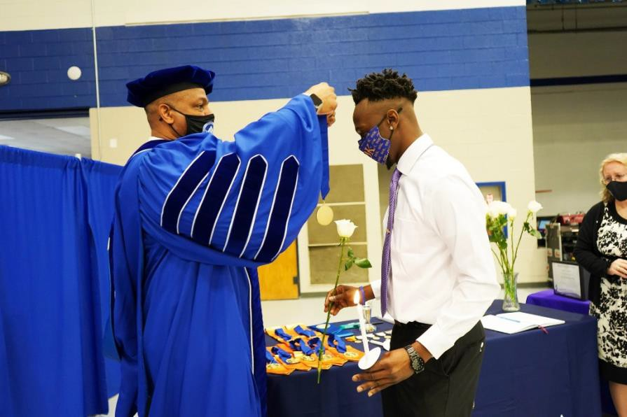

projecting for the future, and arriving at sound vocational decisions. Career planning and placement includes examination of education and training, job-seeking skills, and life-work planning. Portfolios are facilitated and available to be forwarded to prospective employers.

Students are provided an opportunity to evaluate their career choices through the services provided in the Career Center. In addition, students may elect to include Experiential Education in their academic programs. Experiential Education may include internships, part-time and summer work, and cooperative programs.
The Denmark Technical College Placement Office will assist students in preparing a resume, identifying methods of locating appropriate positions, and, in some cases, contacting prospective employers.
The Career Planning and Placement Office is located in Building 025.

Academic Forgiveness
Denmark Technical College will extend academic forgiveness to readmitted students with previously poor academic records who have not been in attendance for a minimum of seven years. This will allow students to have grades earned in previous academic terms excluded from the overall calculations of their cumulative grade point average. These students must petition the college for Academic Forgiveness. If a petition is

96

granted, all courses taken at Denmark Technical College, attempted and completed prior to the seven (7) year limitation, will be eliminated from computations and grade point averages. This includes courses that were completed with satisfactory grades. However, the courses will remain on the student’s transcript. A student may petition for Academic Forgiveness only once.
Procedures for pursuing Academic Forgiveness are as follows: 1. Submit a Re-admission Application. 2. Complete an Academic Forgiveness Form. 3. Submit a letter explaining the reason(s) \why Academic Forgiveness should be considered. Your letter should be addressed to
the Academic Appeals Committee.
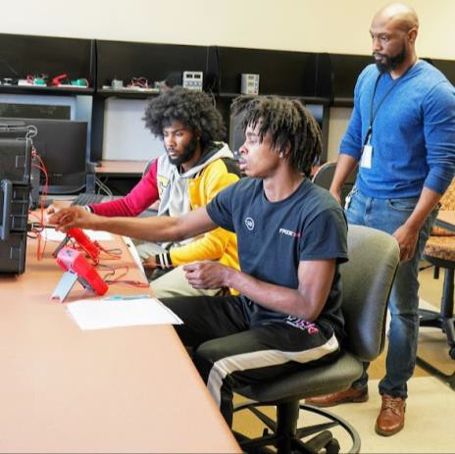

- The committee will determine if the petition for Academic Forgiveness is approved.
- The appeal should be submitted 20 days prior to the semester of enrollment. Once the appeal has been granted for Academic Forgiveness, the student must meet all program admission requirements at the time of enrollment to Denmark Technical College. A copy of the Academic Forgiveness Form will be maintained in the Office of Admissions and Records. This local policy does not override the State or Federal policies related to determination of scholarships or Financial Aid.

Academic Support Center
The mission of the Academic Support Center (ASC) is to provide quality, non-judging, effective academic support services that will enhance student success. The Center is also here to support both faculty instruction and student learning by providing academic assistance which reinforces
and supplements the College’s goals and objectives. Goals to accomplish include:
  - Hiring competent peer tutors to help students identify specific problems they are experiencing with their courses, establish procedures for addressing those problems and providing useful, immediate feedback concerning their progress.
  - Training peer tutors to develop competence in tutoring methodology and interpersonal skills that will demonstrate respect for the whole person, thus building self-respect and self-confidence in the students served leading to them becoming independent learners.
  - Working collaboratively with faculty to allocate tutors in creative and effective ways to meet both instructional demands of the classroom as well as the tutoring needs of students.
  - Offering services that can enhance a student's academic experience as well as remediate.
The Academic Support Center provides tutoring and mentoring support to all registered Denmark Technical College students. Through these services, students will be afforded the opportunity to become independent learners and strengthen their academic weaknesses. The center is located in building 025, Smith Hall and is equipped with a tutorial computer lab for on-line tutoring services. Students may apply for tutoring at any point in a semester. Services are free to currently enrolled DTC students.

Get ahead before you get behind: set yourself up for success with our help. Check out all of our free services designed to help you succeed academically.

Services Offered:
  - Peer Tutoring
  - Professional Tutoring
  - Success Workshop
  - Individual/Group Tutoring

  - Mentoring
  - On-line Tutoring (Smarthinking, PLATO Learning)
To apply for tutoring services, students should email, in writing, the course, date and time in which he or she would like to receive tutoring assistance. Tutors may be available for immediate assistance, or several days may be required to arrange a session. The tutoring schedule is subject to change due to tutor availability.

Hours of Operation
Monday - Wednesday: 8:00 a.m. to 6:00 p.m. Thursday 8:00 a.m. to 5:30 p.m.

Students with Disabilities
The Student Services Division provides counseling and support which helps students with disabilities pursue an academic program of their choice and participate fully in campus life. The counseling office and academic support can arrange counseling, special parking, priority registration and other services needed by students with disabilities. Students with disabilities are encouraged to contact the Dean of Student Services and Academic Support to discuss needs and concerns as they arise.

Service Animals
The South Carolina Technical College System is committed to providing equal access to employment and educational opportunities for persons with disabilities. In keeping with these commitments, service animals are permitted on college property for persons with disabilities in accordance with relevant state and federal laws and the requirements of this procedure.

- Purpose Service animals are allowed to accompany their handlers at all times and in all facilities and programs on campus, except in areas where specifically prohibited due to health, environmental or safety hazards (e.g. laboratories, mechanical rooms, machine shops, custodial closets, and areas where there is a danger to the animal.) The College may not permit service
animals when the animal poses a substantial and/or direct threat to health or safety or when the presence of the animal constitutes a fundamental alteration to the nature of the program or service. The College will make those determinations on a case-by-case basis in alignment with current state and federal laws.

- Definitions when used in this document, unless the content requires other meaning,

  - “Service Animal” means any dog individually trained to do work or perform tasks for the benefit of an individual with a disability, including a physical, sensory, psychiatric, intellectual, or other mental disability, and meets the definition of “service animal” under Title III of the Americans with Disabilities Act (“ADA”), regulations at 28 CFR 36.104. Within Title II of the ADA is a provision allowing miniature horses as services animals provided, they meet specific assessment factors outlined in 28 CFR 35.136(i)(2). The work or tasks performed by a service animal must be directly related to the individual’s disability.

  - “Handler” means the individual with a disability, as defined under federal and state law, who uses a service animal to perform a work or task directly related to the individual’s disability. A handler may also be a personal care attendant who handles the animal for a person with a disability.

  - “Emotional Support Animals” (ESA) means any animal providing emotional support, well- being, or comfort that eases one or more identified symptoms or effects of a documented disability. Emotional support animals may also be referred to as comfort or therapy animals. Emotional support animals are not individually trained to perform specific work or tasks. Pets (as defined below) are not considered ESA.

  - “Pet” means any animal kept for ordinary use and companionship that does not meet the definition of an ESA.

C. Vaccinations

Handler’s Responsibilities

  - Registering A Service Animal 1.) While registering a service animal is not mandatory, students who wish to bring a service animal to campus are encouraged to contact the Office for Students with Disabilities at their College, especially if academic accommodations are required.

  - Service Animal Control & Behavior Requirements 1.) Handlers are expected to maintain control of service animals. If a service animal exhibits unacceptable behavior, the handler may be required to employ appropriate training techniques to correct the situation. Failure to maintain control of the service animal always may be grounds for immediate removal of the service animal from campus.

    - Service animals can be controlled through the use of leashes, harnesses, or tethers unless those devices interfere with the service animals’ ability to perform tasks or unless the handler has a disability that prevents him/her from using such a device.

    - The service animal should always respond to voice or hand commands and be in full control of the handler.

    - To the extent possible, the service animal should be unobtrusive to other individuals and the learning, living, and working environment.

- To the extent possible, the handler should ensure that the service animal does not,

  - Display any behaviors or noises that are disruptive to others, unless part of the service being provided to handler.

  - Block an aisle or passageway to fire egress.
    - Service animals should be vaccinated in accordance with state and local laws

      - Colleges may require proof that a service animal has any vaccinations required by state or local laws that apply to all animals.

D. Waste Cleanup

1.) Cleaning up after the service animal is the sole responsibility of the handler. In the event the handler is not physically able to do so, he/she must hire someone to perform this task. The following are guidelines for animal waste cleanup:

- The handler is required to take the animal to an appropriate area on campus (if applicable) for relief.

- The handler should carry equipment sufficient to clean up the animal’s feces or urine whenever the animal is on campus.

- Properly dispose of waste and/or litter in appropriate containers.

E. Costs Associated with Service Animal

- Handlers are responsible for any costs, damage or injuries caused by their animals and must take appropriate precautions to prevent property damage or injury.

- Costs associated with any damage to the campus facilities or properties resulting from the animal’s behavior are the sole responsibility of their handlers.

- The cost of care, along with maintaining the well-being of the service animal, are always the sole responsibility of the handler.

- Any cost incurred for assistance with waste cleanup is the sole responsibility of the handler.

Student Rights

  - When it is not obvious what service an animal provides, only limited inquiries are allowed. Employees may ask two questions:

- is the service animal required because of a disability, and

- what work or task the service animal has been trained to perform. Employees cannot ask about the person’s disability, require medical documentation, require a special identification card or training documentation for the service animal, or ask that the service animal demonstrate its ability to perform the work or task.

  - Allergies and fear of service animals are not valid reasons for denying access or refusing service to people using service animals. Each request for service animal use should be considered individually recognizing that documented student academic accommodations take precedence in determining any adjustments to access.

  - People with disabilities who use service animals cannot be isolated from other students, treated less favorably than other students, or charged fees that are not charged to other students without animals.

  - A person with a disability cannot be asked to remove his service animal from the premises unless:

- the service animal is out of control and the handler does not take effective action to control it or

- the service animal is not housebroken. When an animal is removed pursuant to this procedure, the college will work with the handler to suggest reasonable alternative opportunities to participate
in college services, programs, or activities without the animal’s presence.

- Removal of Service Animals The following list identifies violations for which service animals may be subject to removal. The list is not all- inclusive, but it reflects the categories of inappropriate behavior and provides examples of prohibited behaviors.

  - Handlers will be asked to remove any animal if it is out of control and the handler does not take effective and immediate action to control it. If the out-of-control behavior happens repeatedly, the handler may be prohibited from bringing the animal into college facilities until the handler can demonstrate that significant steps have been taken to correct and control the behavior.

  - A handler may be directed to remove an animal that is not housebroken.

  - An animal that poses a direct threat to the health or safety of others that cannot be reduced or eliminated by reasonable modifications is not permitted on campus. A handler may be directed to remove an animal that the College determines to be a substantial and direct threat to the health and safety of individuals. This may occur as a result of a very ill animal, a substantial lack of cleanliness of the animal, or the presence of an animal in a sensitive area like a certain laboratory, health science facility, food service program, or mechanical or industrial area.

- Emotional Support Animals Emotional Support Animals that are not trained service animals are not allowed to accompany persons with disabilities on college campuses. Emotional support animals are not individually trained to perform specific work or tasks. Providing emotional support, well-being, or comfort does not constitute "work" or "tasks" for the purposes of the definition of "service animal." Therefore, an ESA is not a Service Animal under the ADA. Emotional support animals are permitted in

college residential facilities according to college policies and the Fair Housing Act. A person with an emotional support animal should follow existing college policies when bringing an emotional support animal to those facilities.

- Grievance Procedures
Any student who is not satisfied with a decision made concerning a purported service animal or emotional support animal may file a written complaint using the SC Technical College System’s Grievance procedures outlined in SCBTE 3-2-106.3.

Classification of Students
To advance from freshman to sophomore standing, a student must have earned a minimum of thirty (30) semester hours with a grade point average of at least 2.0.

Definition of Student Status
The following definitions are used to describe the student’s status based upon the number of hours pursued within a given semester:
- A full-time student is a student enrolled in an associate degree, diploma, or certificate program and registered for 12 or more semester hours.
- A three-fourth time student is a student enrolled in an associate degree, diploma, or certificate program and registered for 9 to 11 semester hours.
- A one-half time student is a student enrolled in an associate degree, diploma, or certificate program and registered for 6 to 8 semester hours.

Course Load
The minimum number of semester hours for a student at Denmark Technical College for matriculation as a bona fide full-time student is twelve (12) semester hours. Eighteen (18) semester hours is the maximum. However, additional credit hours may be approved by the Division Dean and the Vice President of Academic Affairs.

Changes in Program of Study
Students who wish to change their program of study should complete a “Request for Change of Program Form” for the new program after discussing the change with the faculty advisor before or during the pre-registration and/or registration process. Students cannot change a program of study after the drop/add period for the semester period.

The College may drop or change courses, hours, or credits in accordance with institutional capability and as demands change, or according to student interest, or community, or industrial needs.

Independent Study
Denmark Technical College policy provides that students who find themselves with unusual circumstances may be assigned to selected courses on a directed independent study basis so that progress toward successful program completion can be maintained if a course does not appear on the schedule and does not have a lab component State policy prohibits the use of independent study to satisfy requirements listed under the “Required Core Subject” section of any curriculum model.
Students who wish to enroll in independent study courses must get approval from the Division Dean and the Vice President of Academic Affairs.

Attendance Policy
Denmark Technical College expects students to attend 100% of their scheduled classes including lecture and/or laboratory meetings.

Unfortunate situations may arise which are beyond a students’ control, and to work with students as they deal with difficult situations, students who provide documentation that demonstrates an absence should be excused will be allowed to “make-up” the work missed. In all cases, students are still responsible for the material presented in class that was missed due to an excused absence. Because “making-up” work is such a challenge, students should make every effort to attend classes

as scheduled and deliver assigned work on time. Please read carefully the discussion below, regarding Excused Absences and Unexcused Absences.

Regardless of excused/unexcused status for absences, if a student misses more than 25% of their scheduled classes including lecture and/or laboratory meetings for a course, the student may not be able to receive credit for that course.

Due to the varied nature of programs with a lab/clinical component, more stringent attendance requirements may be set by the individual departments.

If a student leaves more than 15 minutes prior to class dismissal, he/she will be considered absent.

If a student must be absent, it is the student’s responsibility to notify the instructor within three business days of the absence. It is also the student’s responsibility to make up all work missed as a result of an excused absence.
However, a student who is absent from a final examination may receive permission from the instructor to take such an examination at a later date.

There is a distinction between excused and unexcused absences.

Excused Absences
Excused absences are given when students who have legitimate documentation to verify an absence. Such absences may include, but are not limited to, death in the family, doctor’s statements, jury duty, and approved student activities.
Excused absences are given by the academic counselors after the appropriate documentation is presented. Students with excused absences will be given the opportunity to make up any work missed as a result of the absence.

Unexcused Absences
Unexcused absences are given when students do
not meet the criteria for excused absences. When an absence is regarded as unexcused, the instructor has the option of deciding whether to allow a student to make up any work missed during the absence.

Tardiness
- Students are expected to attend class on time.
- If a student is more than 15 minutes late for class, the student will be considered tardy, and a “T” will be entered into the student’s attendance record for the course.
Three tardiness will be considered one absence. The specific requirements of a course will be published in the course syllabus and distributed to all students at the beginning of the term. If a student exceeds the 25 % limit, the instructor will apply one of the following:

- If the student’s last day of attendance is on or before the last day of the midterm week, the student is withdrawn, and a grade of “W” is assigned.

- If the student’s last date of attendance is after the last day of the midterm week the student is withdrawn and a grade “WF” or “WP” is assigned at the discretion of the instructor.

- If the student has communicated regularly with the faculty member, exceptions to the withdrawal policy may be made at the discretion of the instructor.

Veterans Affairs Attendance
Veterans are responsible for maintaining satisfactory attendance as outlined in the College’s policy. If a veteran fails to attend at least 75 % of the scheduled meetings of a class, his or her training will be reduced accordingly. (No distinction is made between excused and unexcused by Veterans Regional Office.) Veterans who are students receiving VA educational assistance are required to maintain satisfactory progress according to academic standards of Denmark Technical College as approved by the

state approving agency.

Student Reinstatement
If a student is dropped from a course, the following will apply:
1. A student can be reinstated to each INDIVIDUAL course only ONE time unless there are extremely unusual circumstances (see number 2 below).
      - Any request (s) for subsequent reinstatement due to unusual circumstances or a reinstatement after the term or course withdrawal date MUST be approved in writing by the academic dean.

Grade Reporting
Grades reports are available to students after midterm and at the end of each semester.

Grading System
Denmark Technical College shall use a grading and grade point system in which the calculation of the student’s grade point average (GPA) is based on a 0-to-4-point numerical scale. The grades and numerical values used in the calculation of the GPA are as follows:
A = Excellent… Earns 4.0 Quality Points
B = Above Average. .Earns 3.0 Quality Points
C = Average… Earns 2.0 Quality Points
D = Below Average…Earns 1.0 Quality Point F = Failure…Earns 0.0 Quality Points
WF = Withdrawn Failing…No Credits or Grade Points

Other grade and course symbols authorized for use are as follows:
AU = Audit…No Credit or Grade Points
I = Incomplete…No Credits or Grade Points W = Withdrawn…No Credits or Grade Points WP = Withdrawn Passing…No Credits or Grade Points
SC = Satisfactory Completion…Earns Institutional Credits, No Grade Points
S = Satisfactory Progress... No Credits, No Grade Points
U = Unsatisfactory Progress…No Credits or Grade Points
E = Exempt…Earns credits, No Grade Points TR = Transfer...Earns credits, No Grade Points CF = Carry Forward...Earns no credit hours, No Grade Points

Grades of W, S, SC, U, CF, AU, TR, and WP and the corresponding credit hours are not included in calculating the GPA. Credits transferred to Denmark Technical College are only used to determine eligibility to graduate. They are not used to calculate the GPA. A cumulative GPA of
2.00 is required for graduation. I and CF grades are temporary and must be replaced by an academic grade. While the I and CF grades and the corresponding credit hours are on the student’s permanent record, they are not included in calculating the student’s GPA. A student receiving an I grade must complete the coursework necessary to earn an academic grade by midterm of the following semester or the grade will automatically turn into an F.

A student receiving a CF grade must complete the work necessary to earn a grade by the end of the following semester or the grade will automatically turn into an F.

Credits earned in courses numbered less than 100 shall not be creditable towards a certificate, diploma or degree and shall not generate grade points for use in GPA calculations.
The highest grade earned in a course is to be computed in a student’s grade point average. However, the student’s complete academic records shall be reflected on the transcript.

Students may appeal a grade by acting in accordance with the College’s grade appeal procedure.

Grade Point Average
A grade point average will be maintained for each student. To determine GPA, numerical values are

assigned to final grades as shown in the following example:

Total Quality Points (divided by) Credits Hours Attempted = GPA

For an A, 4 quality points are awarded for each semester hour of credit attempted; for a B, 3 quality points; for a C, 2 quality points; for a D, 1 quality point; and for an F, FA or WF no quality points. The grade point average is calculated by multiplying Credit Hours Attempted by the Quality Points Earned for each course grade, summing the Total Quality Points per course, and dividing the sum of the total number of Credit Hours Attempted.

Standards of Academic Progress
To remain in good standing, students pursuing a degree, diploma or certificate who are enrolled in curriculum courses must maintain a minimum credit hour grade point average (GPA) according to the following scale:

Credit Hours Earned
Credit Hours Earned Minimum GPA 0-35 1.50
36-50 1.80
51-above 2.00

Transitional Courses
Denmark Technical College students enrolled in Transitional Studies courses are given SC grades for satisfactory completion, S grades for satisfactory progress, and U grades for unsatisfactory progress. These grades are not included in the grade point average calculations. According to Title IV regulations, students who do not complete the transitional courses after 30 hours are no longer eligible for financial aid.
Contact the Financial Aid Office for further clarification.

Academic Probation and Suspension
Students who fail to maintain a minimum required GPA as specified will be placed on probation
during the next semester in which they enroll in the College. Students must complete a “Program Course Plan” form with their academic advisor before registering for the next semester. Students must follow the completed Program Course Plan which outlines the courses to be taken. Students must register for and attend COL 101. Students who withdraw from or do not attend COL 101 will be administratively withdrawn from the College. Students who do not achieve the required GPA for good standing will be suspended; however, the student can petition the Vice President of Academic Affairs for reinstatement. If the petition is denied, the suspension may be appealed to the President of the College. The President’s decision is final.
A student on probation and suspension will receive a letter from the Vice President of Academic Affairs explaining the student’s status.

Related Policies
- Students on probation shall not take more than 12 credit hours.
- Students on probation shall not be a candidate for or serve in any school-wide elective offices or be appointed to any administrative or social committees.
- A student who has been suspended academically from Denmark Technical College must apply for re-admission.
- Probation or suspension indicators will appear each semester on the student’s grade report and transcript, when applicable.
- Academic status within a given semester will be changed only if there is a grade change or removal of an I.

Advanced Standing
Denmark Technical College has established policies and procedures which may allow students to enter certain curriculum programs with advanced standing. In many cases, credit may be awarded through transfer or credit from other
post-secondary institutions, challenge examinations, the College Level Examination Program, military experience or credit for non-

academic achievement, thus giving the student advanced standing. In addition, many of the College’s programs have developed articulation agreements with vocational/technical education centers in the College’s service area which also allow for advanced standing. Students interested in advanced standing should furnish appropriate documentation to the Admissions Office. After this information has been reviewed by the appropriate academic department, students will be notified regarding academic credits awarded.

Tri-County Educational Business Alliance
Tri-County Educational Business Alliance, Denmark Technical College, USC-Salkehatchie and area businesses, along with the school districts in Allendale, Bamberg, and Barnwell Counties have formed the Tri-County Educational Business Alliance.

The Alliance programs build bridges between secondary education and post-secondary education to prepare students for careers in technology – teaching student’s skills that will be in demand today and tomorrow. With Alliance, students can take applied courses in mathematics, science, and communications, as well as courses in specific technical fields. Upon graduation from high school, students will be prepared to either enter the workplace directly or continue their education at a technical college.
Alliance articulation agreements provide an option through which high school students may receive advanced standing in college vocational and technical programs.
For more information about the program, contact the Office of Academic Affairs at (803) 793-5108.

Credit by Examination
A student may earn up to one-third of the semester hour credits required for an associate degree and enter certain curriculum programs with advanced standing through credit-by-examination options. Total credit awarded may come from standardized tests, such as Advanced Placement
(AP) or a combination of AP, College-Level Examination Program (CLEP) and/or the Proficiency Examination Program (PEP).
Information about these tests is available at the Testing Center.

CLEP
The College-Level Examination Program (CLEP) is a nationally standardized series of tests designed primarily for students who have acquired college- level knowledge outside the classroom. Students may receive college credit for CLEP equivalent courses by making an acceptable
score on the CLEP test. A student is normally awarded between two and four semester credit hours for passing a CLEP subject examination. Credit will be awarded when scores are officially recorded.

Credits will be given for the following subjects: Calculus with elementary functions, college algebra, college composition, computers and data processing, educational psychology, English Composition, general biology, general chemistry, general psychology, human growth and development, introduction to business law, introduction micro/macroeconomics, introductory marketing, introductory sociology, money and banking.

Proficiency Examination Program
The Proficiency Examination Program (PEP) is an alternative to obtaining college credit through traditional classroom course work. Students may earn credit for both formal and informal education with PEP. Students demonstrating sufficient knowledge of material covered in a course may elect to earn credit or exempt a course by examination. The student must complete the examination with a passing score of 80 percent to earn credits. PEP examinations will not be given for subject areas when CLEP examinations are available.

Institutional Credit by Examination

Students regularly enrolled or formerly enrolled in the College may obtain credit by examination for courses in which they have had no class attendance or semester standing. However, permission must be obtained from the Dean of the division involved. A grade of not less than C on the examination is necessary to receive credit for the course. Examinations are not permitted in courses in which students have previously enrolled either regularly or as an auditor. Before the examination, applicants must pay the Business Office a $15 examination fee, and if required, a fee of $101 per semester hour. * These fees are non-refundable. The Business Office issues a receipt which must be shown to the Dean of the division conducting the examinations. The Division Dean reports the results of the examination to the Office of Admissions and Records. Credits earned under this regulation are recorded as hours earned.

*Tuition rate subject to change.

Military Service School Credit
Following enrollment, a student may obtain credit for experience in the Armed Services. In order to receive credit, the student must have a DD295 and Certificates of Completion. Students who qualify should contact the Office of Admissions and Records.

Following a review by the Admissions Office, using A Guide to the Evaluation of Educational Experiences in the Armed Services, a recommendation for credit is made to the Dean of the student’s major area. The final decision as to the credit awarded is made by the Dean of the division in which the student is enrolled.

OTHER ACADEMIC REGULATIONS

Post-Secondary Non-Academic Achievement for College Credit
To be eligible to receive post-secondary non- academic achievement for college credit, the student should be least 25 years old and have been employed for five years, including at least two years of full-time work experience related to the
specific course content requested for credit. The student may be eligible to receive up to one-third of their course work for an associate degree, diploma or certificate program based on Denmark Technical College’s policy concerning the awarding of credit for post-secondary non- academic achievement. Contact the Office of the Vice President of Academic Affairs for further information.

Repetition of Course Work
It is the policy of the College that permanent records of students show the actual course work completed. Under no circumstances can a grade be deleted from a student’s record. In instances where a course is repeated, only the quality points and credit hours associated with the higher grade will be counted in the calculation of the student’s GPA. In the event of identical grades, the quality points and credits of the latest repetition will be included in the calculation of the student’s GPA.

Program Completion
Students must complete program curriculum requirements as stated in the Catalog in effect at the time of their enrollment at Denmark Technical College. Students who discontinue their enrollment for a period of one term must complete the program curriculum requirements in the Catalog in effect at the time of their re-entry.

Change of Program
Students who elect to change from one program of study to another must contact their current Division Dean. The student will be referred to the new academic advisor who will determine the student’s eligibility for the new program and will complete a Program Change Form. The completed Program Change Form should be returned to the office of Admissions and Records.

Course Substitution

All substitutions of courses required for graduation must be approved by the faculty,
Divisional Dean, and Vice President
of Academic Affairs. Students must still meet the minimum number of hours required for graduation.

Auditing a Course
A student who desires to attend classes, but does not wish to receive grades or credits, may register to audit the class. The instructor may decide whether the student auditing the course may participate in class discussions, assignments, or examinations. An auditor is expected to register and pay appropriate fees. After the Drop/Add period, a student enrolled in a course for audit cannot change to credit and a student enrolled in a course for credit cannot change to audit.

An audited course may be repeated for credit. To receive credit for previously audited courses, the student must register, pay fees, and meet all requirements of the course. Audited courses appear on the transcript.

Exemption Procedures
By assessment, students may demonstrate knowledge equivalent to an approved curriculum course due to “life experiences” or other relevant experiences. Any student at the College desiring to exempt a course, should:
- Meet with the academic advisor.
- The academic advisor completes the Course Exemption Request Form and submits it to the appropriate Divisional Dean for approval.
- The student submits the approved form along with the credit hour cost and a $15 non-refundable fee for each course to the Business Office.
- The instructor will return the form to the Office of Admissions and Records with a grade attached after assessment.
- If the exemption is approved, the student receives credit for the course, with a grade of E recorded on the academic transcript.
- Exemption of a course may be challenged only once.
- A student may earn a grade of E for a maximum of twenty-five percent (25%) of the credits required by a program.

Statute of Limitation for All Courses
Any required course that has a completion date of over six years must be repeated before the degree/diploma/certificate will be conferred.
However, courses with a completion date of over six years may be approved by the Academic Appeals Committee and the Vice President of Academic Affairs.

Placement Test (COMPASS)
The placement test scores are valid for three years after the test date.

Length of Programs
Denmark Technical College operates on a 16- week academic semester format. The projected time for completing a program of study is shown in the curriculum display. If a student enrolls on a part-time basis, he or she may expect to take a longer time to complete the program of study.

ACADEMIC RECORDS

Official Student Records
The permanent academic record of each student contains entries of all courses taken for credit and/or non-credit and is housed in the Office of Admissions and Records.
The permanent academic record of each student contains the following:
  - Student’s Name
  - Social Security Number
  - Date of Birth
  - Permanent home address
  - Transcript(s)
  - Course entries, course number, course title, grade, credit hours, quality points
  - Admitted program
  - Current and cumulative statistics
  - Transcript key
  - Academic credit
  - Transfer credit

  - Official signature (on official transcript)
  - Confidentiality Statement
  - Name and address of institution

Change of Name and Address
It is the obligation of every student to notify the Office of Admissions and Records of any change in name and/or address. Failure to do so can cause serious delays in the handling of student records and in the notification in case of emergencies.
When a change of name is requested, the student must present proof to justify the change.

Privacy of Student Records
Denmark Technical College safeguards the privacy of all student records. The confidentiality of all records is respected in accordance with the 1974 Family Educational Rights and Privacy Act (FERPA), which, as amended, prescribes the conditions under which information pertaining to students can be released. Therefore, no information, other than directory information, may be released to the public without prior consent of the student. Only members of the College’s administration, faculty, or counseling staff, who have legitimate educational, administrative, or statistical purposes may have access to student records.

Transcript Fees
A transcript is released only when a student makes a written request to the Office of Admissions and Records.
The first copy requested by the student is free. Additional copies of transcripts are $3.00 each. Transcript requests may be made by mail.
Telephone requests will not be accepted. In all cases, financial obligations to the College must be paid in full before a transcript or any other information can be released.
High school transcripts and any other college transcripts must be maintained in the student’s file and cannot be released by student request. The student must request copies from the high school or institution where the credits were earned.

Honors and Presentations Honor Students
A student who carries a course load of 12 credit hours or more and maintains a semester GPA of
3.0 or above will be placed on the Dean’s List of Honor Students. A student who carries a course load of 12 credit hours or more and maintains a semester GPA of 4.0 or above will be placed on the President’s List of Honor Students. Students with an incomplete grade or a CF grade are not eligible for the Dean’s or President’s List.

Academic Honors for Part-Time Students
A part-time student with a cumulative GPA of 3.5 or greater is eligible for the Honors List if he or she:
- is enrolled in a major (certificate, diploma or associate degree program), and
- has completed at least 18 semester credit hours.

Academic Awards
Senior Honor Awards are given to the top three graduating seniors with the highest GPAs in the Associate, Diploma, and Certificate programs.

Achievement Awards are presented to graduating seniors in each division who have a GPA of 3.5 or above in their program area.

Achievement Awards are presented to other students in each division who maintain a 3.0 or above GPA in their program areas.

Special Academic Presentations
The Presidential Achievement Award is given by the President of the College and is presented to a graduating senior who has demonstrated exemplary scholarship, leadership, congeniality, citizenship and served as an exemplary ambassador for the College.

Phi Theta Kappa International Honor Society Phi Theta Kappa is a scholastic honor organization that consists of student members who have a grade

point average of 3.5 or better and who are enrolled as full-time students with 12 credit hours or above.

Graduation Requirements Residency Requirements
To complete the requirements for graduation, students must earn at least 25 percent of credit hours through courses offered by Denmark Technical College.

General Requirements
- Satisfactory completion of the required number of general education courses for the degree, diploma, or certificate.
- Satisfactory completion of the required number and type of courses required for the major.
- Satisfactory completion of the required number of hours specified by the curriculum in which the student is specializing.
- Payment of all required fees, including the graduation fee, licensing application and examination fees (Cosmetology, Barbering, and Nursing students), and any other financial obligations due the College.
- Completion and filing of an official application for a degree, diploma or certificate with the Office of Admissions and Records.
- Completion of all course requirements with a minimum cumulative GPA of 2.0 and a minimum grade of C in each course specific to the discipline.
- Completion of Denmark Technical College’s residency requirements (students must successfully earn at least 25 percent of credit hours through courses offered at the College).
- All students have the option of satisfying requirements for graduation as found in the College Catalog in force on the date of the first entrance to Denmark Technical College or the catalog that is in effect on the date of graduation.
- A minimum of 15 credit hours must be taken in general education courses for the Associate Degree.
- A minimum of 9 credit hours must be taken in general education courses for the Diploma.
- Completion of a minimum of 1,500 clock hours of clinical experience is required for Barbering and Cosmetology students.
- Additional requirements for an associate degree, diploma, and certificate programs are noted in the specific curriculum displays.

Transfer and Articulation Transfer Credit
Denmark Technical College may accept and give credit for work completed at other accredited colleges and universities.

Applicants seeking such credits should complete the regular application form and request an official transcript of work from all colleges previously attended. A “Confidentiality Statement” form from each college attended must also be completed. If fewer than 15 hours have been earned on the collegiate level, a complete high school transcript must be submitted. The rules regulating the transfer of credit will be at the discretion of the Vice President for Academic Affairs and the appropriate Divisional Dean using the following guidelines:
- Courses being transferred must cover the competencies of courses being offered by Denmark Technical College.
- Courses being transferred must have a grade of C or better.
- Transfer credit will be included in the computation of the student’s GPA.
- Any required course that has a completion date of over six (6) years is not eligible for transfer.

Applicants may apply for advanced standing by being awarded transfer credit when they have earned academic credit form another accredited post-secondary educational institution. New students applying to the college in a transfer status will provide official transcripts from each accredited post-secondary institution for which they are seeking transfer credit. Course work is evaluated individually based on its content and credit hours received. For transfer credit to be

awarded, a comparable Denmark Technical College course must exist within the student’s curriculum with the course content and credit hours being equivalent as described in the catalog of approved courses. When advanced standing has been awarded for transfer credit, a grade of TR will be posted on the student’s approved curriculum profile and recorded on the student’s academic transcript. The submission of fraudulent records or information constitutes ground for denial of admission or dismissal from the College.

Other Transfer Options
The institution also accepts Advanced Placement (AP), College Level Examination Program (CLEP), and Technical Advanced Placement (TAP) credits in appropriate programs.

Articulation Agreements
Denmark Technical College complies with the Statewide Articulation Agreement. The College maintains articulation agreements for specific majors with the following state institutions:

Benedict College Columbia, South Carolina

Central Wesleyan College Central, South Carolina

Claflin University Orangeburg, South Carolina

Clemson University Clemson, South Carolina

Clinton College
Rock Hill, South Carolina

Coker College
Hartsville, South Carolina

College of Charleston Charleston, South Carolina

Erskine College
Due West, South Carolina

Francis Marion
Florence, South Carolina

Lander University Greenwood, South Carolina

Limestone College Gaffney, South Carolina

Medical University of South Carolina College of Health Professions Charleston, South Carolina

Morris College Sumter, South Carolina

South Carolina State University
Orangeburg, South Carolina

The Citadel, The Military College of South Carolina
Charleston, South Carolina

Voorhees University
Denmark, South Carolina

Although the College cannot guarantee the transferability of its courses, articulation agreements are generally accurate guidelines regarding the acceptability of Denmark Technical College’s courses by the participating institutions.

Post-Secondary Non-Academic Achievement Denmark Technical College offers potential mature students, with full-time jobs and demanding schedules, an opportunity to earn an associate degree, diploma, or certificate through credit for work or public service by taking courses at Denmark Technical College, and through other approved testing options.

Any person who is at least 25 years old and has not been enrolled in a higher education institution for the past five years or is resuming his
110 education after a one-year break, must have a minimum of five years of acquired work or public
service

experience in order to be eligible for credit for Non-Academic Achievement.

A potential student may be awarded a maximum of one-third of the credits for program completion. Potential students are not exempted from the College’s admissions requirements or other academic regulations.

State Transfer Policies and Procedures Background Section 10-C of the South Carolina School-to-Work Transition Act (1994) stipulates that the Council of College and University Presidents and the State Board for Technical and Comprehensive Education, operating through the Commission on Higher Education, will develop better articulation of associate and baccalaureate degree programs. To comply with this requirement, the Commission upon the advice of the Council of Presidents established a Transfer Articulation Policy Committee composed of four-year institutions’ Vice Presidents for Academic Affairs and the Associate Director of Instruction of the State Board for Technical and Comprehensive Education. The principal outcomes derived from the work of that committee and accepted by the Commission on Higher Education on July 6, 1995, were:

- An expanded list of 86 courses which will transfer to four-year public institutions of South Carolina from the two-year public institutions.

- A statewide policy document on good practices in transfer to be followed by public institutions of higher education in the State of South Carolina, which was accepted in principle by the Advisory Committee on Academic Programs and the Commission.

- Six task forces on statewide transfer agreements, each based in a discipline or broad area of the baccalaureate curriculum. In 1995, the General Assembly passed ACT 137, which stipulated further that the South Carolina Commission on Higher Education “notwithstanding any other provision of law to the contrary, will have the following

Transfer Officer
The College Transfer Officer is the Vice President for Academic Affairs and Student Services, who can be contacted at Denmark Technical College, 1126 Solomon Blatt Blvd. Post Office Box 327, Denmark, SC 29042; phone (803) 793-5109.

additional duties and functions with regard to the various public institutions of higher education.” These duties and responsibilities include the Commission’s responsibility “to establish procedures for the transferability of courses at the undergraduate level between two-year and four-year institutions or schools.” This same provision is repeated in the legislation developed from the Report of the Joint Legislative Study Committee, which was formed by the General Assembly and signed by the Governor as Act 359 of 1996.

Act 137 directs the Commission to adopt procedures for the transfer of courses from all two-year public to all four-year public institutions of higher education in South Carolina. Proposed procedures are listed below. Unless otherwise stated, these procedures became effective immediately upon approval by the Commission and were to be fully implemented, unless otherwise stated, by September 1, 1997.
Statewide Articulation of 86 Courses

- The Statewide Articulation Agreement of 86 courses already approved by the South Carolina Commission on Higher Education for transfer from two to four-year public institutions will be applicable to all public institutions, including two-year institutions and institutions within the same system. In instances where an institution does not have synonymous courses with those on this list, it will identify comparable courses or course categories for acceptance of general education courses on the statewide list.
* As of 12/2002

Admissions Criteria, Course Grades, GPA’s, Validation

- All four-year public institutions will issue annually in August a transfer guide covering at least the following items:

  - The definition of a transfer student and requirements for admission both to the institution and, if more selective, requirements for admission to particular programs.

  - Limitations placed by the institution or its programs for acceptance of standardized examinations (e.g., SAT, ACT) taken more than a given time ago, for academic coursework taken elsewhere, for coursework repeated due to failure, for coursework taken at another institution while the student is academically suspended at his or her home institution, and so forth.

  - Institutional and, if more selective, programmatic maximums of course credits allowable in transfer.

  - Institutional procedures used to calculate student applicants’ GPAs for transfer admission. Such procedures will describe how nonstandard grades (withdrawal, withdrawal failing, repeated course, etc.) are evaluated; and they will also describe whether all course work taken prior to transfer or just coursework deemed appropriate to the student’s intended four-year program of study is calculated for purposes of admission to the institution and/or programmatic major.

  - Lists of all courses accepted from each technical college (including the 86 courses in the Statewide Articulation
Agreement) and the course equivalencies (including the “free elective” category) found at the home institution for the courses accepted.
  - Lists of all articulation agreements with any public South Carolina two-year or other institution of higher education, together
with information about how interested parties can access these agreements.

  - Lists of the institution’s Transfer Officer
(s) personnel together with telephone and FAX numbers, office address, and e-mail address.

  - Institutional policies related to “academic bankruptcy” (i.e., removing an entire transcript or parts thereof from a failed or underachieving record after a period of years has passed) so that the re-entry into the four- year institution with course credit earned in the interim elsewhere is done without regard to the student’s earlier record.

  - “Residency requirements” for the minimum
number of hours required to be earned at the institution for the degree.

- Coursework (individual courses, transfer blocks, statewide agreements) covered within these procedures will be transferable if the student has completed coursework with a “C” grade (2.0 on a 4.0 scale) or above, but transfer of grades does not relieve the student of the obligation to meet any
G.P.A. requirements or other admissions requirements of the institution or program to which application has been made.

- Any four-year institution which has institutional
or programmatic admissions requirements for transfer students with cumulative grade point averages (GPAs) higher than 2.0 on a 4.0 scale will apply such entrance requirements equally to transfer students from regionally accredited South Carolina public institutions regardless of whether students are transferring from a four-year or two- year institution.

- Any multi-campus institution or system will certify by letter to the Commission that all

coursework at all of its campuses applicable to a particular degree program of study is fully acceptable in transfer to meet degree requirements in the same degree program at any other of its campuses.

- Any coursework (individual courses, transfer blocks statewide agreements) covered within these procedures will be transferable to any public institution without any additional fee and without any further encumbrance such as a “validation examination,” “placement examination/instrument,” verification instrument,” or any other stricture, notwithstanding any institutional or system policy, procedure, or regulation to the contrary.
Transfer Block, Statewide Agreement, Completion of the AA/AS Degree

- The following Transfer Blocks/Statewide Agreements taken at any two-year public institution in South Carolina will be accepted in their totality toward meeting baccalaureate degree requirements at all four-year public institutions in relevant four-year degree programs as follows:

- Arts, Humanities, and Social Sciences: Established curriculum block of 46-48 hours

- Business Administration: Established curriculum block of 46-51 semester hours

- Engineering: Established curriculum block of 33 semester hours

- Science and Mathematics: Established curriculum block of 51-53 semester hours.

- Teacher Education: Established curriculum block of 38-39 semester hours for Early Childhood, Elementary, and Special Education students only. Secondary education majors and students seeking certification who are not majoring in teacher education should consult the Arts,
Humanities, and Social Sciences or the Math and Science transfer blocks, as relevant, to assure transferability of coursework.

- Nursing: By statewide agreement, at least 60 semester hours will be accepted by any public four-year institution toward the baccalaureate completion program (BSN) from graduates of any South Carolina public associate degree program in nursing (AND), provided that the program is accredited by the National League of Nursing and that the graduate has successfully passed the National Licensure Examination (NCLEX) and is currently licensed as a Registered Nurse.

- Any “unique” academic program not specifically or by extension covered by one of the statewide transfer blocks/agreements listed in #4 above must either create its own transfer block of 35 or more credit hours with the approval of CHE staff or will adopt either the Arts/Social Science/Humanities or the Science/Mathematics block. The institution at which such program is located will inform the staff of the CHE and every institutional president and vice president for academic affairs about this decision.
- Any student who has completed either an Associate of Arts or Associate of Science degree program at any public two-year South Carolina institution which contains within it the total coursework found in either the Arts/Social Sciences/Humanities Transfer Block or the Math/Science Transfer Block will automatically be entitled to junior-level status or its equivalent at whatever public senior institution to which the student might have been admitted. (Note: As agreed by the Committee on Academic Affairs, junior status applies only to campus activities such as priority order for registration for courses, residence hall assignments, parking, athletic event tickets, etc. and not in calculating academic degree credits.)

Related Reports and Statewide Documents

- All applicable recommendations found in the Commission’s report to the General Assembly on
the School-to-Work Act (approved by the Commission and transmitted to the General Assembly on July 6, 1995) is hereby incorporated into the procedures for transfer of coursework among two and four-year institutions.

- The policy paper entitled State Policy on Transfer and Articulation, as amended to reflect changes in the numbers of transfer blocks and other Commission action since July 6, 1995, is hereby adopted as the statewide policy for institutional good practice in the sending and receiving of all course credits to be transferred (Contact the Division of Academic Affairs for copies of this report.)

Assurance of Quality

- All claims from any public two- or four- year institution challenging the effective preparation of any other public institution’s coursework for transfer purposes will be evaluated and appropriate measures will be taken to reassure that the quality of the coursework has been reviewed and approved on a timely basis by sending all receiving institutions alike. This process of formal review will occur every four years through the staff of the Commission on Higher Education, beginning with the approval of these procedures.

Statewide Publication and Distribution of Information on Transfer

The staff of the Commission on Higher Education will print and distribute copies of these procedures upon their acceptance by the Commission. The staff will also place this document and the Appendices on the Commission’s Home Page on the Internet under the title “Transfer Policies.”
- By September 1 of each year, all public four-year institutions will place the following materials on their internet websites:

  - A copy of this entire document.

  - A copy of the institution’s transfer guide.

- By September 1 of each year, the State Board for Technical and Comprehensive Education will place the following materials on its internet website:

  - A copy of their entire document.

  - Provide to the Commission staff in a format suitable for placing on the Commission’s website a list of all articulation agreements that each of the sixteen technical colleges has with public and other four-year institutions of higher education, together with information about how interested parties can access those agreements.

- Each two-year and four-year public institutional catalog will contain a section entitled “Transfer: State Policies and Procedures.” Such a section at a minimum will:

  - Publish these procedures in their entirety (except Appendices).

  - Designate a Chief Transfer Officer at the institution who will:

—provide information and other appropriate support for students considering transfer and recent
transfers

—serve as a clearinghouse for information on Issues of transfer in the State of South
Carolina

—provide definitive institutional rulings on transfer questions for the institution’s students under
these procedures

—work closely with feeder institutions to assure ease in transfer for their students

  - Designate other programmatic Transfer Officer (s) as the size of the institution and the variety of its programs warrant.

- Refer interested parties to the institution Transfer Guide (if applicable).

- Refer interested parties to institutional and Commission on Higher Education’s websites for further information regarding transfer.

In recognition of its widespread acceptance and use in the United States, SPEEDE/EXPRESS should be adopted by all public institutions and systems as the standard for electronic transmission of all student transfer data.

- In conjunction with the colleges and universities, develop and implement a statewide Transfer Equivalency Database at the earliest opportunity. (As an electronic counseling guide, this computerized, online instrument will allow students and advisors to access all degree requirements for every major at every public four-year institution in South Carolina. Also, the Database will allow students to obtain a better understanding of institutional programs and program requirements and select their transfer courses accordingly, especially when
the student knows the institution and the major to which he or she is transferring.)

Development of Common Course System

- Adopt a common statewide course numbering system for common freshman and sophomore courses of the technical colleges, two-year regional campuses of the University of South Carolina, and the senior institutions.

- Adopt common course titles and descriptions for common freshman and sophomore courses of the technical colleges, two-year regional campuses of the University of South Carolina, and senior institutions. The Commission will convene statewide disciplinary groups to engage in formal dialogue for these purposes.

(A common course numbering system and common course titles and descriptions for lower-division coursework at all public institutions in the state can help reduce confusion among students about the equivalency of their two-year coursework with lower-division coursework at the four-year level. To
this end, a common system leaves no doubt about the comparability of content, credit, and purpose among the lower-division courses at all public colleges and universities in South Carolina. It would also help eliminate institutional disagreement over the transferability of much lower-division course work, thus clearing a path for easier movement between the technical colleges and senior institutions.)

Statewide Articulation Agreement
Listed below are the Statewide Articulation Agreements of Technical Colleges courses that are transferable to Public Senior Institutions.

General Information
Continuing Education Admission
Requirements for admission to the various courses in Continuing Education (Personal Interest,

Occupational Advancement and Community Service) depend on the nature of the course involved. Generally, the student enrolls in the selected course by completing general information and paying fees. Information on these courses may be obtained by contacting the office of Continuing Education at the College. For further information check the Continuing Education section of this catalog.

Registration
Students may register at the Office of Continuing Education at the college. The office of Continuing Education can be reached at 803.793.5153.

Fees
The registration fee for each course depends on the nature of the course. All cashier’s checks or money orders should be made payable to Denmark Technical College.

Books and Supplies
The cost of textbooks for most classes is included in the registration fee. Uniforms needed are not included in the registration fee.

Continuing Education Program
The Continuing Education department is committed to the instructional development and support of the institution. The Continuing Education program strives to meet the continuing community needs and interests. It endeavors to enhance the educational and economic advancement, personal fulfillment or enrichment, and general social effectiveness of the society it serves.

The Continuing Education program consists of any courses, or organized groupings of courses, structured to meet specific occupational or professional needs offered for a specified number of class meetings for which no institutional credit toward a diploma or degree is awarded. Courses offered in this program are specially planned, designed, and conducted for the purpose of:

- Maintaining and/or improving professional competence.
- Advancing vocational/occupational growth; and educational activities which do not meet standards for CEU awards.

Programs in Continuing Education Occupational Upgrading
Continuing Education courses, seminars or workshops are offered to the public, for professional, technical, occupational, and vocational skills development or improvement that meet the Occupational Upgrading criteria and/or requirements for CEU classification.

Healthcare
The Continuing Education department offers healthcare programs that build upon basic nurse aid skills and trains students to perform nursing assistant duties, obtain vital signs, collect and prepare specimens, and perform EKGs, phlebotomy, and other laboratory procedures. The
U.S. health care system is changing and growing at a rapid pace, so if you’re ready to start an exciting career in an industry with many opportunities for advancement, our health services programs can help. According to the U.S. Bureau of Labor Statistics*, “The healthcare and social assistance industry is projected to create about 28 percent of all new jobs created in the U.S. economy by 2020. This industry—which includes public and private hospitals, nursing and residential care facilities, and individual and family services—is expected to grow by 33 percent, or 5.7 million new jobs.”

Industrial Training
This is a customized program of instruction requested by an industry, trade or professional organization. Training is conducted for a specific group of employees using unique instructional objectives, at the request of a business, industrial or organizational representative. Programs included in this category must meet the requirements of Occupational Upgrading.

Ready SC
Ready SC is operated under the management of the Economic Development Division of the State Technical and Comprehensive Education System on a statewide basis in cooperation with the

college. These services ensure industry of trained employees necessary for plant start-up. Special training is also available to existing industries which are expanding plant operations in the College’s service area. Each program is individually designed to meet the manpower needs of the company. Training is coordinated with the South Carolina Unemployment Security Commission.

Apprenticeship Carolina™
Apprenticeship Carolina™ (AC), a division of the South Carolina Technical College System, leads South Carolina in registered apprenticeship programs that help businesses and communities thrive economically. Through innovation, partnerships, and a spirit of excellence, AC catalyzes the promotion of registered youth, adult, and pre-apprenticeships. AC is also a resource to help employers create, maintain, and maximize the use of these programs. AC is committed to creating and strengthening career pathways that enrich and enhance South Carolina’s existing and future workforce.

Apprenticeship Carolina™, a division of the South Carolina Technical College System, works to ensure all employers in South Carolina have access to the information and technical assistance they need to create demand-driven registered apprenticeship programs. At no cost to the employer, apprenticeship consultants are available to guide companies through the registered apprenticeship development process from initial information to full recognition in the national Registered Apprenticeship System.
Apprenticeships are earned while you learn training models that combine structured on-the-job training, job-related education, and a scalable wage progression.

Seminars and Workshops
Short-term training is designed to develop, reinforce, or refine knowledge, skills and/or attitudes.

Community Service and Personal Interest Courses are scheduled as a service to the tri- county area of Denmark Technical College – Allendale, Bamberg and Barnwell counties. Non- credit courses of interest to the public are offered and then are taught when the required enrollment level is reached. The courses are self-supporting.

Work Keys ACT
Denmark Technical College will provide unique and special access to all services of the Work Keys system including job profiling (analysis), assessment, instructional support, reporting services and job placement/matching.

Continuing Education currently assesses the following Work Keys workplace skills: Applied Mathematics, Graphic Literacy, Workplace Documents, Applied Technology, Business Writing and Workplace Observations. Each skill is described by a skill scale. The same skill scale is the basis of the system and its four components.

The assessments measure the skills of the individual; profiling measures the level of skill required for a particular job or occupation; instructional support provides structure for teaching the skills, and reports and research serve as the communication links between examiners, employers, and educators.

The Work Keys system from American College Testing (CT) is an effective network of information services designed to help bridge this skills gap. By providing individuals with reliable information regarding their own workplace skill levels and the skill levels required by jobs, Work Keys empowers individuals to make informed career decisions. By providing employers with a common metric for evaluating the jobs they need to staff, and people who want to work, Work Keys facilitates fair and useful hiring strategies.

Admission Procedure

The application process for the PN Program is as follows:
- Apply to Denmark Technical College
- Take college placement tests
  - Minimum scores for the PN Program application must be met.
- Attend a Nursing Information Session
- Apply to the Practical Nursing Program
- Take the Kaplan Entrance Test
  - Must score 60% or higher
- Arrange for a criminal background check through DTC
  - (Fee paid to the DTC Cashier)
- Take a drug screening
- Attend a Nursing Information Session

Admission to the PN Program has additional admission requirements due to the limited availability of admission slots. Program admission is academically competitive with admission decisions based on the applicant’s academic preparation, assessment results, clear drug screening and clear criminal background check. The clinical facilities require several screenings prior to approval for student eligibility for participation in clinical experiences. One is the criminal background check, provided by SLED for S.C. residents and by the FBI for non-
S.C. residents and drug screening. Clinical facilities may refuse student participation in clinical experiences if screenings reveal unclear reports. Students must be able to attend all clinical experiences during the academic year to complete course and program requirements.

Selected program applicants are admitted once per year in the fall semester. After acceptance into the PN Program, students are required to attend a Practical Nursing Orientation Session and provide required current medical information.

Progression Procedure

The Practical Nursing curriculum is divided into general education and nursing courses. To be
eligible to graduate from the program a student must meet the following criteria:

- Make a minimum grade of C on all nursing courses that have a PNR prefix. Any student that fails to meet the minimum grade requirement of C or above will not be able to progress in the program. The student will receive notification by the Nursing faculty immediately that he/she will not be able to enroll in the next semester in the nursing courses. The student may proceed in the general education courses if desired. The student will be informed of their options for readmission if desired.
- Make a minimum grade of C on all co- requisite general education courses. General education courses are those that have an ENG, BIO, MAT or PSY prefix. A student that does not meet the minimum grade requirement of C or above in a co- requisite course will not be allowed to progress in the nursing program. This includes any grade of D, F, W, or WF.

Examples:
  - Must achieve a grade of C or above in PNR 110 to progress to PNR 120.
  - Must achieve a grade of C or above in PNR 120, BIO 210, ENG 101, and MAT
155 to progress to PNR 122 and PNR 130.
  - Must achieve a grade of C or above in PNR 130 to progress to PNR 140.
  - Must achieve a grade of C or above in PNR 140, PNR 122, and BIO 211 to
progress to PNR 165 and PNR 170.
  - Must achieve a grade of C or above in PSY 201, PNR 165 and PNR 170 to
graduate from the PN program.

- Have a minimum GPA of 2.5 and completed all PN program curriculum courses, both nursing and co-requisite general education courses, with a “C” or better to be considered for graduation from the program.

118

- An overall grade of Satisfactory is required on the lab/clinical component of the course. A grade of “Satisfactory” or “Unsatisfactory” will be based on mastery of stated lab/clinical competencies as outlined on the evaluation form. The student will be evaluated and a rating of “Satisfactory” must be achieved. A student who achieves a theory grade of 80% or above but has an “Unsatisfactory” rating on the lab/clinical component fails the course and will be withdrawn from the program. A student who achieves a “Satisfactory” rating on a lab/clinical component and achieves a theory grade of less than 80% fails the course and will be withdrawn from the program.
- 5. Academic Dismissal: The student may be academically dismissed at any time by:
- Earning a grade of less than a C in a required nursing course or required general education course.
- Not maintaining a GPA of 2.5. Students should refer to Student Code and Grievance Procedure found in the Denmark Technical College Academic Catalog and Student Handbook
- Nursing courses are offered in sequence and the program requires three consecutive semesters of coursework for completion.
- Should a criminal background check disclose an adverse report resulting in not being able to participate in clinical experiences, the student will be withdrawn from the program.
- A student who does not have a C average in any course at midterm is encouraged to discuss their situation with their instructor.
- Students who withdraw prior to midterm will receive a grade of W. Students who withdraw after midterm with a C or better receive a grade of W. Students who withdraw after midterm without a grade of C or better will receive a WF.

GRADING SCALE FOR NURSING COURSES
The grading scale for all nursing courses is as follows:

Grade | Average (GPA)
A 93-100 | 4.0
B 85-92 | 3.0
C 80-84 | 2.0
D 75-79 | 1.0
F 74 & below | 0.0

The nursing grading scale is more stringent than other DTC courses. Nursing students are held to a higher standard of success and competency due to the critical component for safe nursing practice.
As a result, the nursing grading scale is elevated to a level more consistent with expectations on the NCLEX-PN licensure exam.

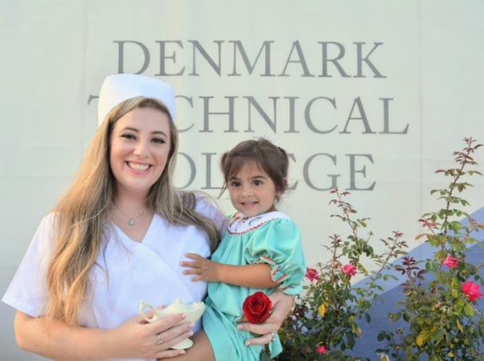

NURSING GRADUATE’S PROCEDURE

PN graduates are eligible to apply to take the National Council Licensure Examination for the Practical Nurse (NCLEX-PN). An endorsement of completion will be sent to the SC State Board of Nursing by the PN Program Dean for eligible students that meet all endorsement criteria. In order to meet graduation requirements of the Practical Nursing Program, a student must do the following:

Have a minimum overall GPA of 2.5 with a C or better in all courses in the curriculum.

Show safe and adequate nursing practice on all clinical evaluations.
File a DTC graduation application. Complete applications to take the National
Council Licensure Examination for the Practical Nurse (NCLEX-PN).
Obtain fingerprinting background check. Mail in a passport picture, copy of Driver’s License and Social Security Card.
**Any student that has a prior conviction of a crime (excluding minor traffic violations) or a drug or alcohol abuse problem could make the student ineligible to take the NCLEX-PN. Early notification to the SC State Board of Nursing is suggested. See the Dean of Nursing for questions regarding the NCLEX-PN.

PRACTICAL NURSE LICENSURE EXAMINATION
Upon graduation from an approved nursing program, the National Council Licensure Examination for the Practical Nurse (NCLEX- PN) is required for licensure as a licensed practical nurse as required by the South Carolina Board of Nursing and the National Council of State Boards of Nursing. Please go to the SC Board of Nursing website for current information regarding requirements for licensure at: http://www.llr.state.sc.us.POL/NURSING/.

PRACTICAL NURSING PROGRAM READMISSION PROCEDURE

- Student may only apply for readmission into the Practical Nursing Program one time.

- A Request to Re-Enter Form (see appendix) must be completed and submitted to the Dean of Nursing at the beginning of the course prior to the desired readmission date. Forms may be picked up from the Nursing Division.

- All nursing courses must be completed within a 2-year period beginning at the first admission into the program. The 2-year period is the academic year when the student was
unsuccessful and the immediately following academic year (example: In 2008-2009 student was unsuccessful; they must apply for readmission into the 2009-2010 academic year). Readmission candidates not able to complete the program the following academic year must reapply to the program as a new student and begin with PNR 110 Fundamentals of Nursing and progress through the entire program schedule of classes.

- Readmission is based on space availability & eligibility. Currently progressing students have priority in enrollment in nursing courses, as there are only 20 slots available in each nursing course.

- If there are more students seeking readmission than can be accommodated, the date the student completed all requirements for readmission will be the deciding factor in the order in which available space is awarded.

- To be eligible for readmission, the student is required to meet current admission criteria into the nursing program.

- Apply to the Office of Admissions for readmission into the college the semester prior to requested readmission.

- Follow PN application process as outlined in the nursing readmission application packet.

- A student requesting readmission into the nursing program are required to submit updated criminal background check and updated drug screen results.

- Submit current CPR and First Aid cards and updated medical form, including current PPD and immunizations.

- A dropped, withdrawn or failed course must be successfully completed before the student can progress to the next nursing course(s).

- A student who makes a D, F, or WF in a nursing course on the first attempt, must make a C, 80 or above, on the second attempt. No required nursing course may be attempted more than twice in order to earn a C. If the student fails to earn a C on the second attempt, he/she will not be eligible for future readmission into the nursing program.

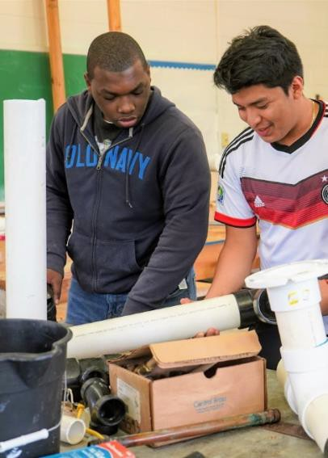

Transitional Studies

Degrees, Diplomas and Certificates Associate in Arts and Science Majors Associate in Arts
Associate in Science
Associate in Applied Science Majors Administrative Office Technology Computer Technology
Criminal Justice Technology Early Care and Education
Electromechanical Engineering Technology General Business
General Technology Human Services

Diploma in Applied Science Majors
Administrative Support Barbering Cosmetology
Practical Nursing

Option I Students
These are high school graduates who did not score successfully on the Placement Test in Mathematics, Reading and/or English and therefore need remediation. Option I students are advised by both the program advisor and Transitional Studies advisor.

Option II Students
As of July 1, 2012, students who are non-high school graduates do not qualify for Title IV funds unless they meet Denmark Technical College’s guidelines and policy and procedures for the equivalency of a high school diploma.
These are students who are not high school graduates and are admitted into one of the certificate programs that do not require high school credentials.
Upon receiving high school credentials, these students have the option to change their program or continue in the certificate program they are currently enrolled in.
Option II students are advised by both the program advisor and Transitional Studies advisor.
- It is advised that students complete requirements for Transitional Studies in two semesters.

Certificate in Applied Science Majors
Accounting
Building Construction Fundamentals Computer Servicing & Repair Criminal Justice
Culinary Arts Cybersecurity
Early Childhood Development Entrepreneurship/Small Business Management General Studies
Gerontology
Multimedia Web Graphics Design Nurse Aide Assistant
Plumbing Pre-Medical Welding
Word Processing

Alma Mater

O’ Alma Mater, waving high The Pride of all our hearts Real manliness, Fidelity That never doth depart.

We love thy large and tiny halls, Thy lawns and sunny plains.
We give thee praise with all our might And yours we will remain.

Chorus:
To thee, dear, Denmark Tech Our hearts are beating true.
We give thee praise and loyalty In everything we do.

Alvin O. Jackson Class of 1950

(Sung to the tune of “Auld Lang Syne”)
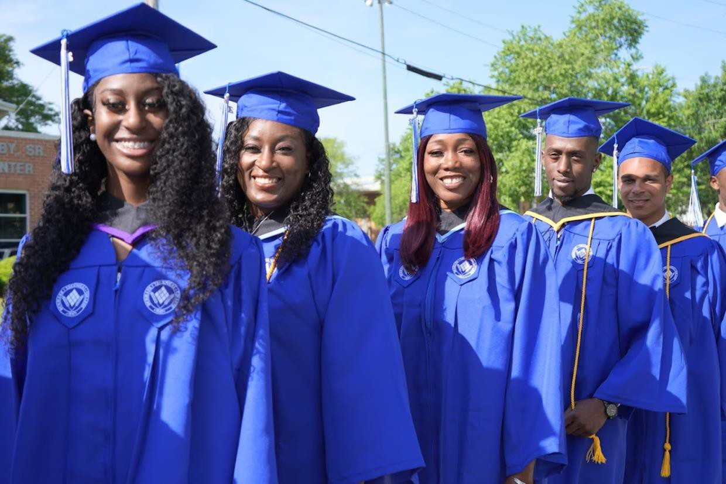

122
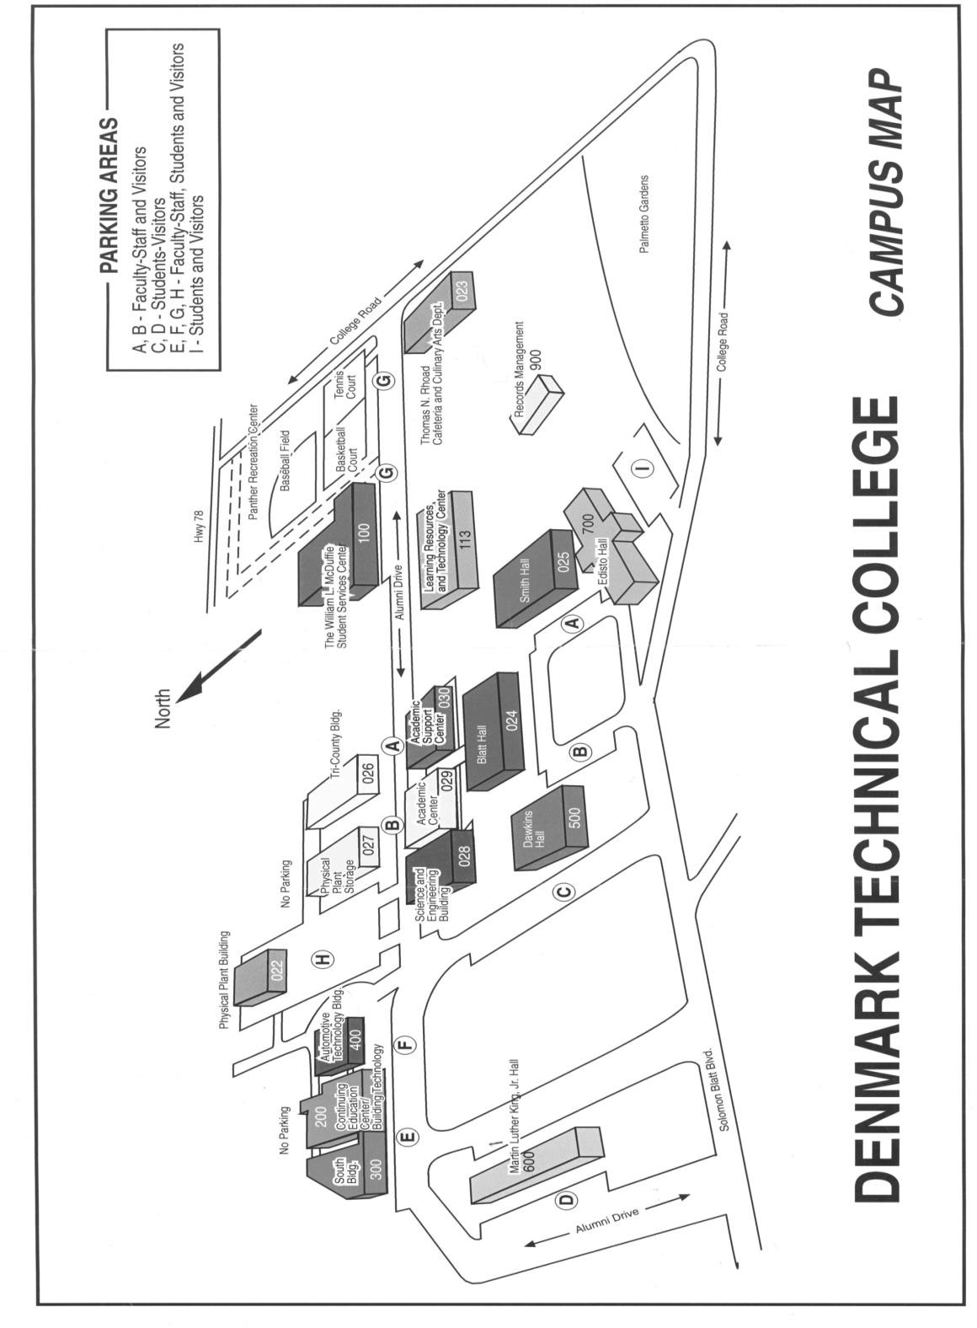

123

